**Git:**

Git is a free and open source distributed version control system designed to handle everything from small to very large projects with speed and efficiency.

Difference between git and github:

Git is a version control system that allows you to track changes to your code, and it is a great way to keep track of your work. It is also a great way to share your code with others, and it can be very useful when you are working on a project that involves a lot of collaboration.

Github is a web-based Git repository, that is. Cloud-based storage is offered by this hosting company. Git’s distributed version control and source code management capabilities are all provided by GitHub, along with some additional features. Utilising Git facilitates collaboration. The public can access GitHub repositories as well. GitHub serves as a networking platform for online professionals since developers from all over the world may engage, contribute to one another’s code, and edit or improve it. Social coding is another name for the process of participation and engagement.

Differencebetween git and svn:

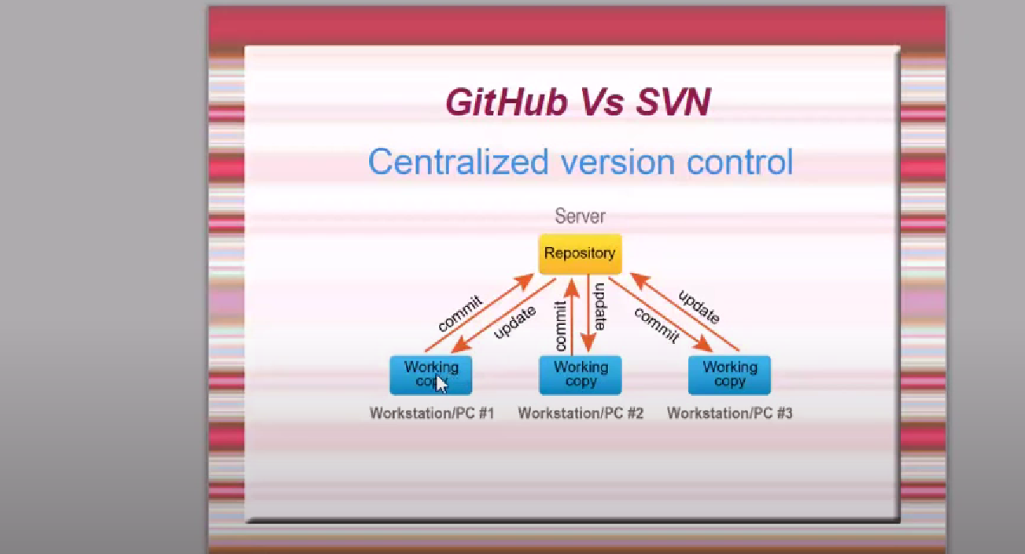

u must have internet connection.

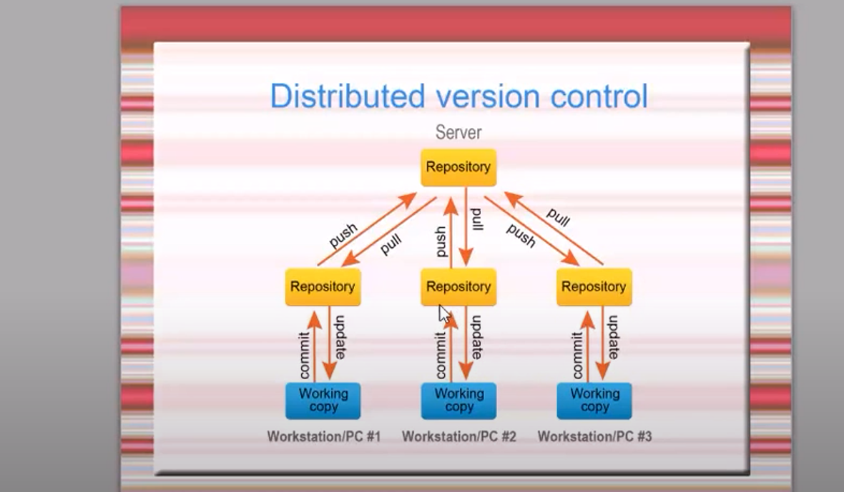

SVN:

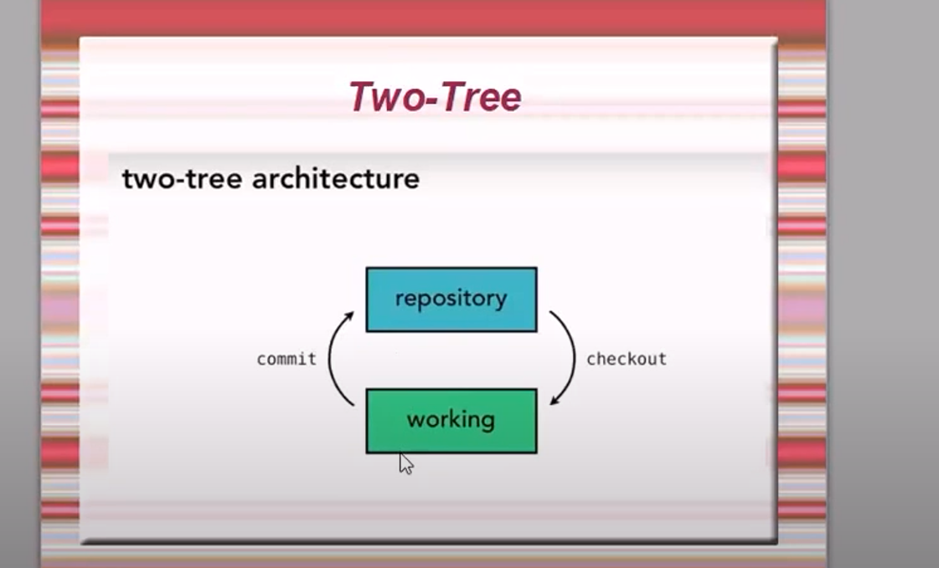

GIT:

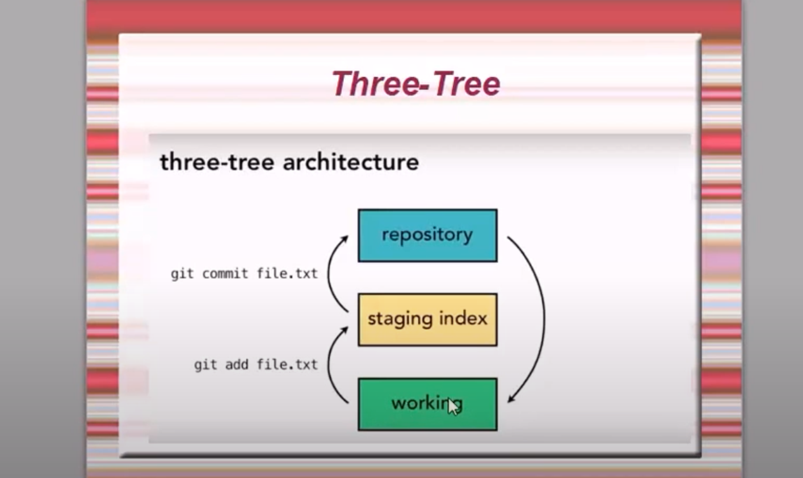

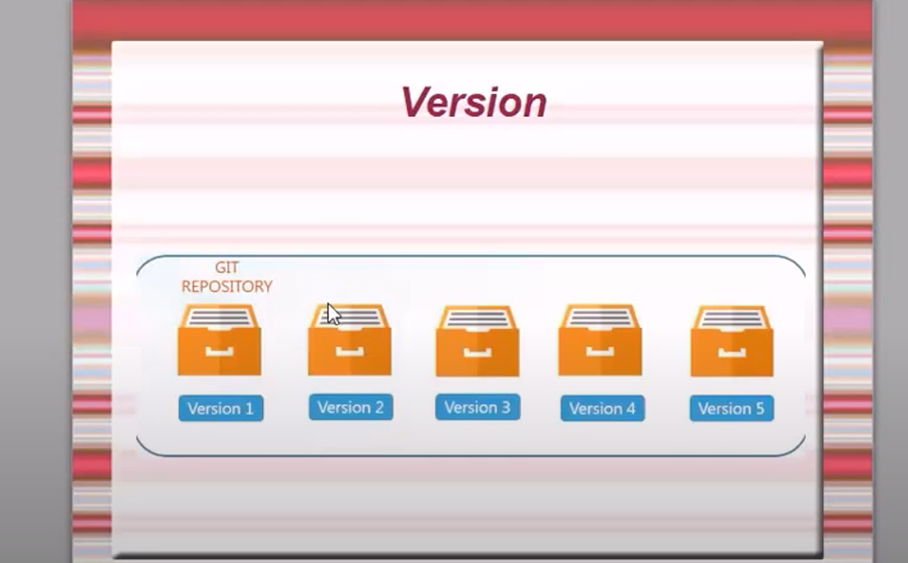

Every changes there will be a version.

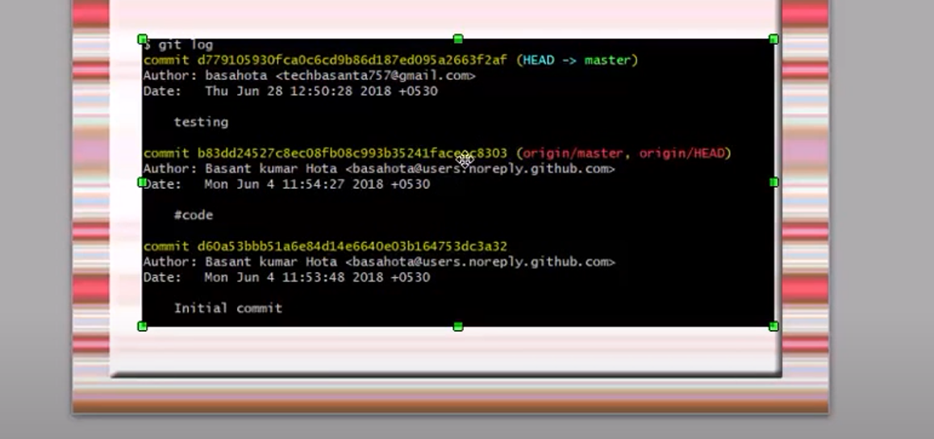

Need to install git using below command

<https://git-scm.com/downloads>

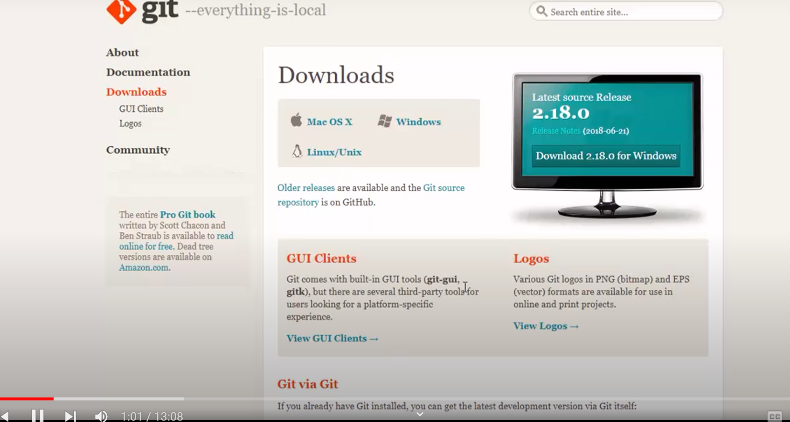

Click on download2.18.0 for windows

Lets create the maven project in eclipse

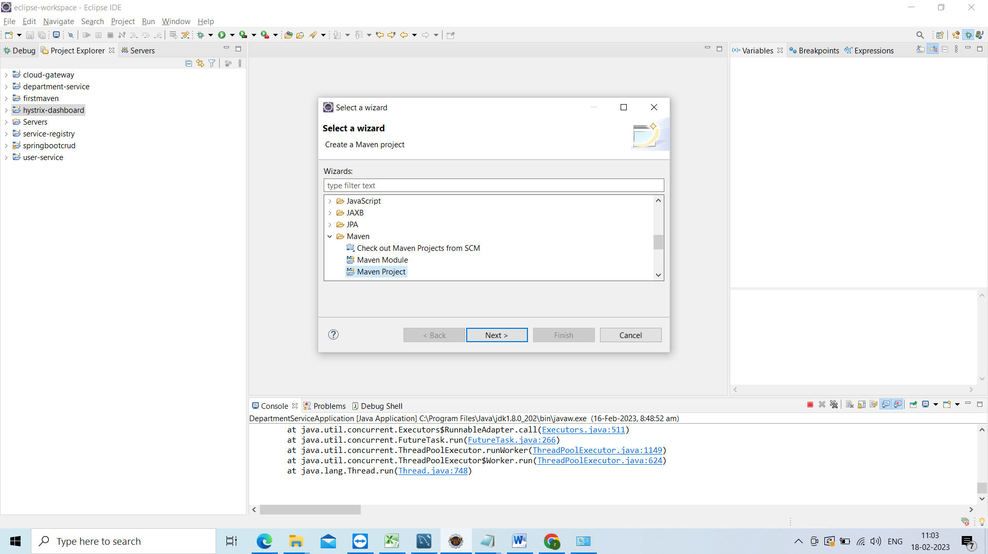

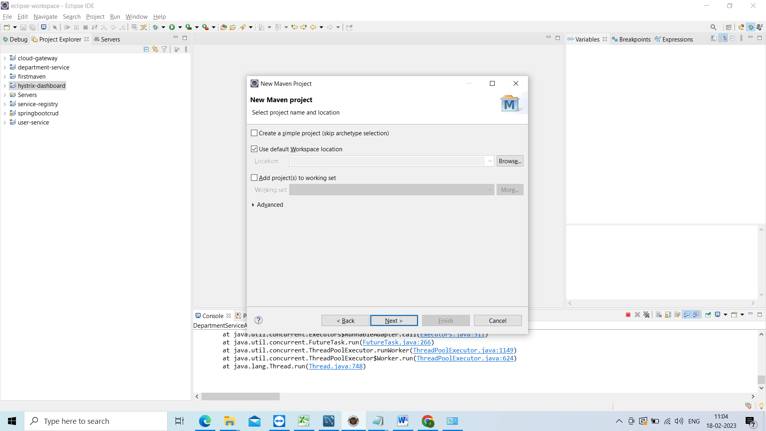

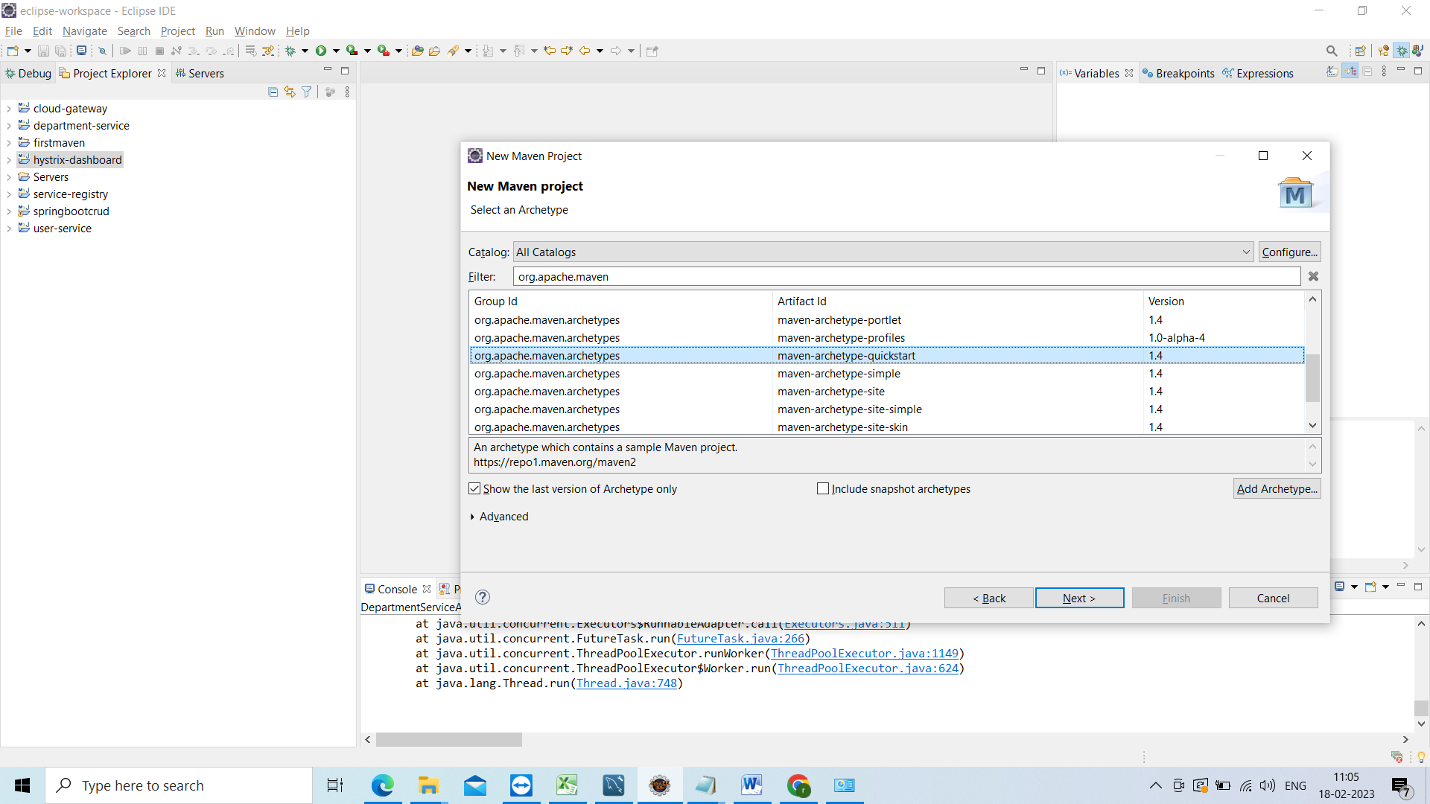

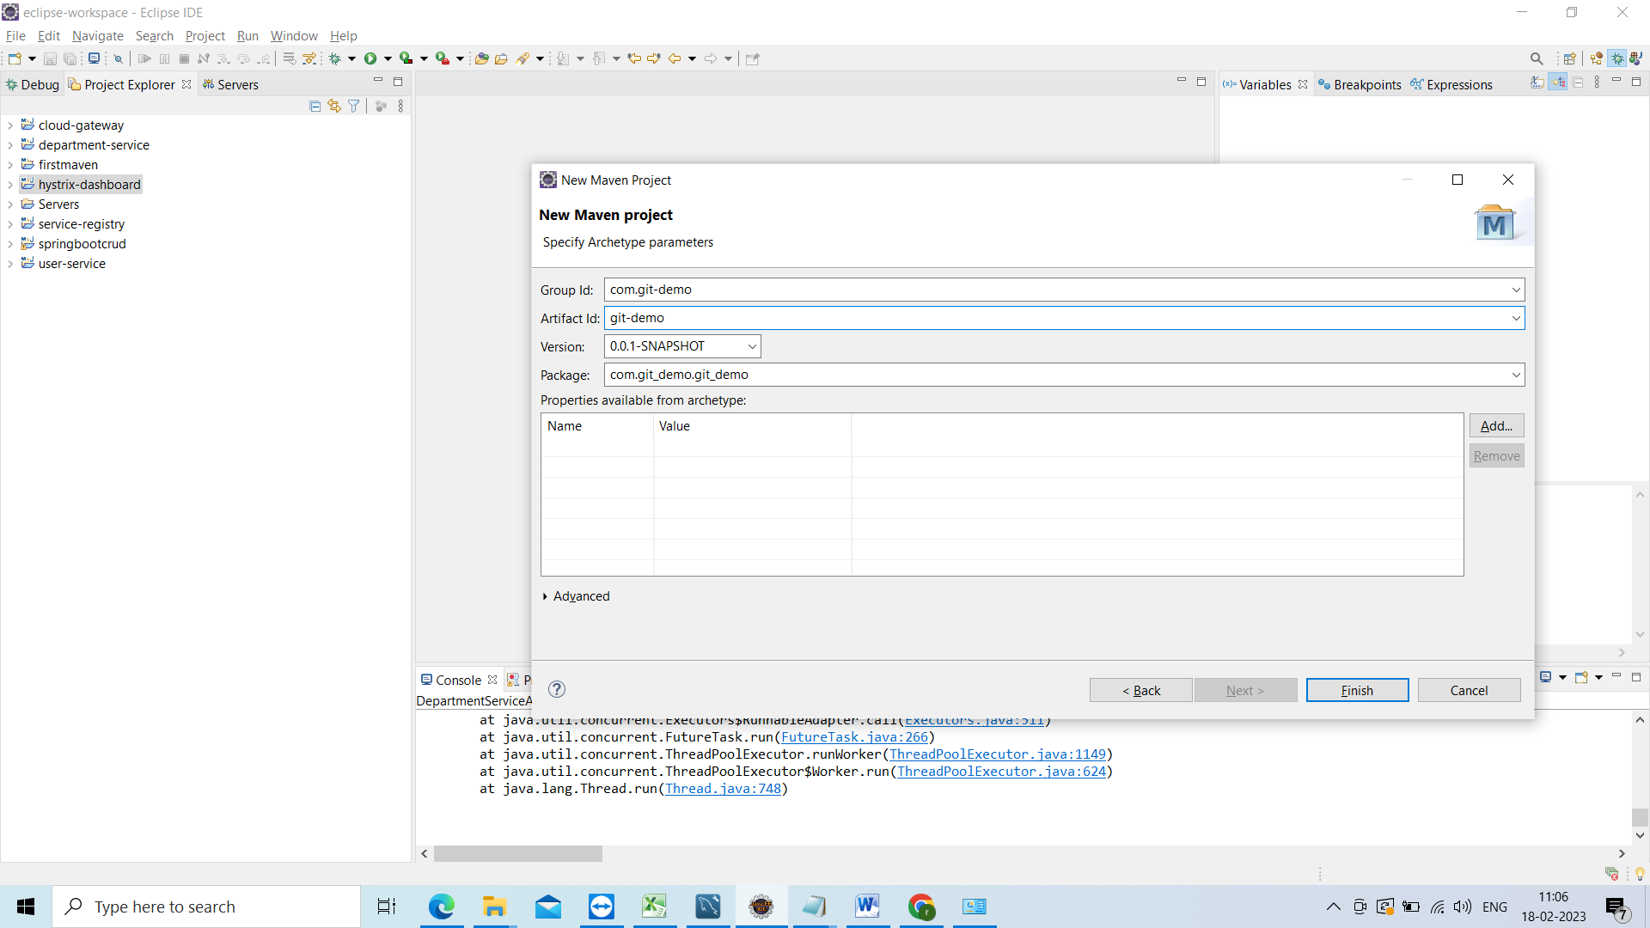

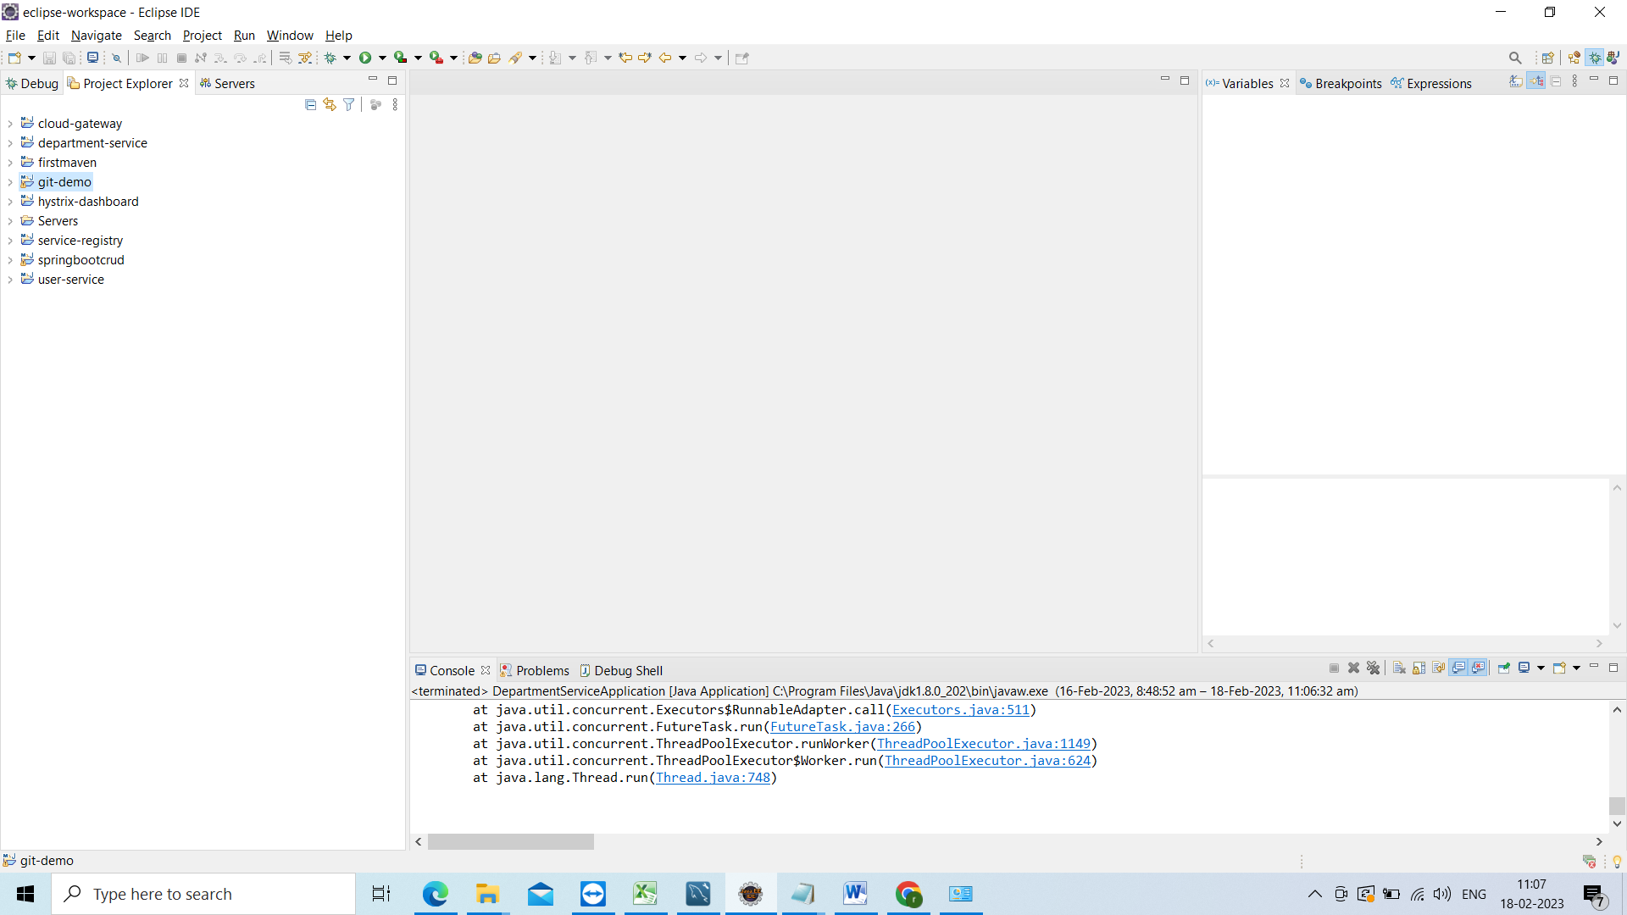

Project has been created.

Create some dummy method

In APP.java

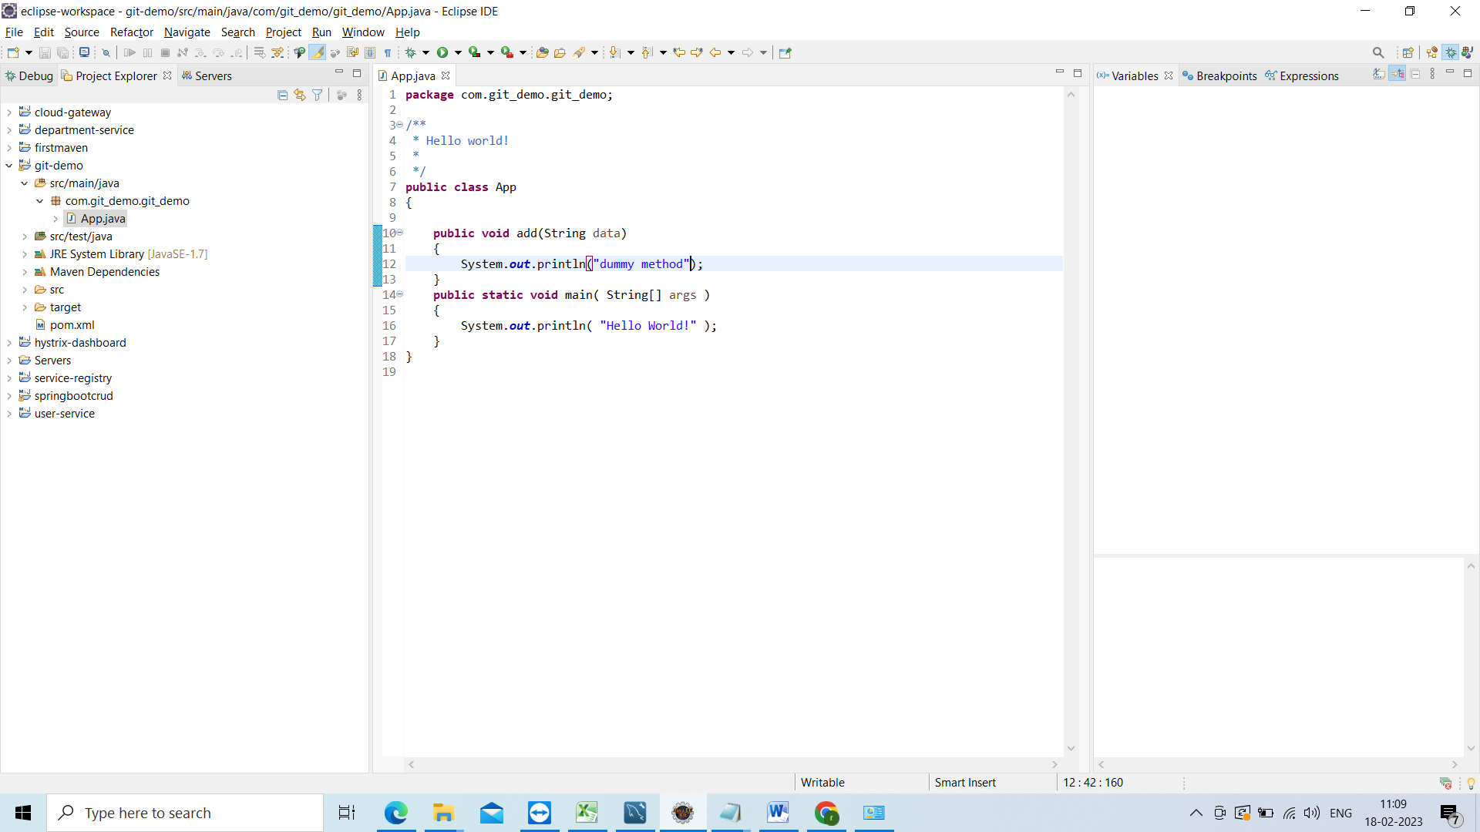

Now go to the project directory and do the git bash here

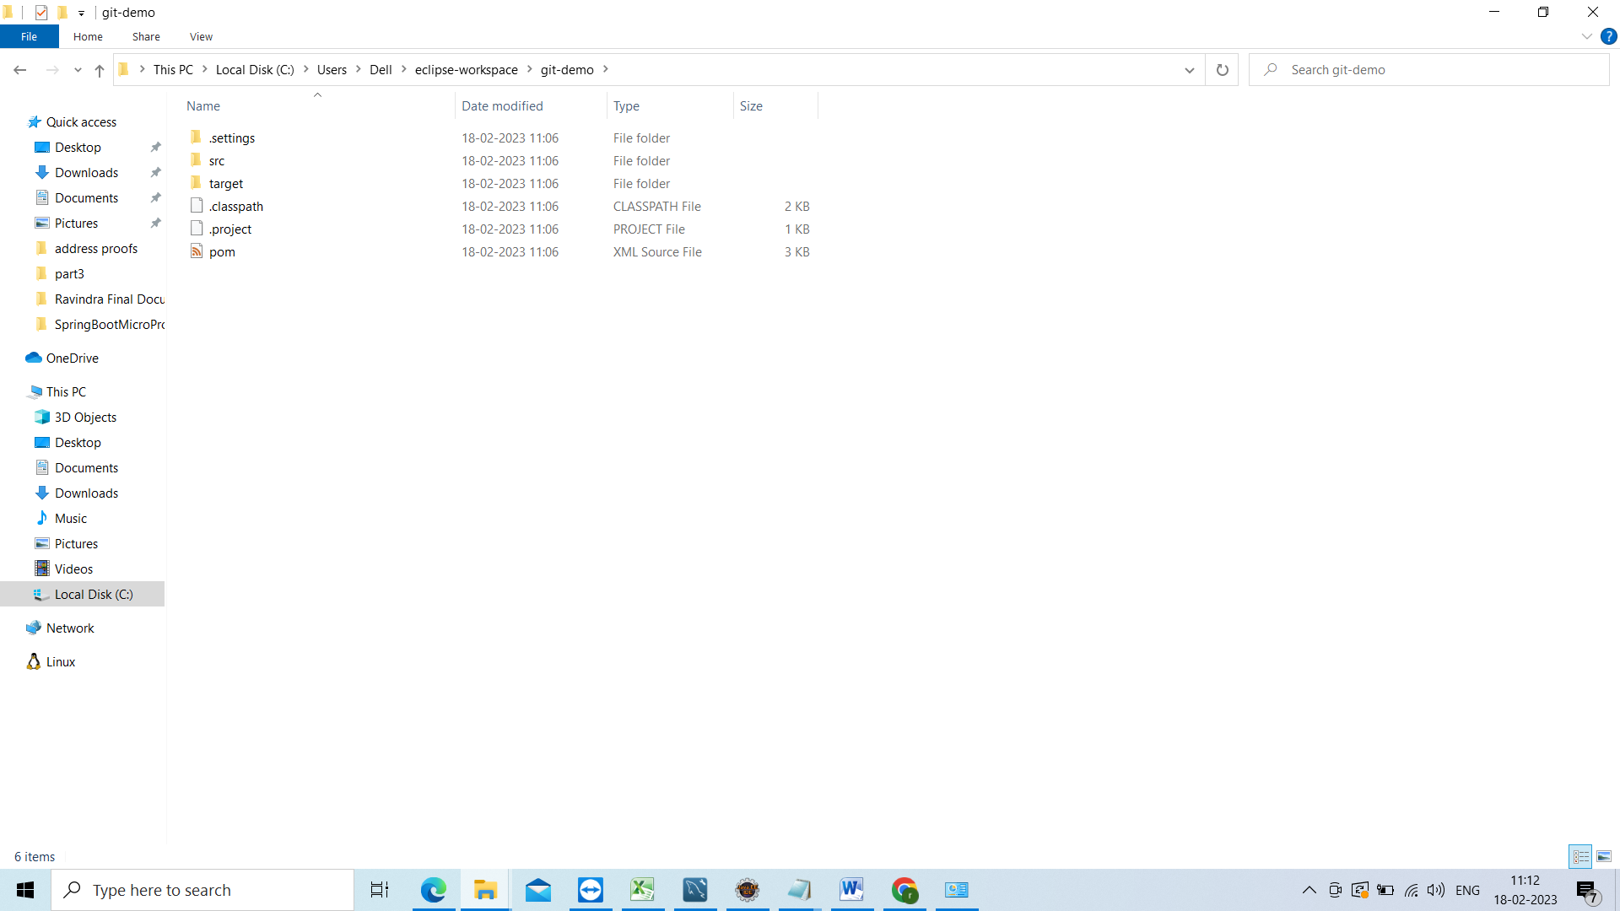

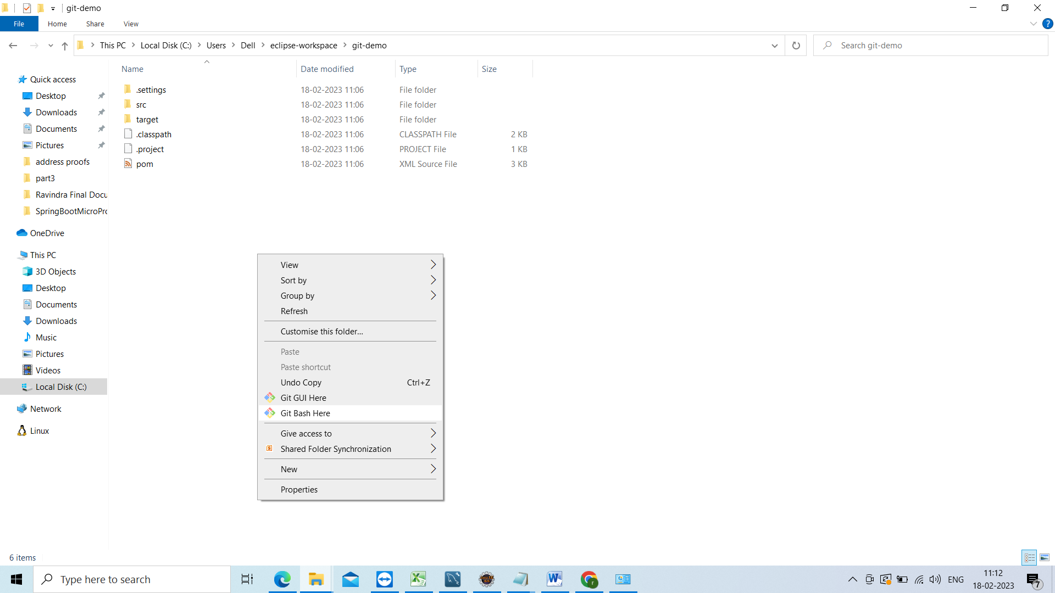

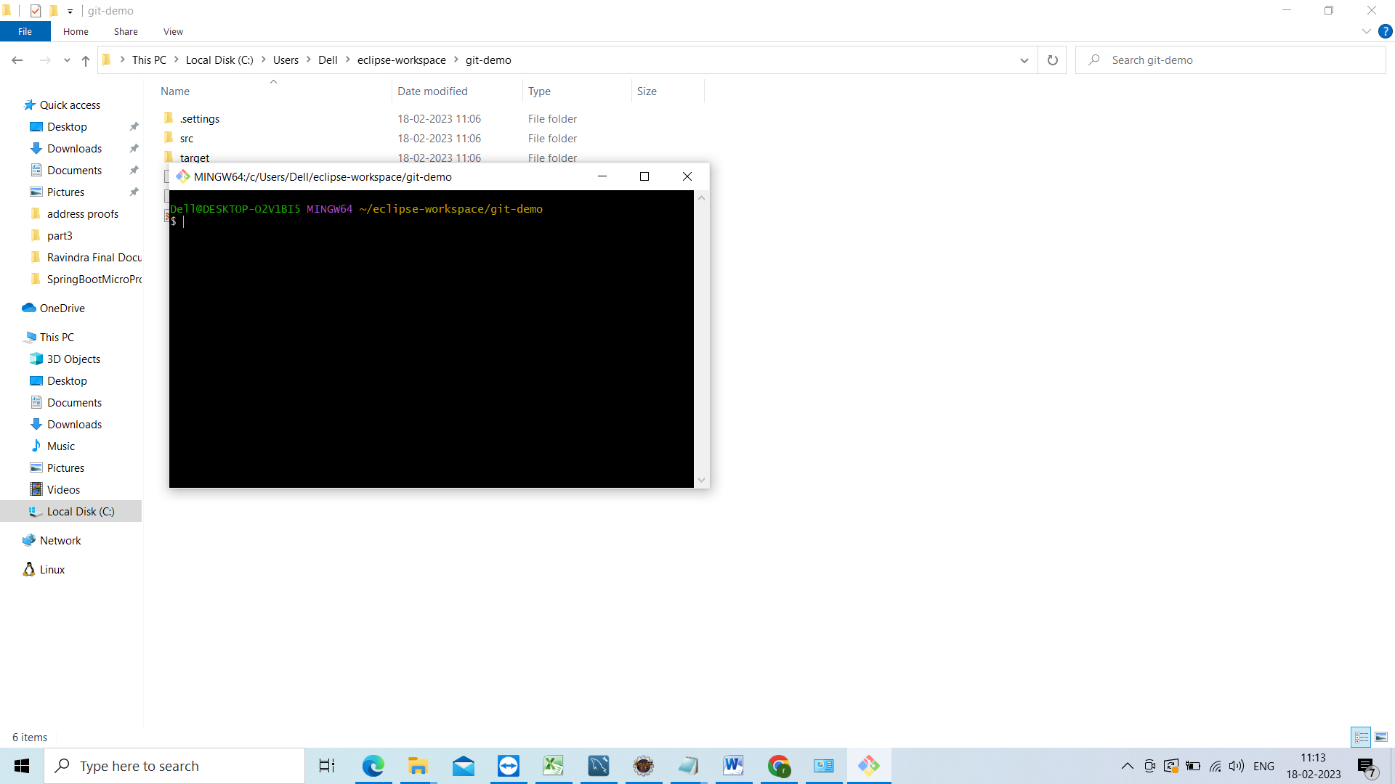

Now check any local repository created or not

For that need to use

Git status

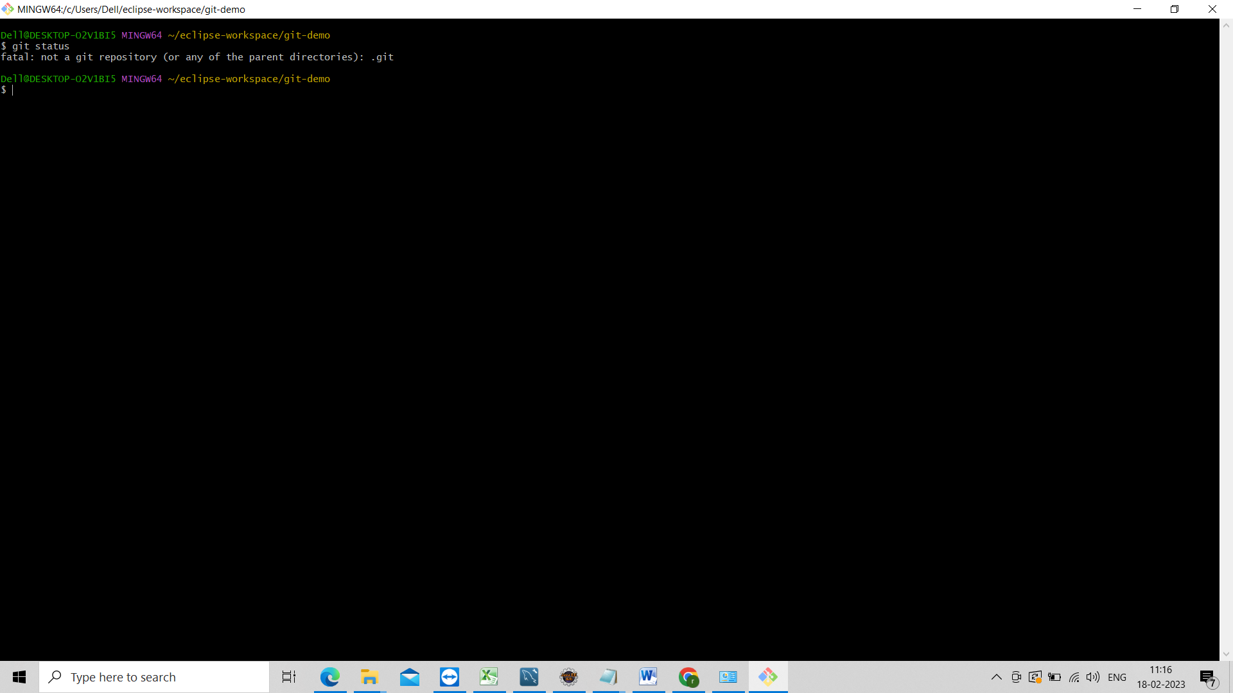

Not created

To initialize the local repository we need to use command called

Git init

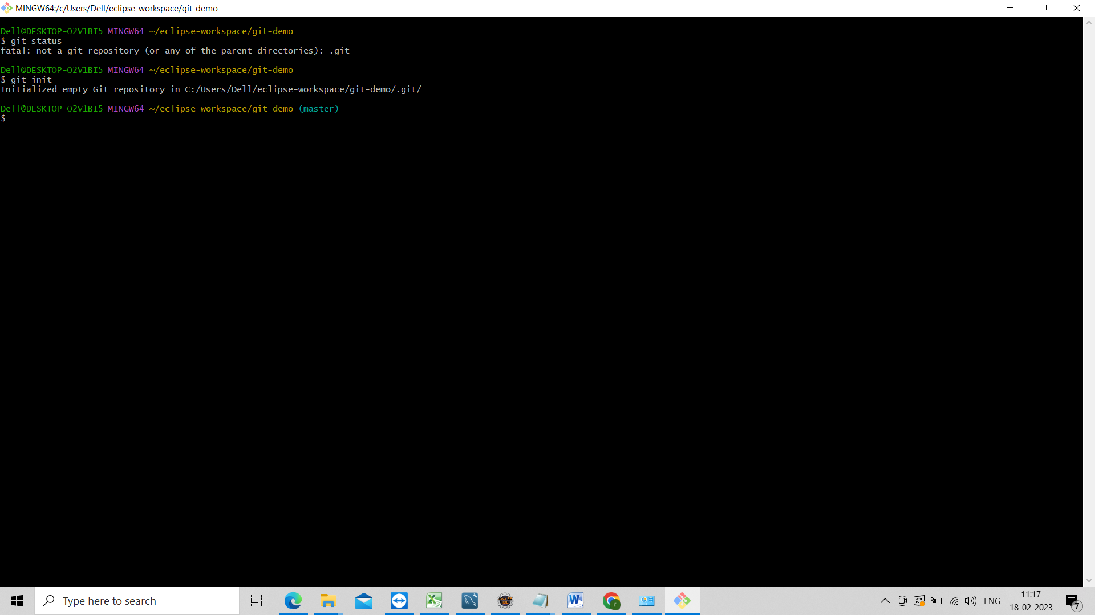

Now check changes in the code

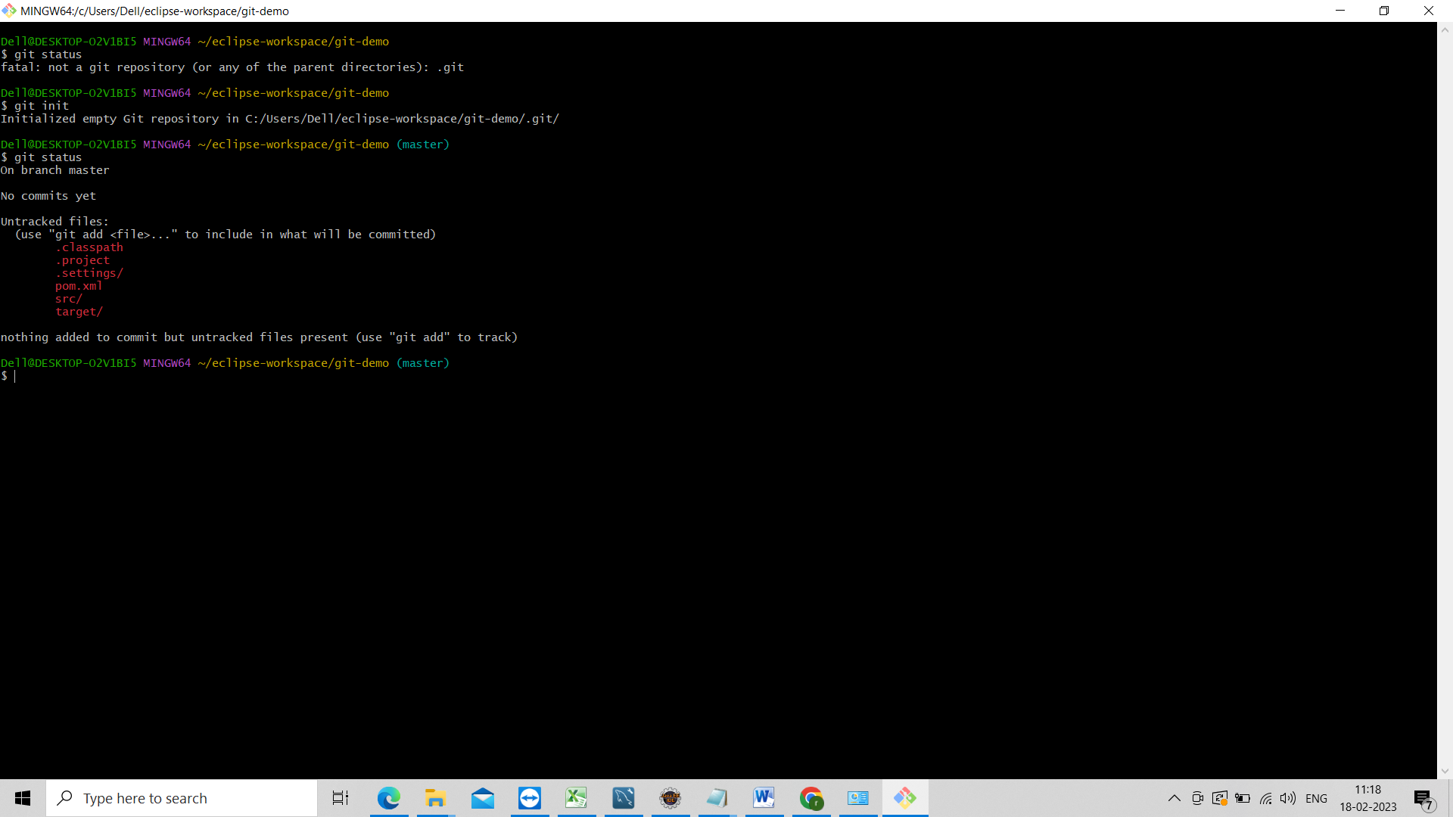

Now we need to add those changes to staging area

Git add .

It will add all the files to the staging area

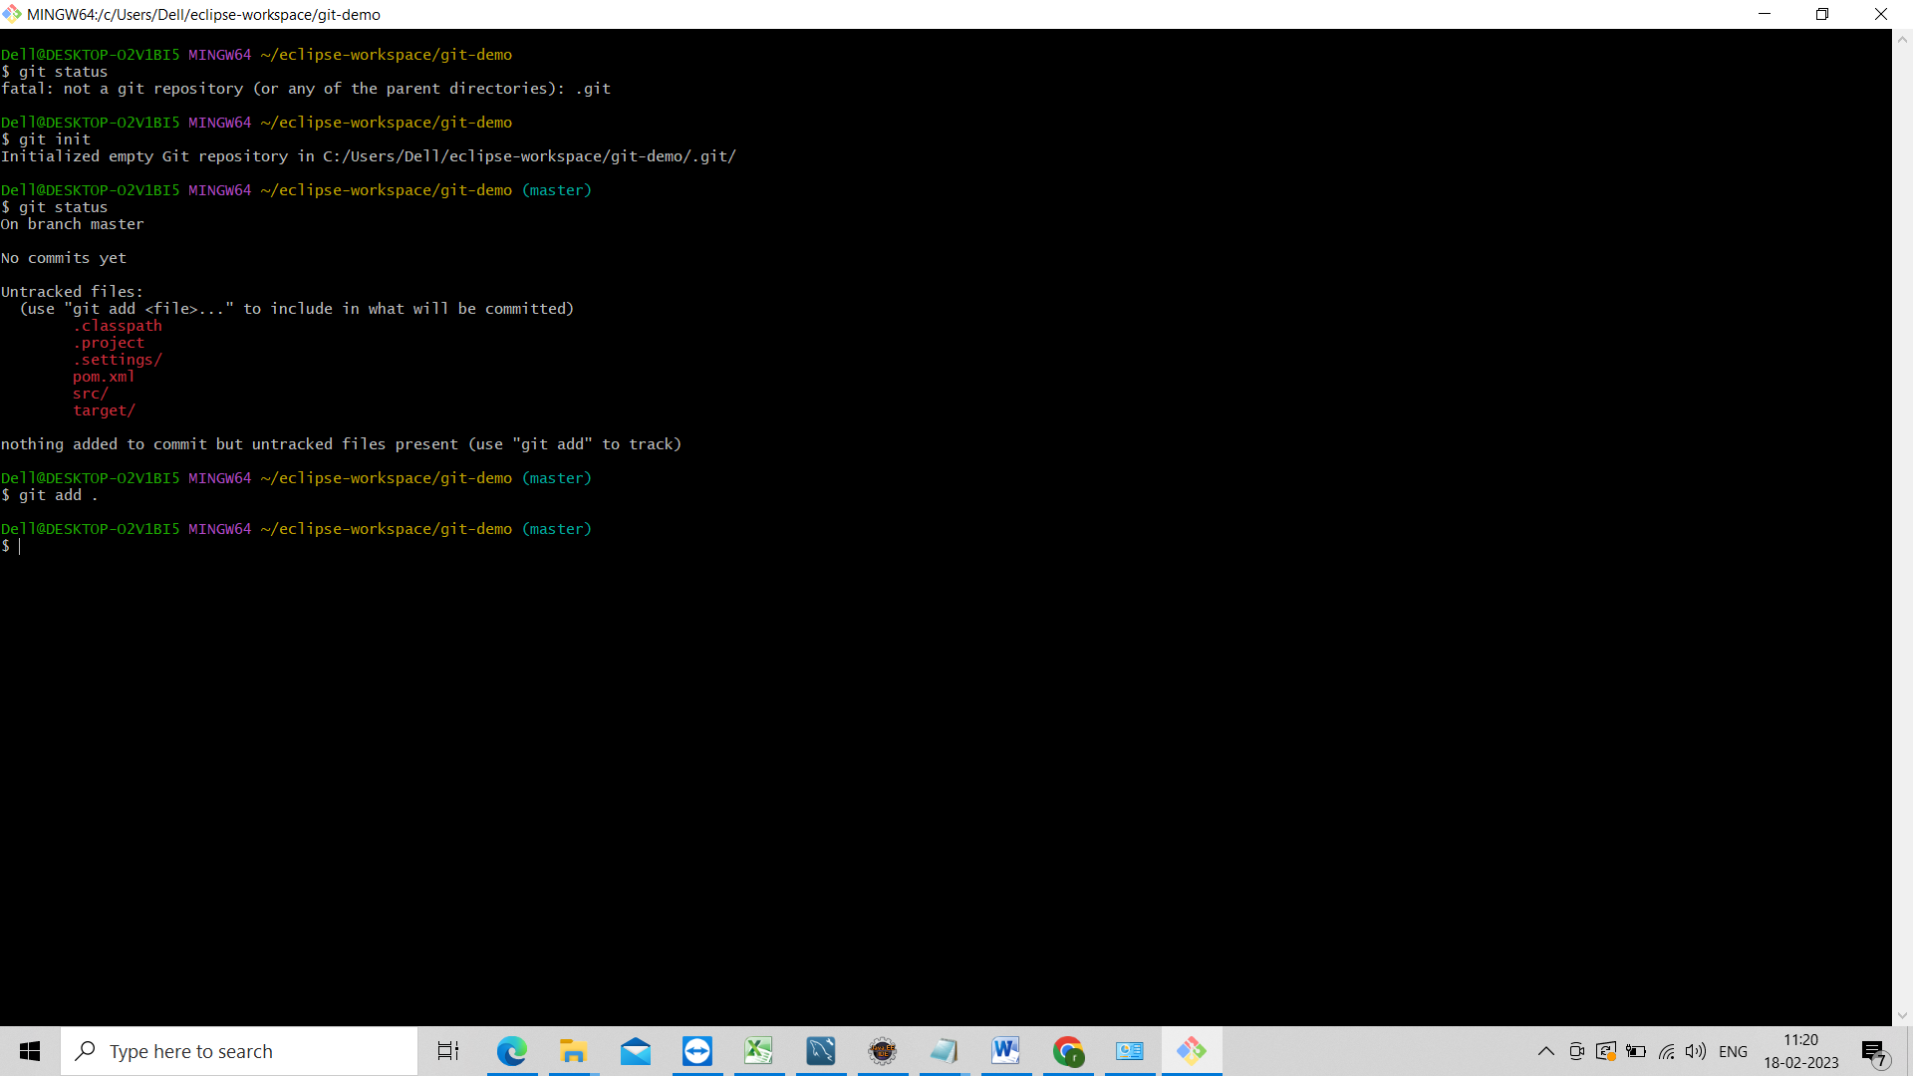

Now check the git status

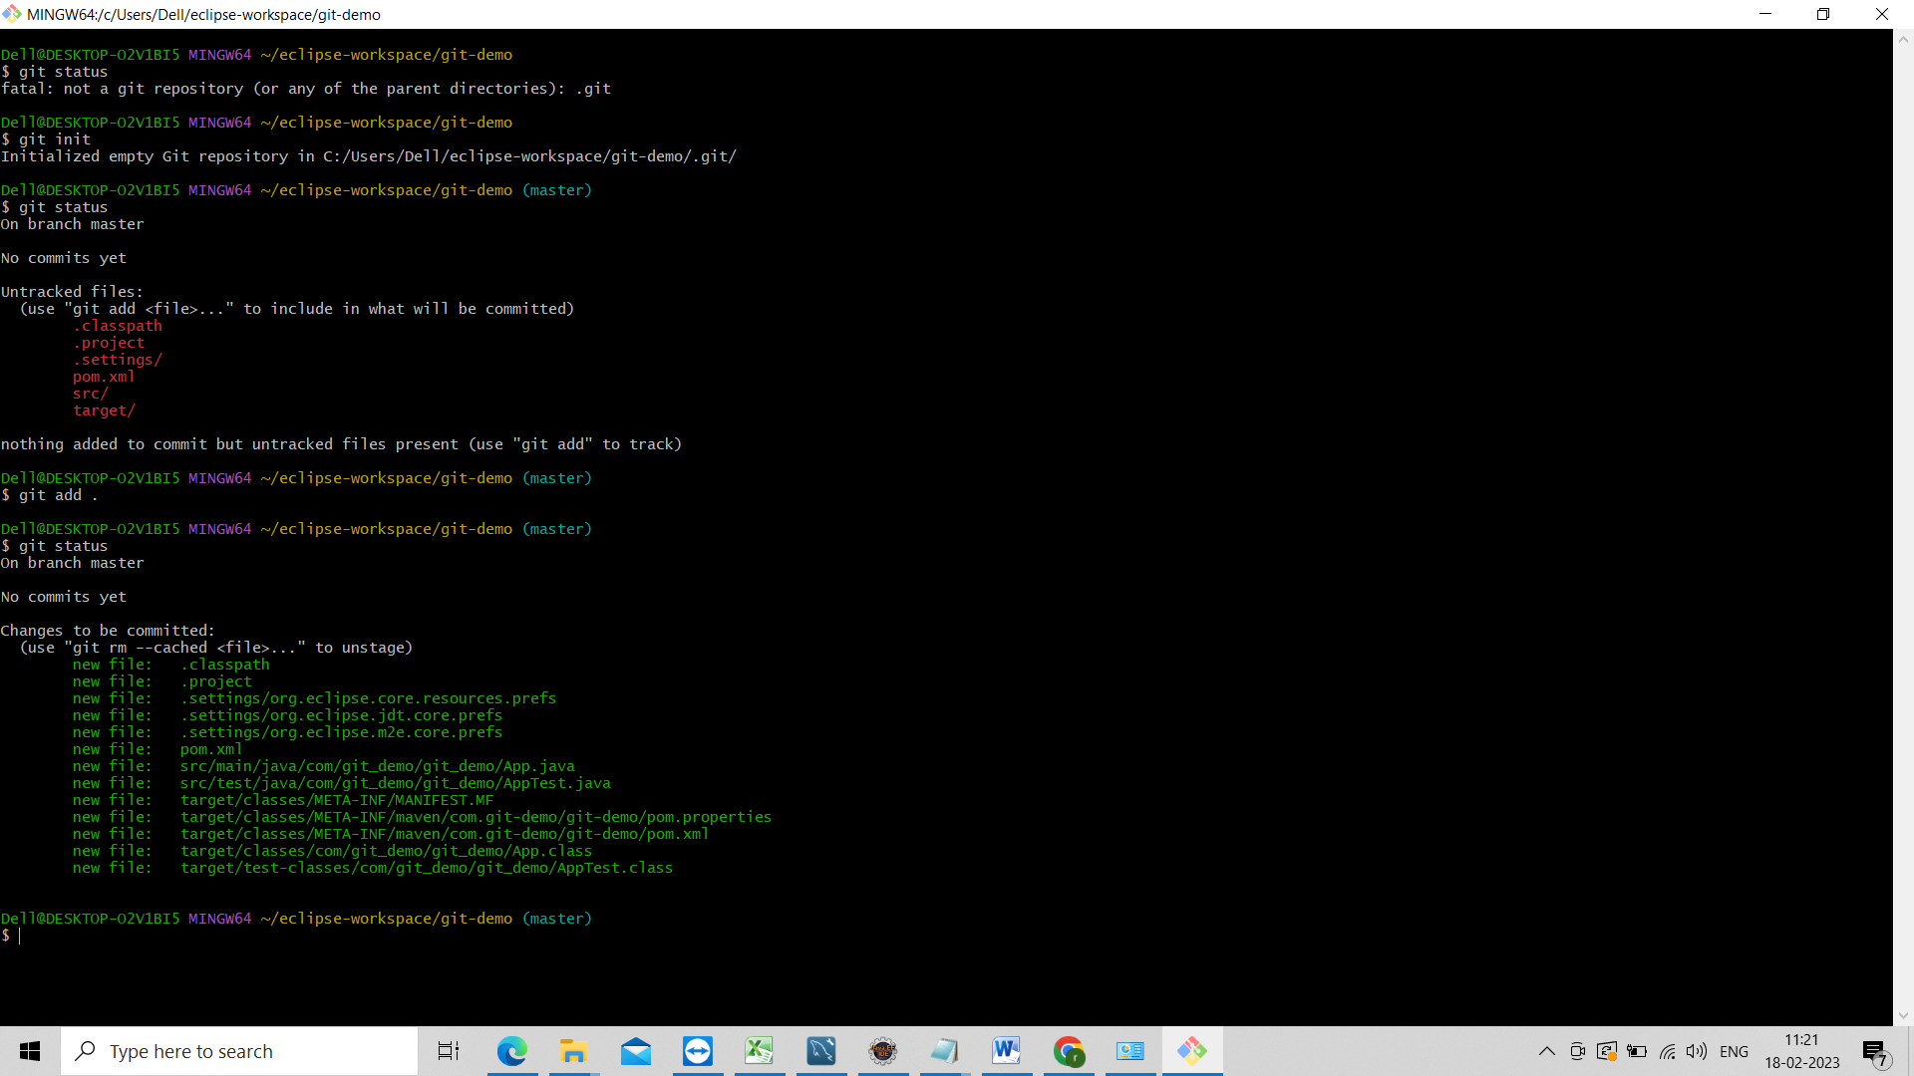

Now add the all the files to the local repository for that need to use command called

Git commit –m “commit message any thing”

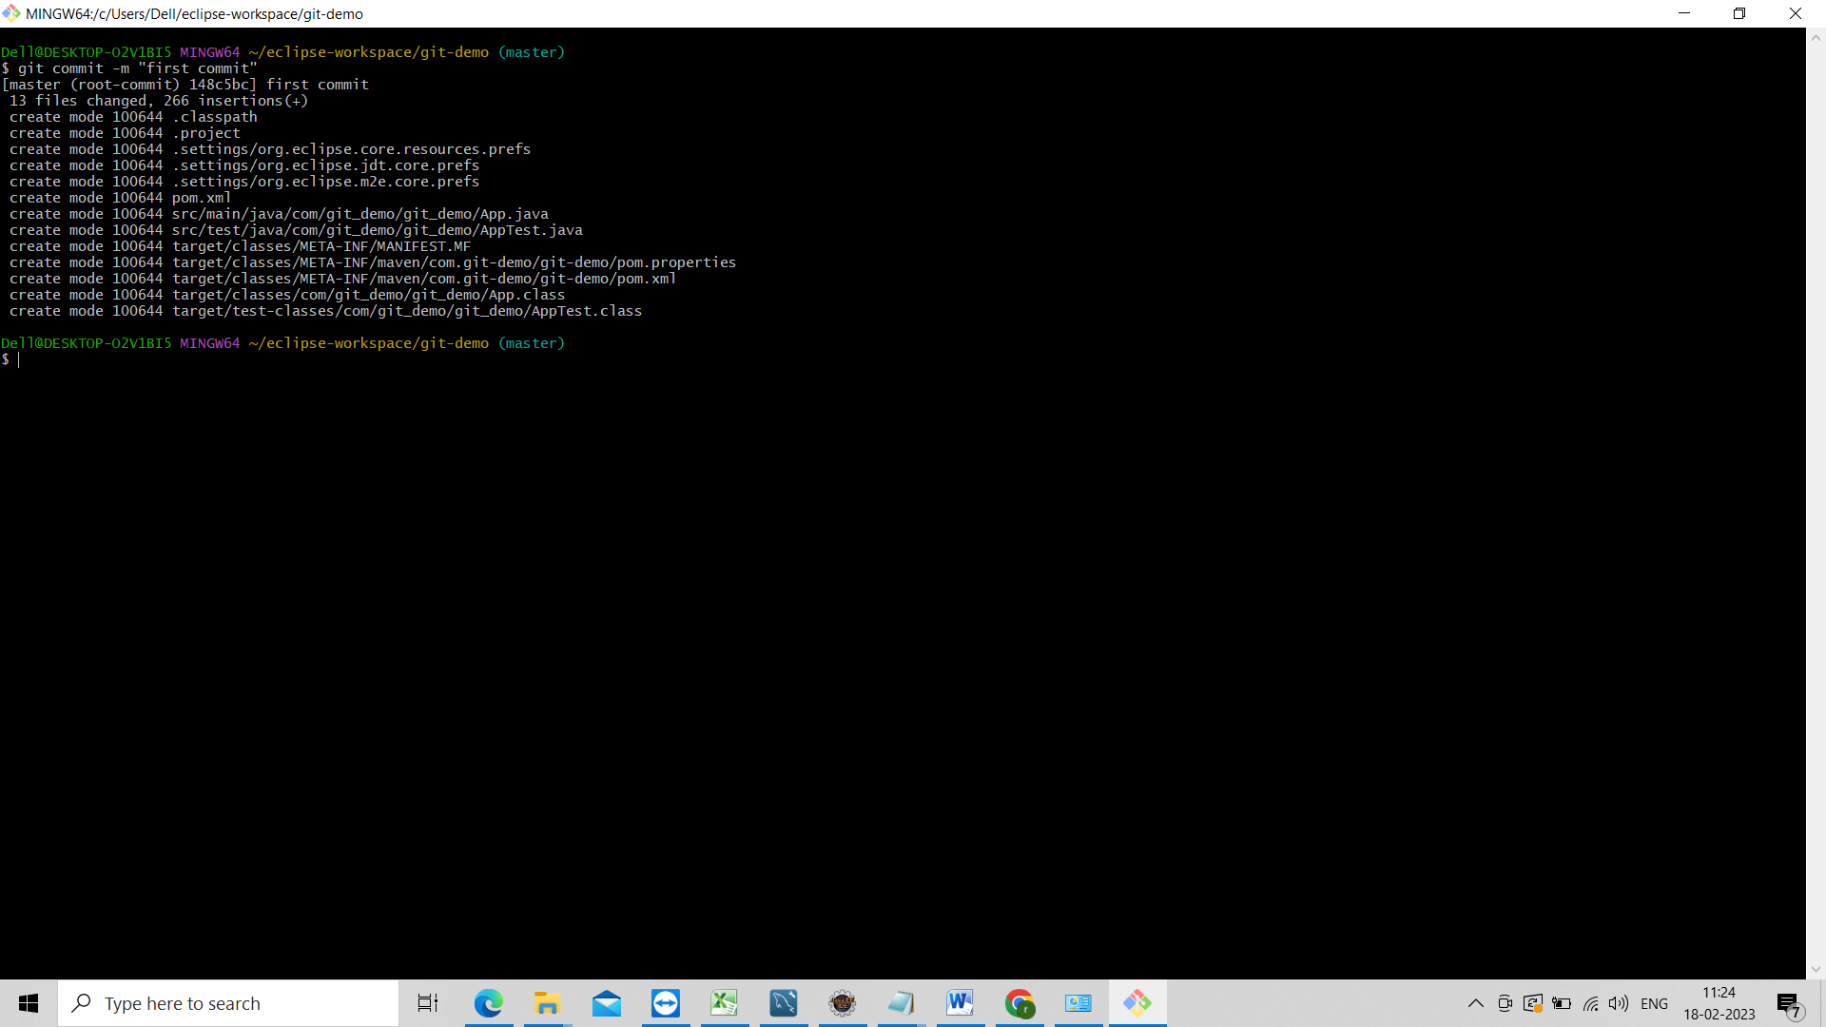

Now check the git staus

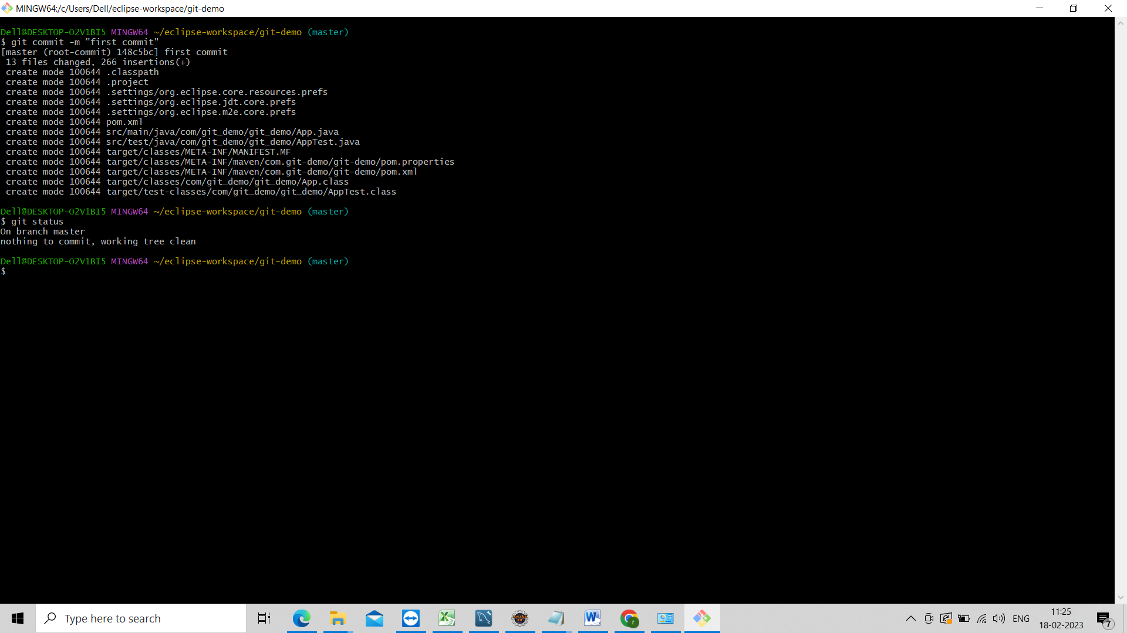

Now check git log

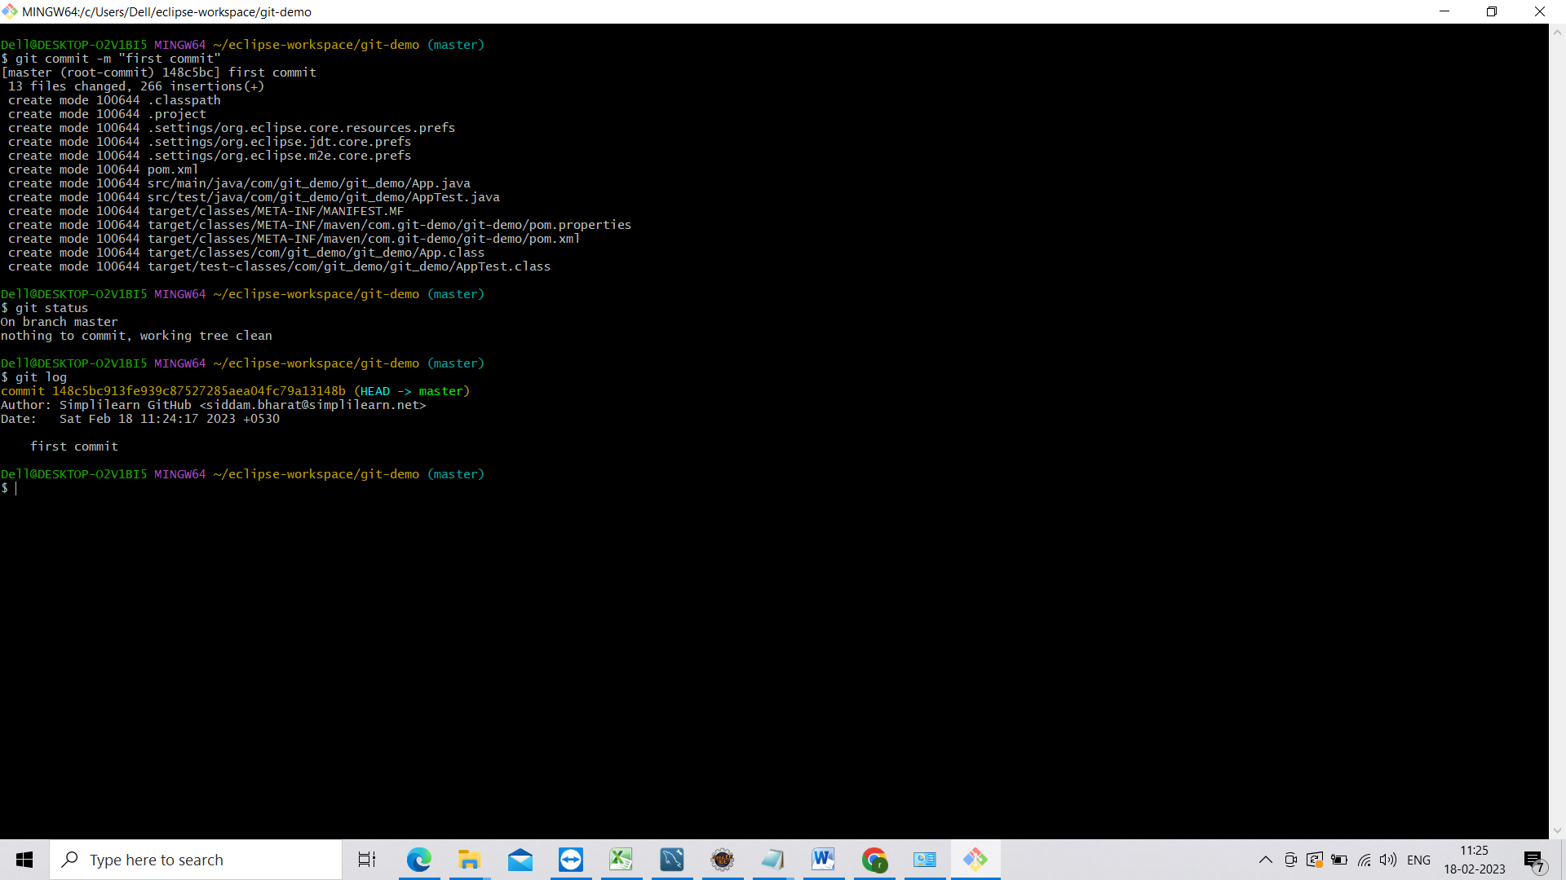

Checks has been created.

Now go to code do some changes

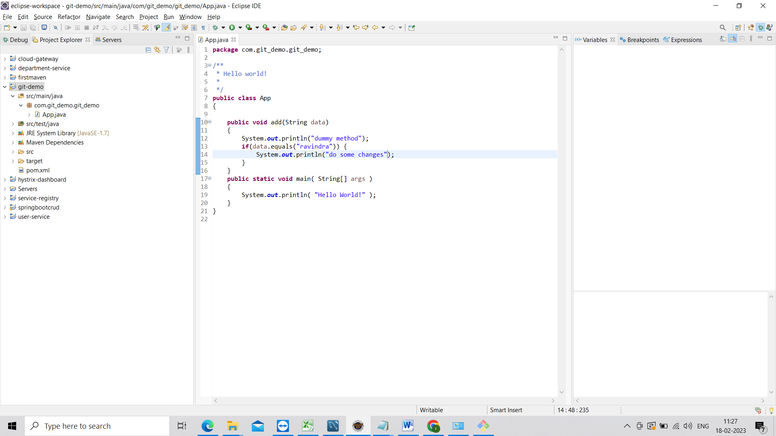

Now go to git bash and check git status

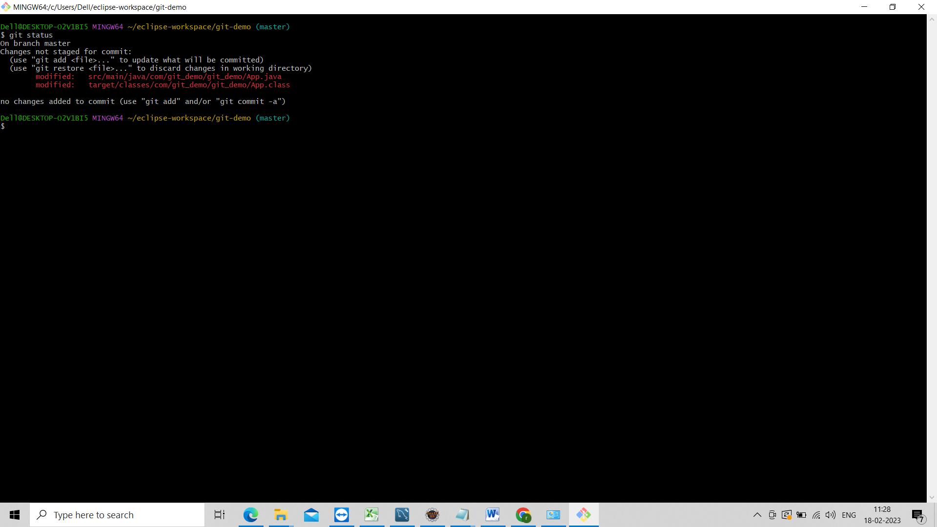

Now again need to add that file to the staging area and local repo

First use git add . then use git commit –m “message”

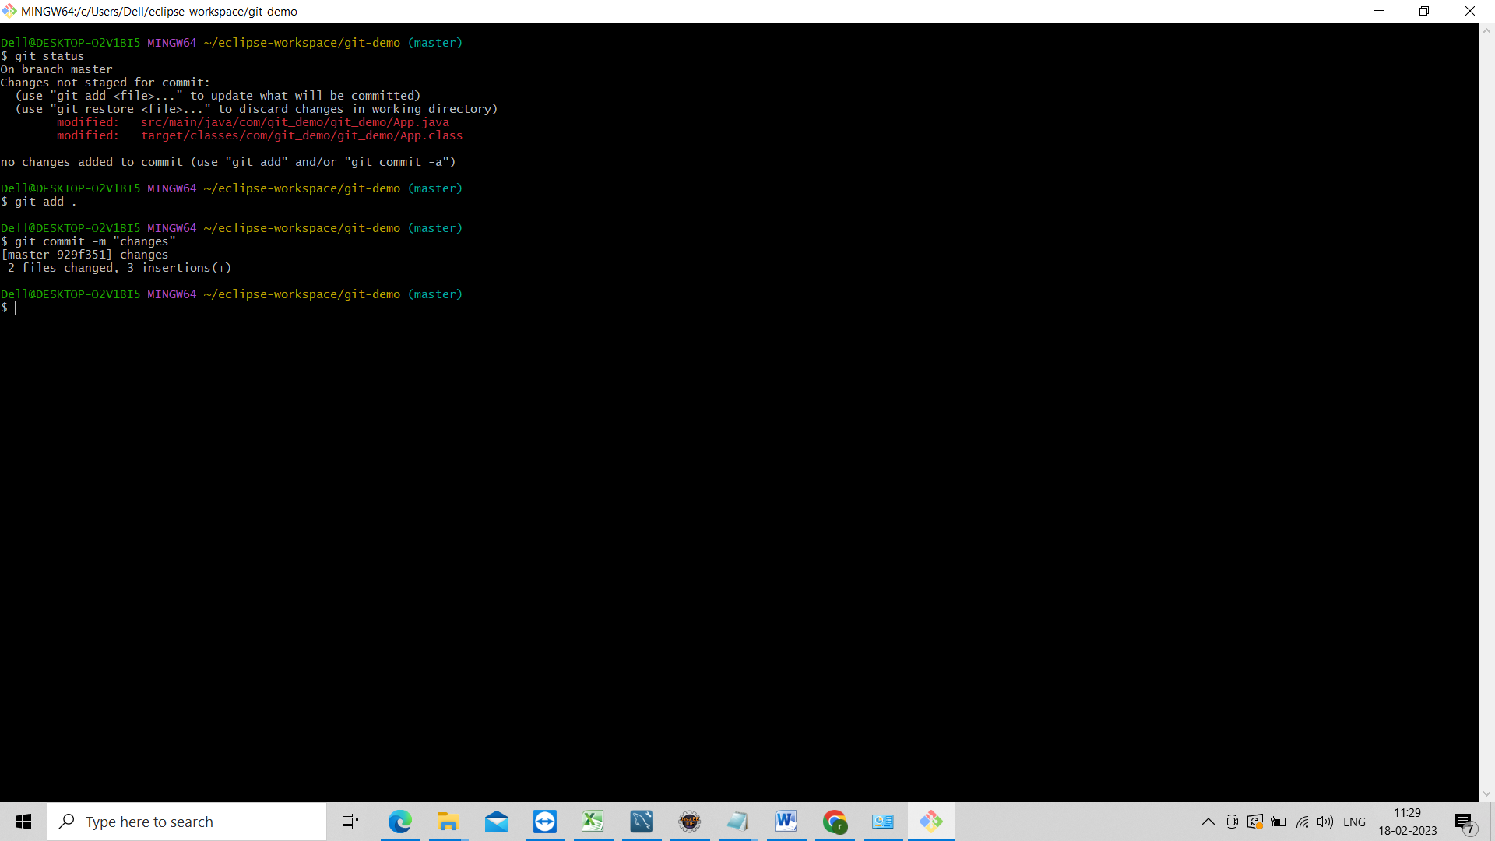

Next am going show u how to push local repository changes to remote repository.

For that u have to create the remote repository in github.

Click on + and select new repository

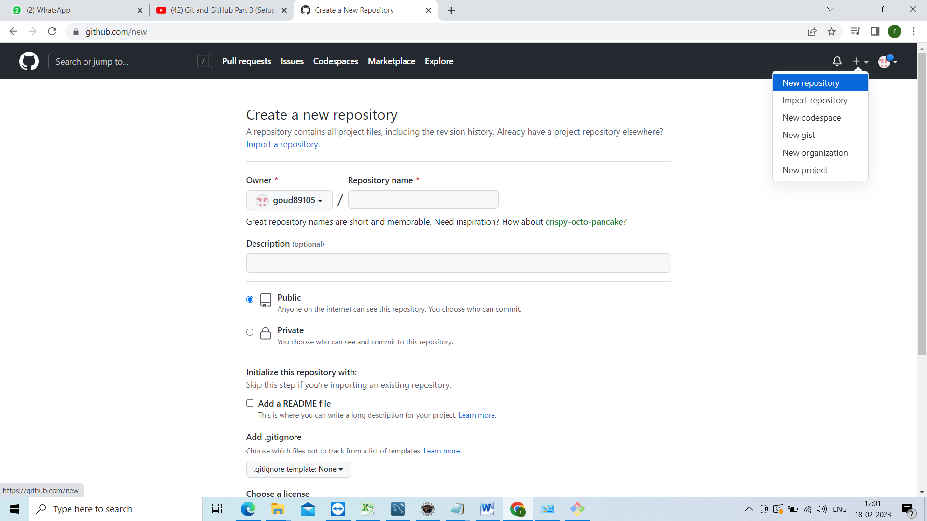

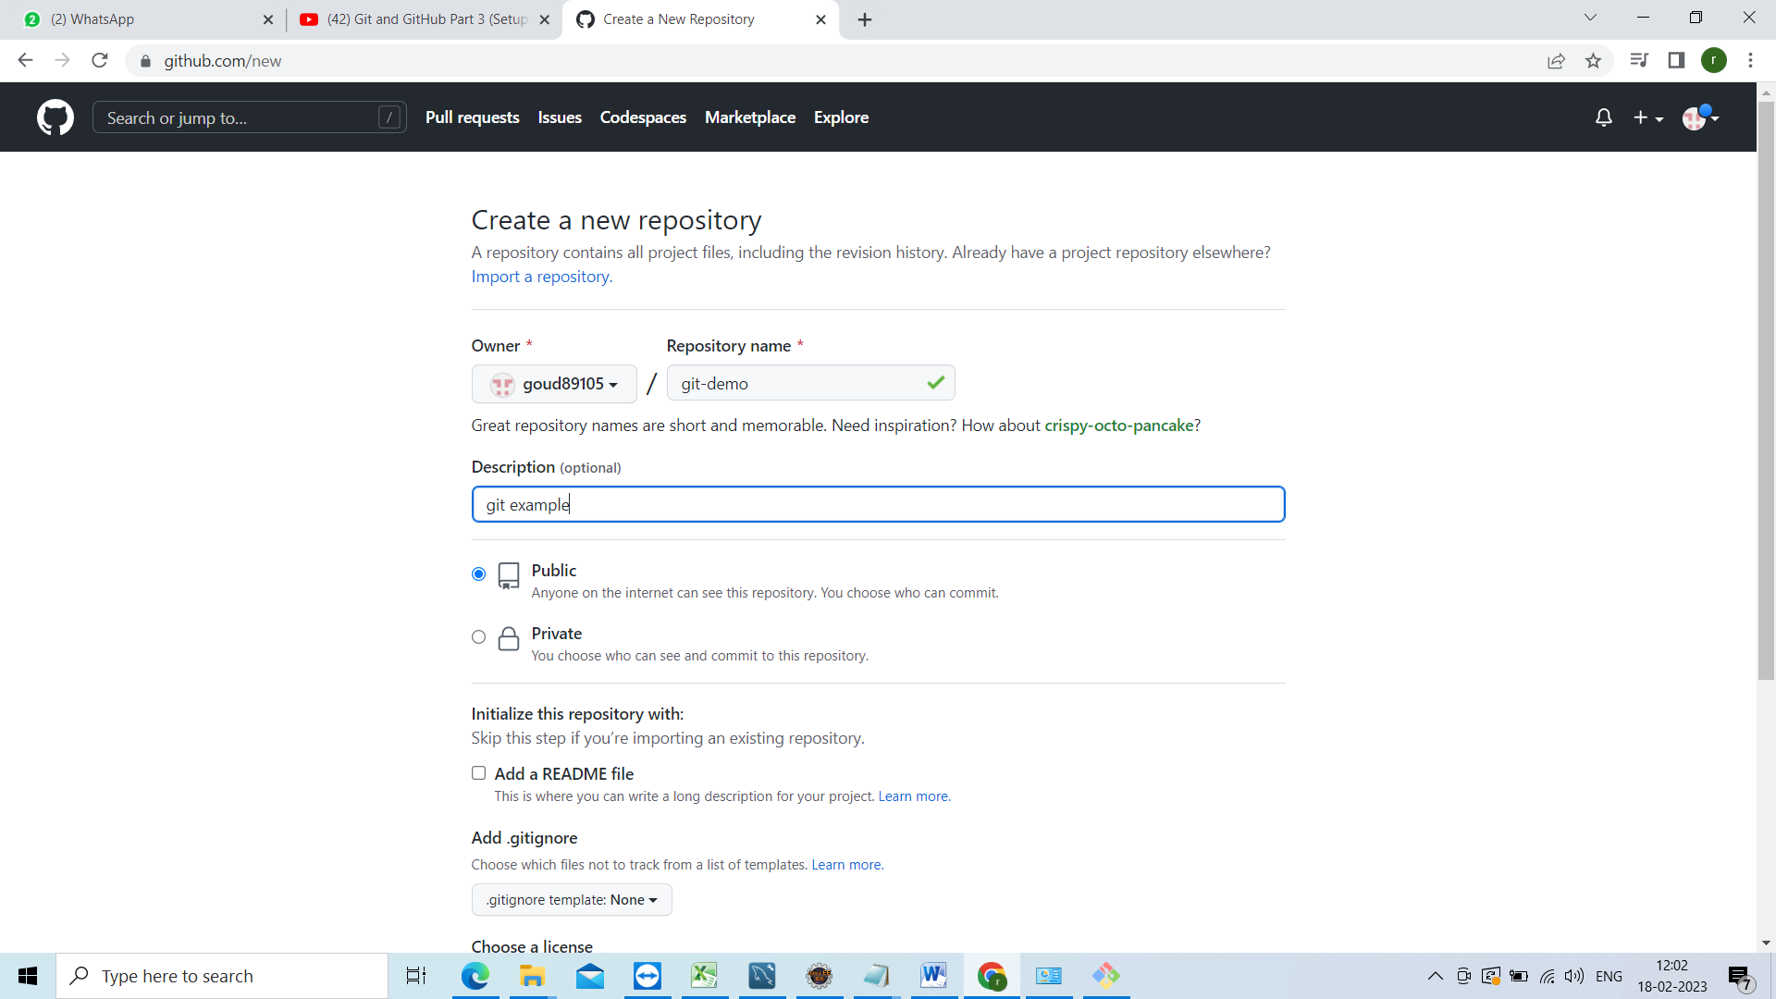

Click on create repository.

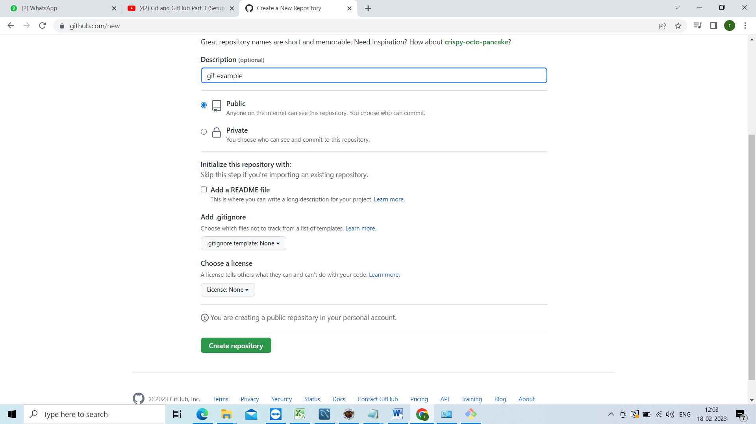

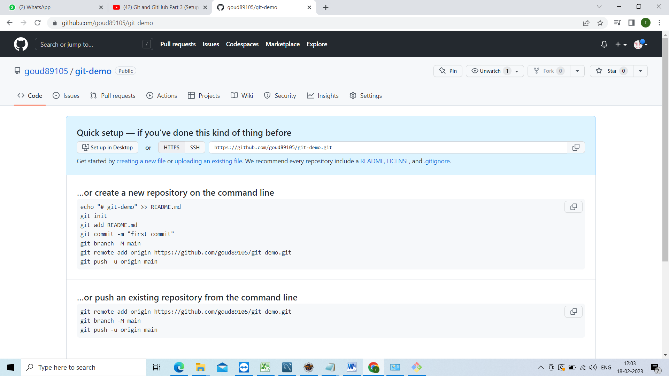

Now go to project directory which u have created previously do git bash from there.

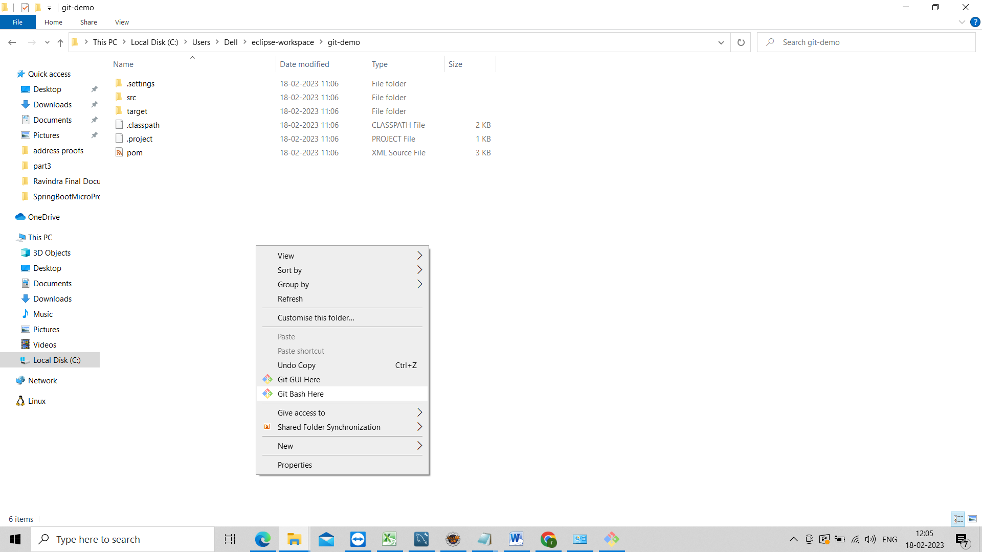

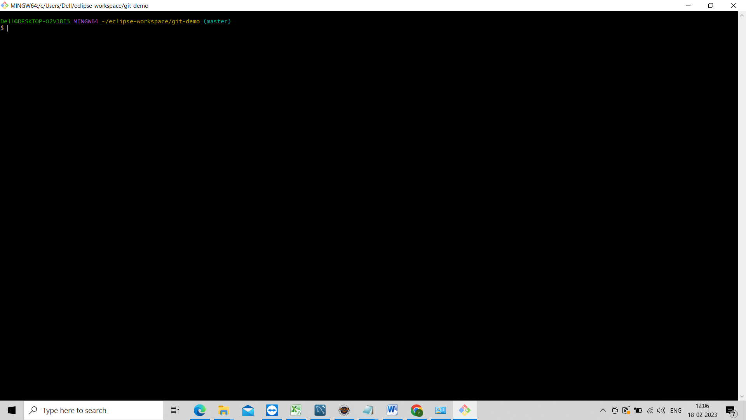

We need to set from local repository to remote repository to set that use below command

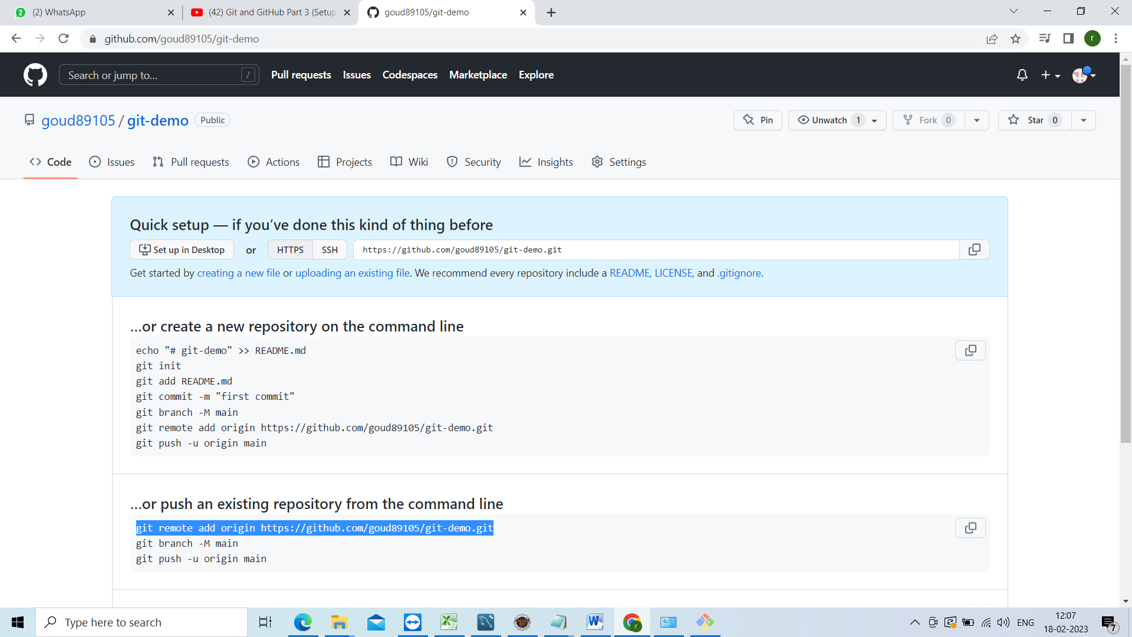

git remote add origin <https://github.com/goud89105/git-demo.git>

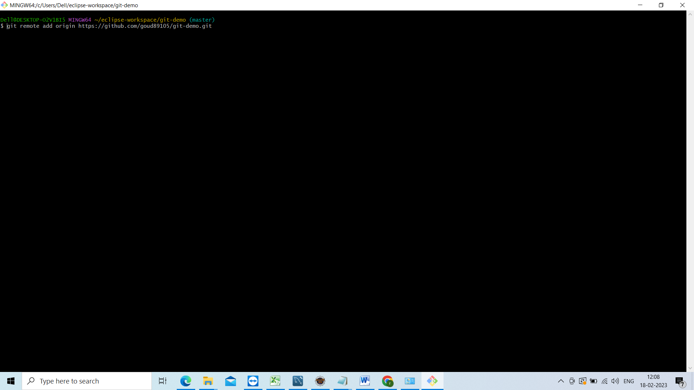

And enter

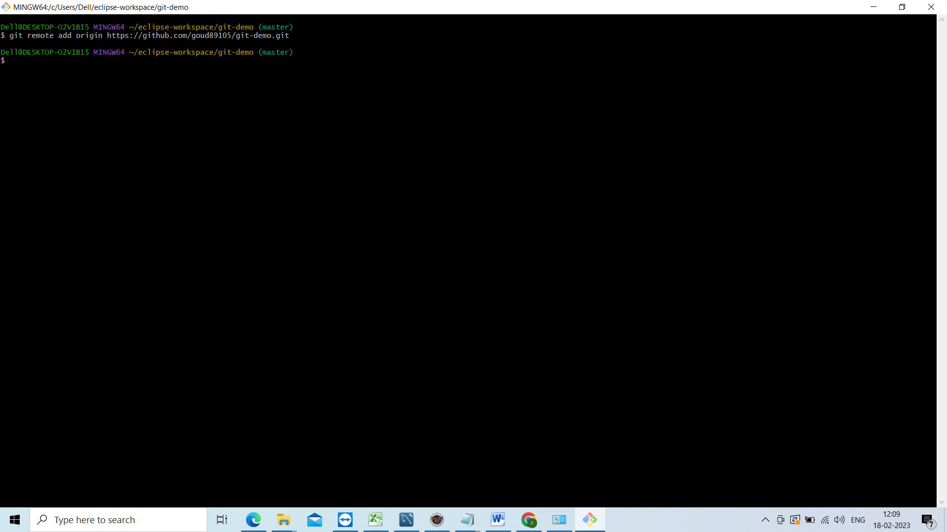

Now push our changes to remote repository

U se below command

Git push –u origin master

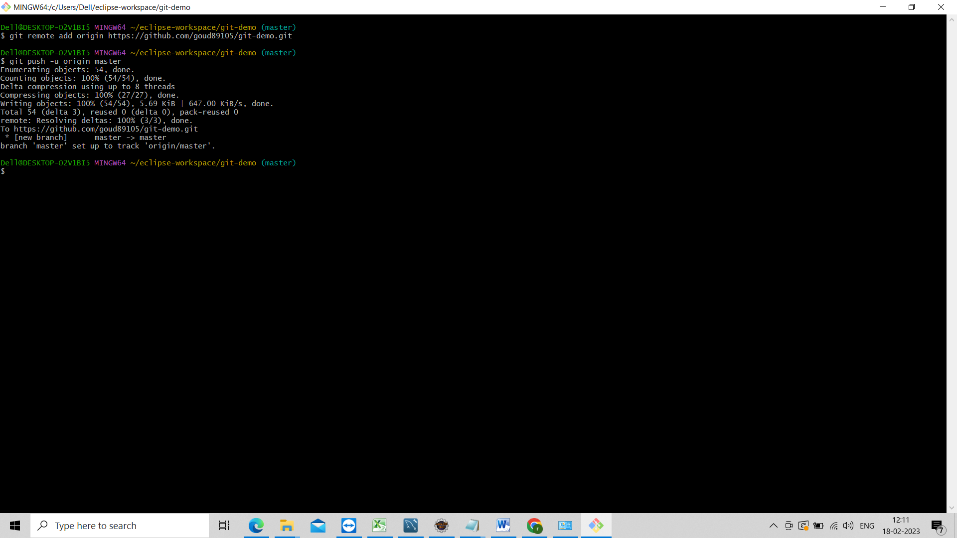

Now our local changes push to git hub

Go to github and refresh the page

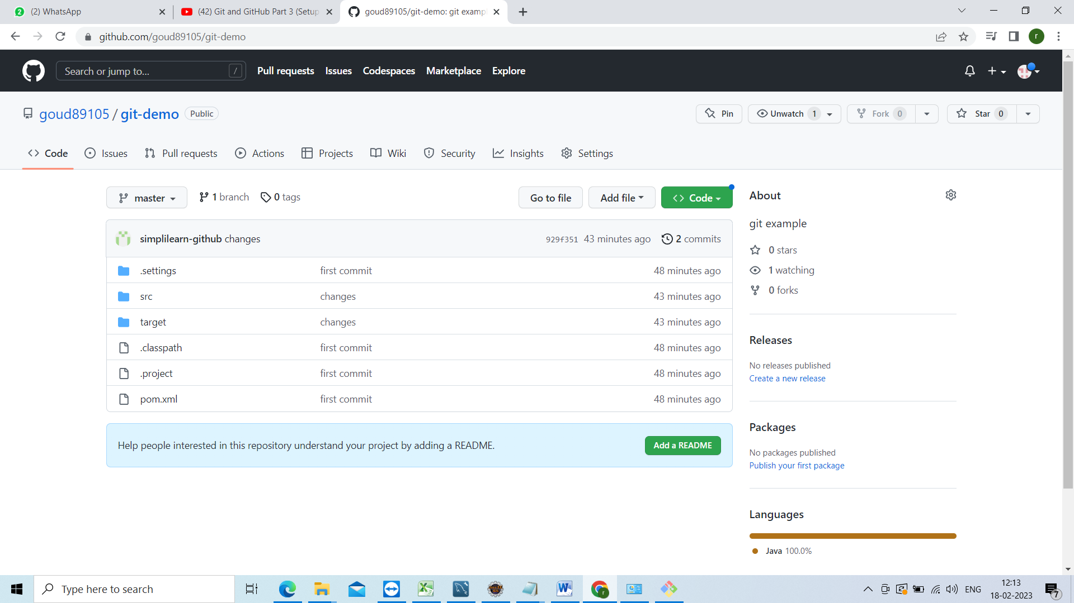

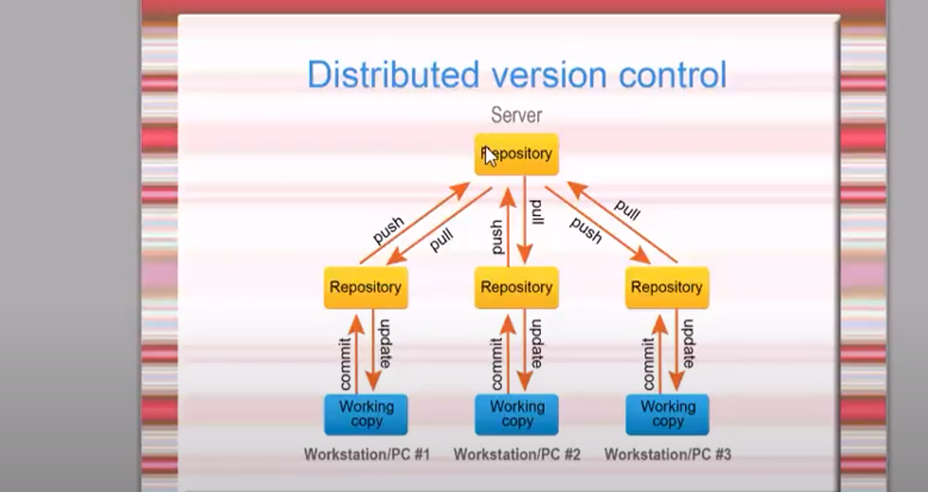

Changes was in local repository now we push those changes to remote repository.

Now will go to our application in local and do some changes

Created the Constant class and declare the variable and have called that variable from App.java

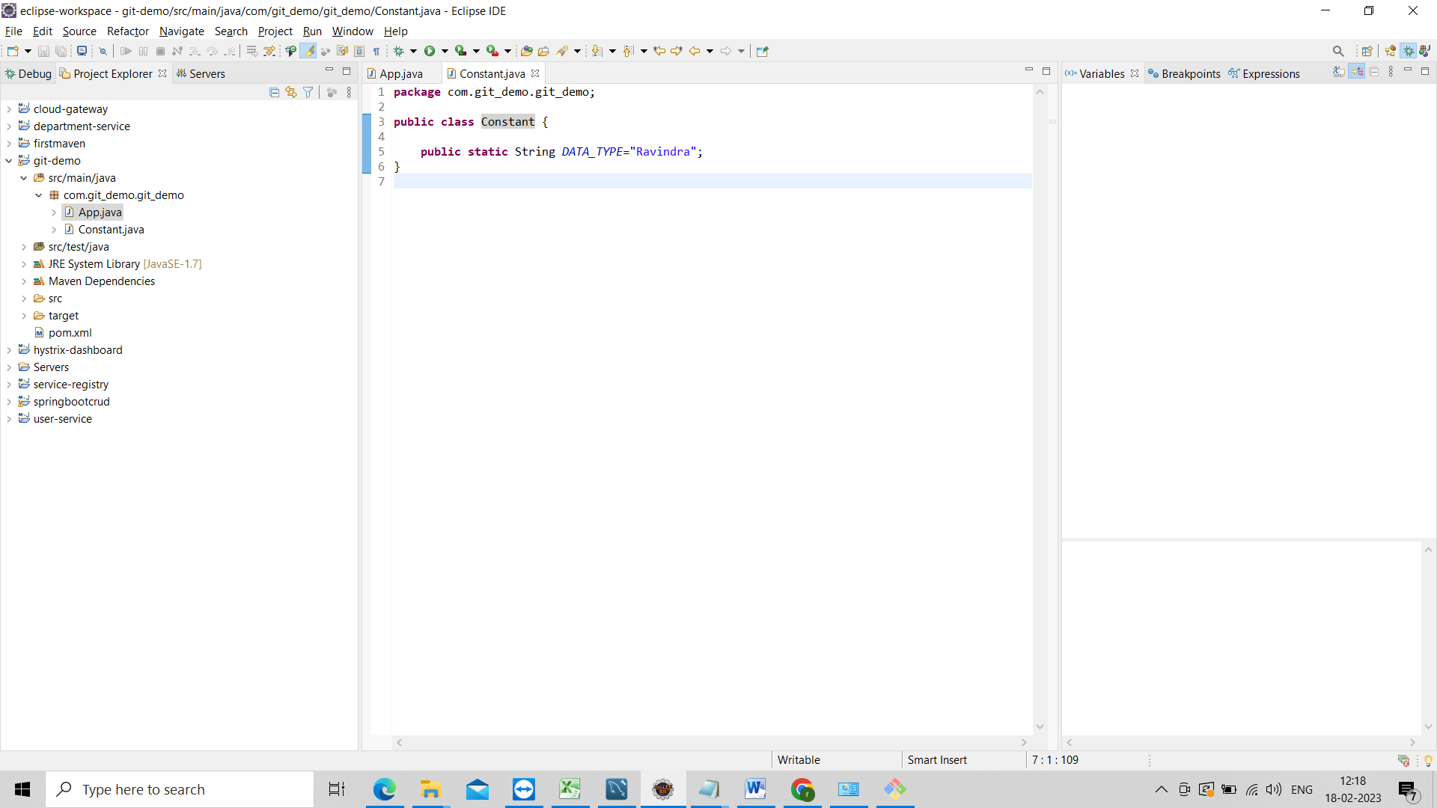

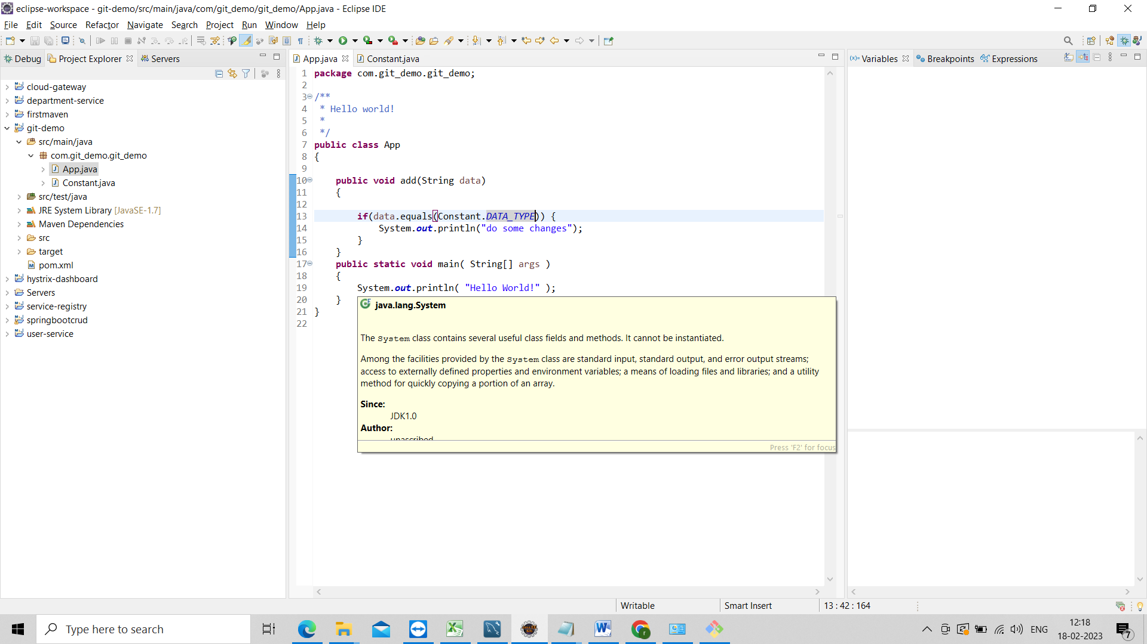

Now we will push those changes to the local and from local we push to the remote

Check in the local gitbash using git status

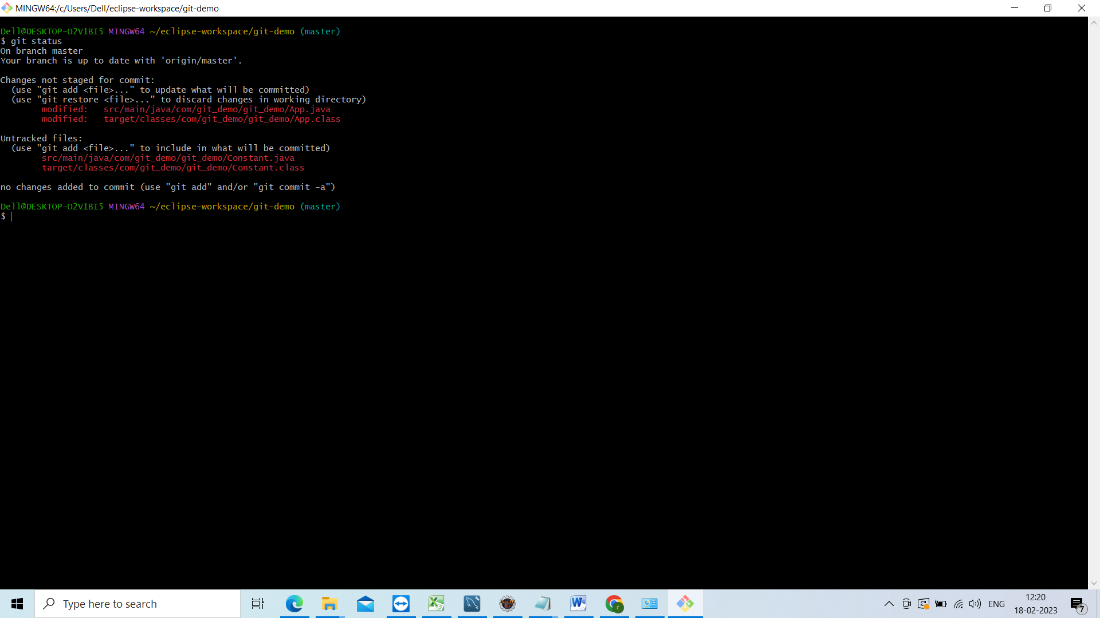

And those changes to the staging using git add .

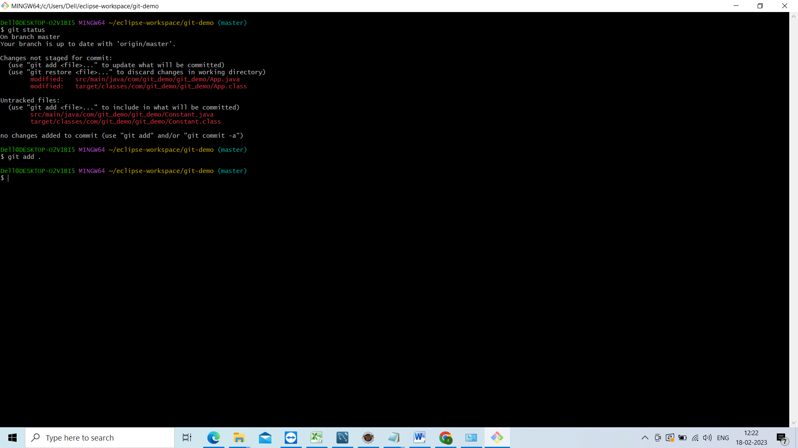

Now commit those chages to the local repository

Git commit –m “added constant file and changes in App.java”

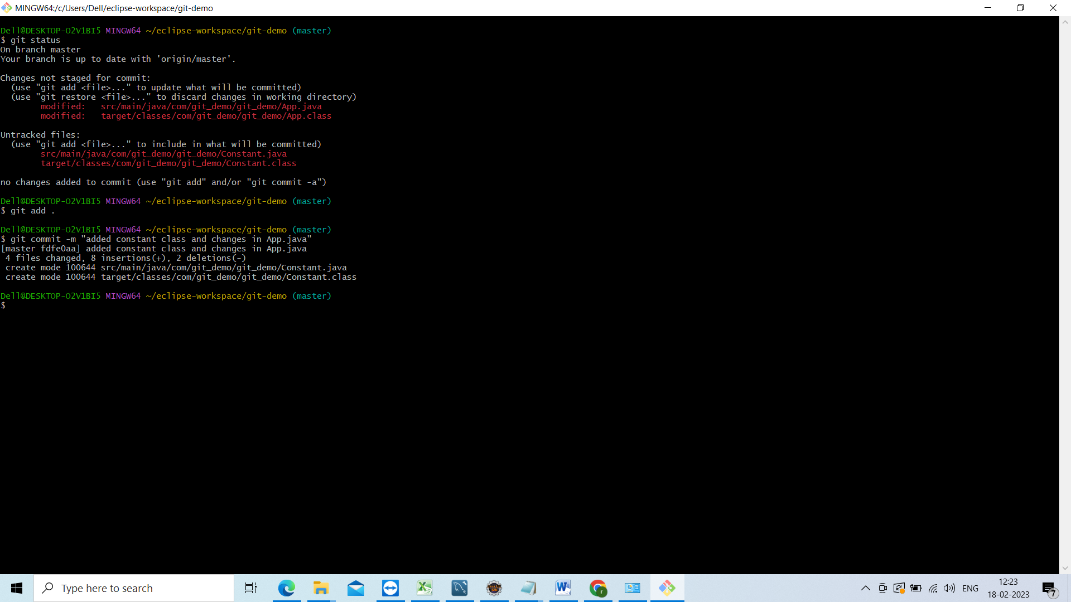

Now have commited chages to local repository those chages not reflected in the

Remote repository means in the git hub.

To push those chages to remote

Git push –u origin master

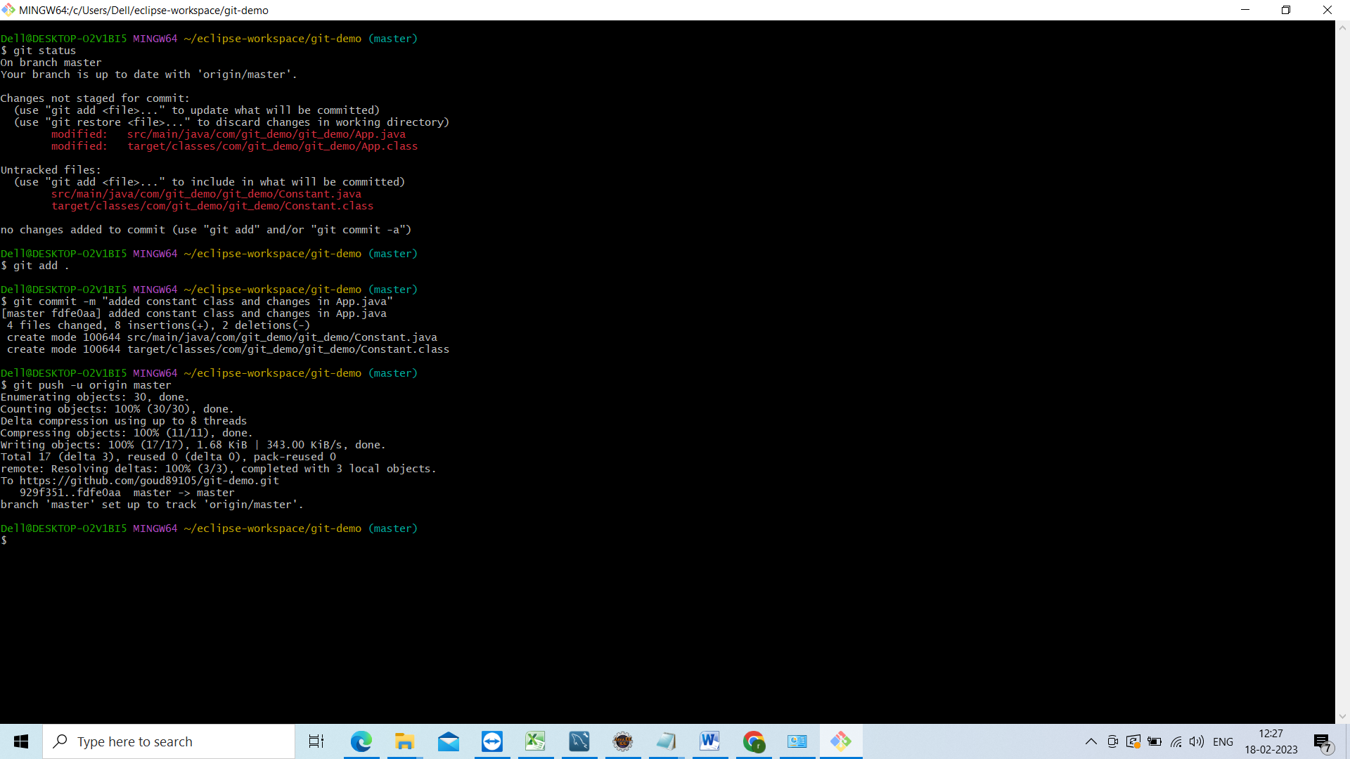

Now go to remote repository and refrest the page

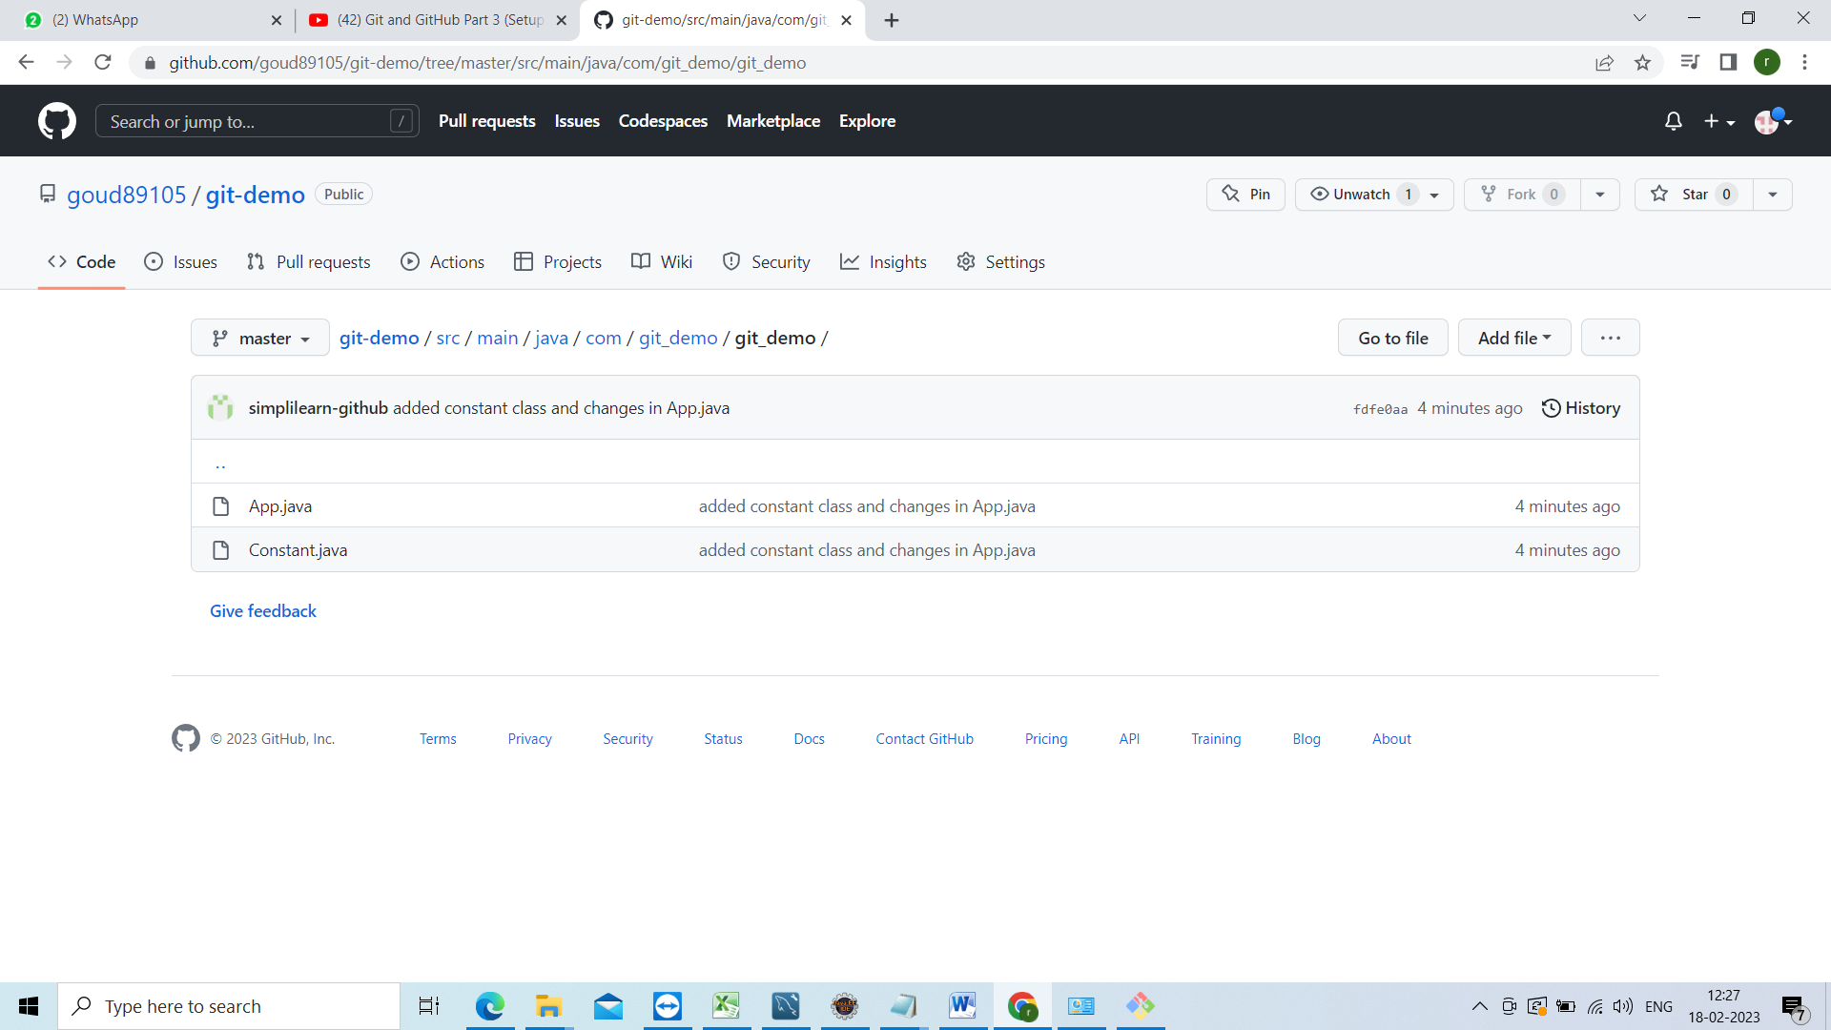

Now am going to show u how to checkout the code and how to update the code

Assume u have joined the project newly they have given git link I will show how to checkout the code from github

Frist go to the any drive and create the folder and open the git bash from that folder and do git init

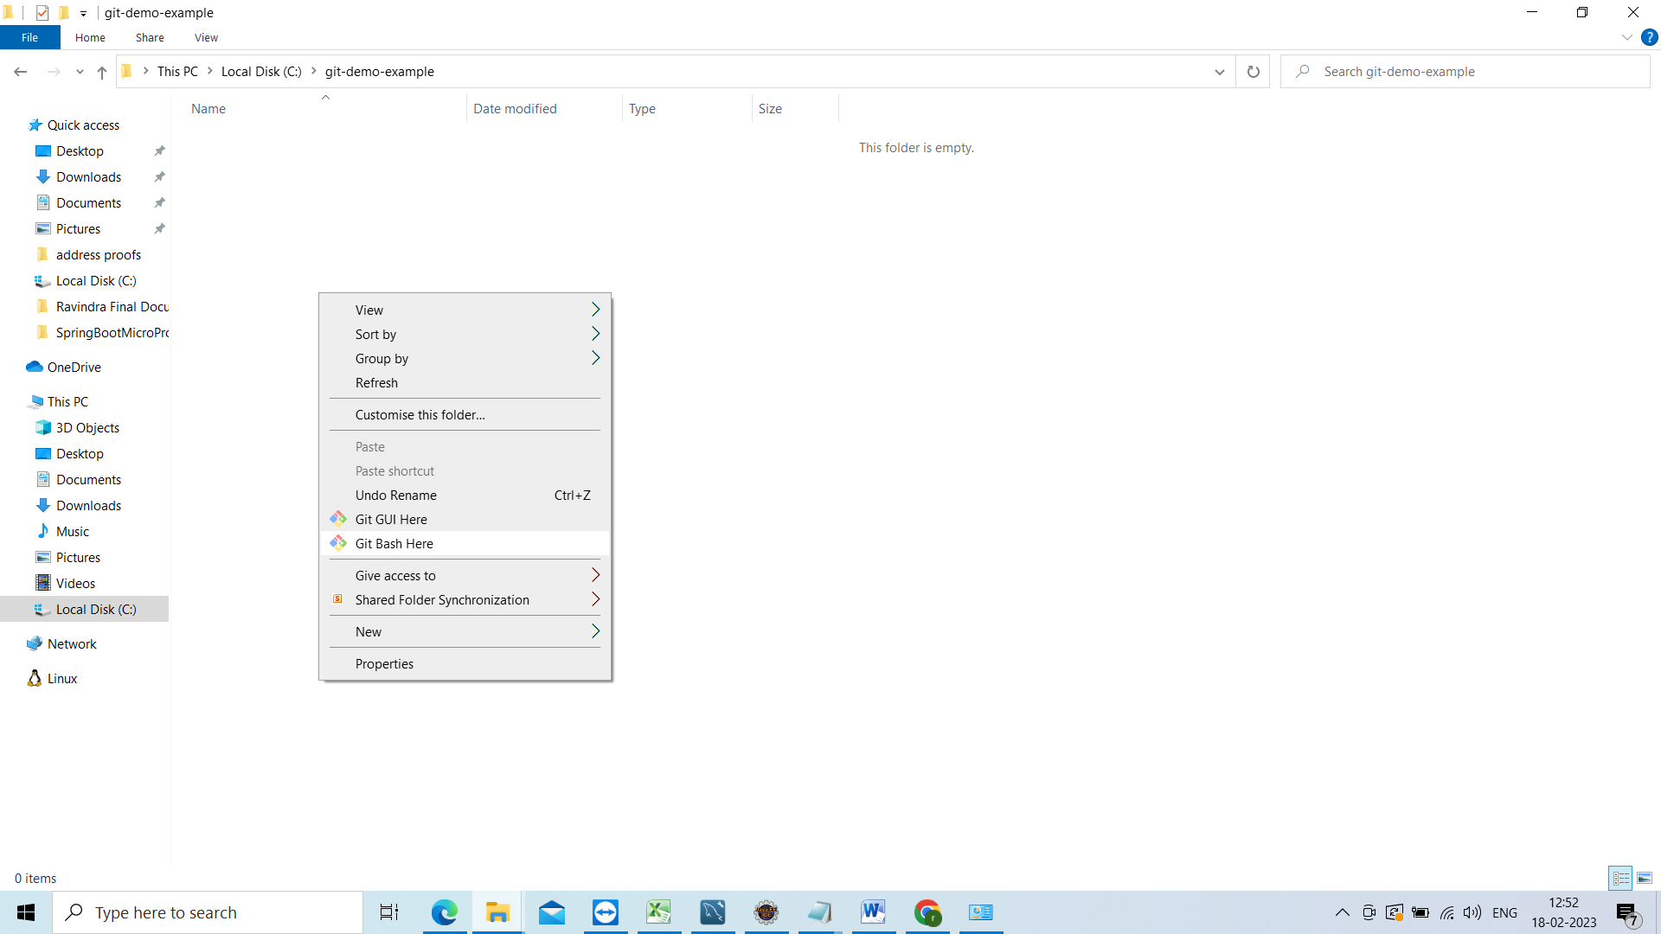

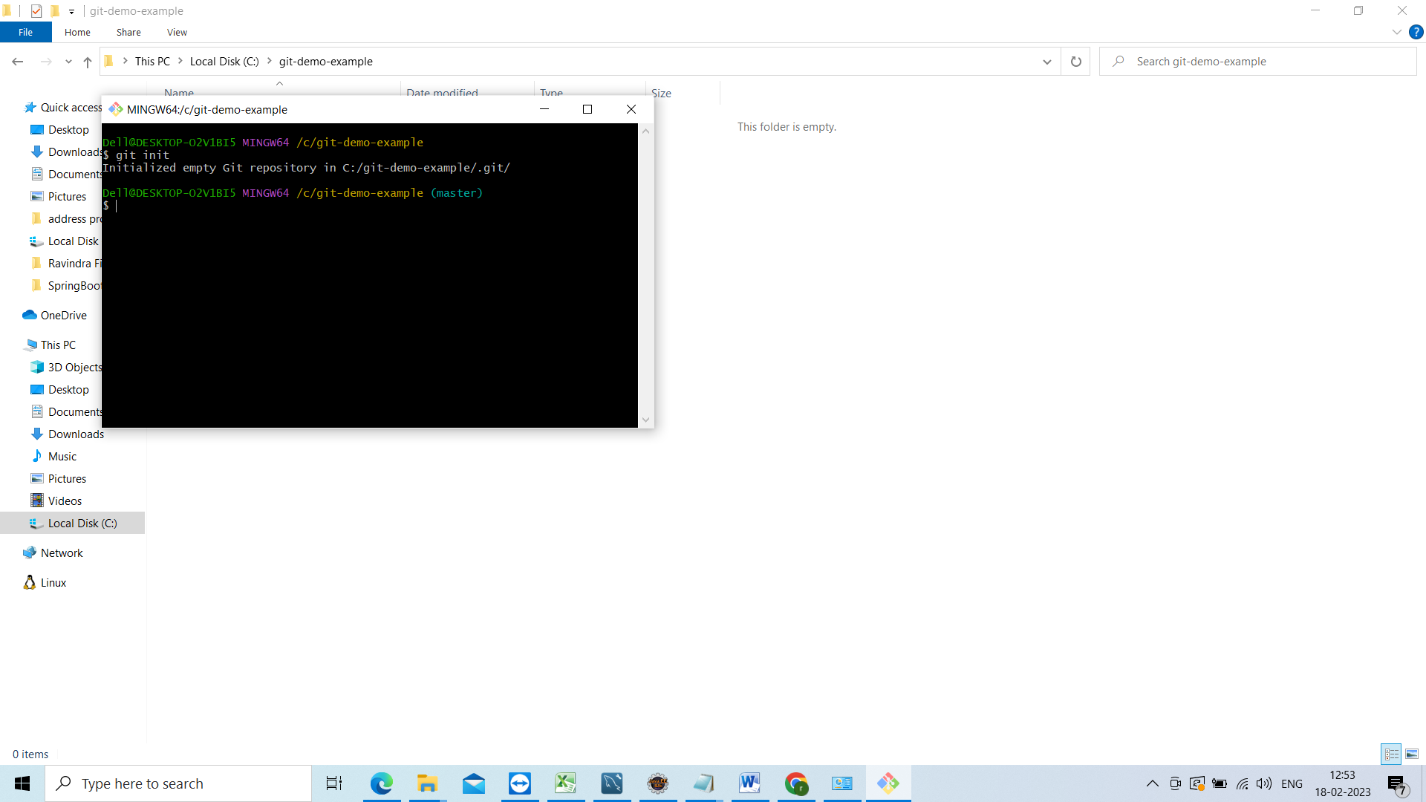

And now go to git hub and copy the link from below https

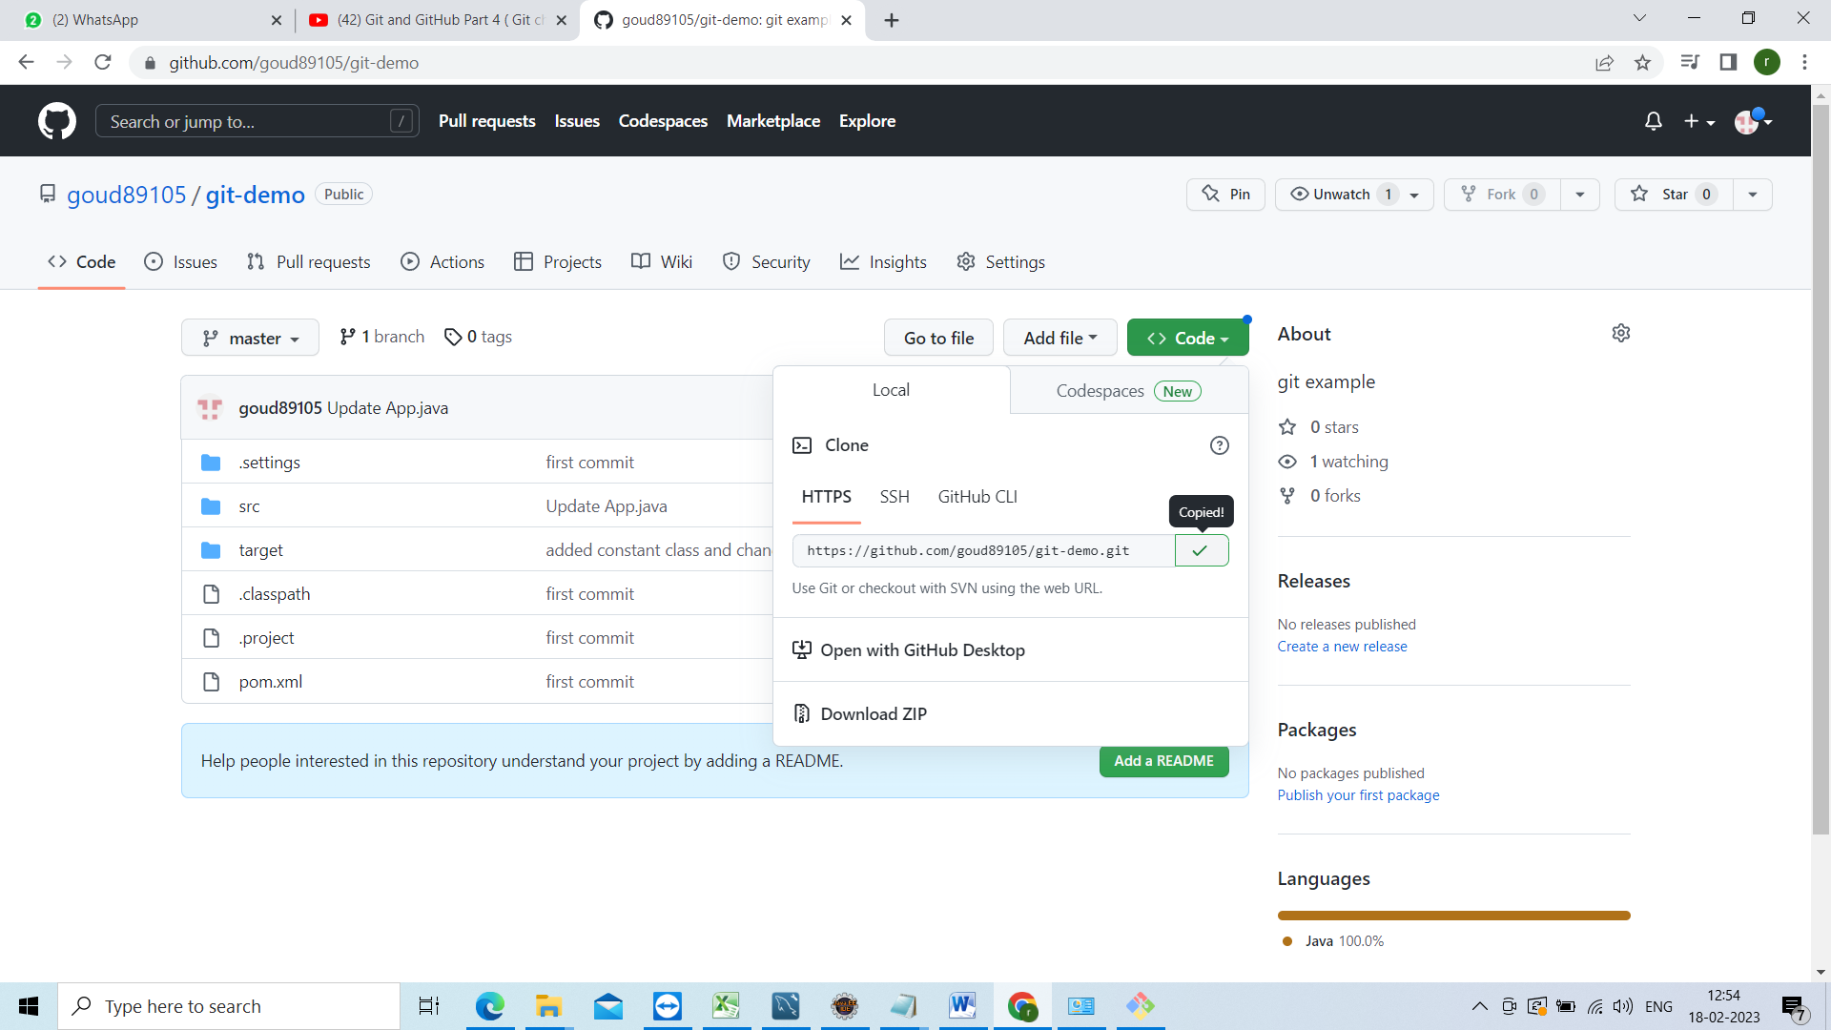

Now go to git bash execute the below command

Git clone URL

<https://github.com/goud89105/git-demo.git>

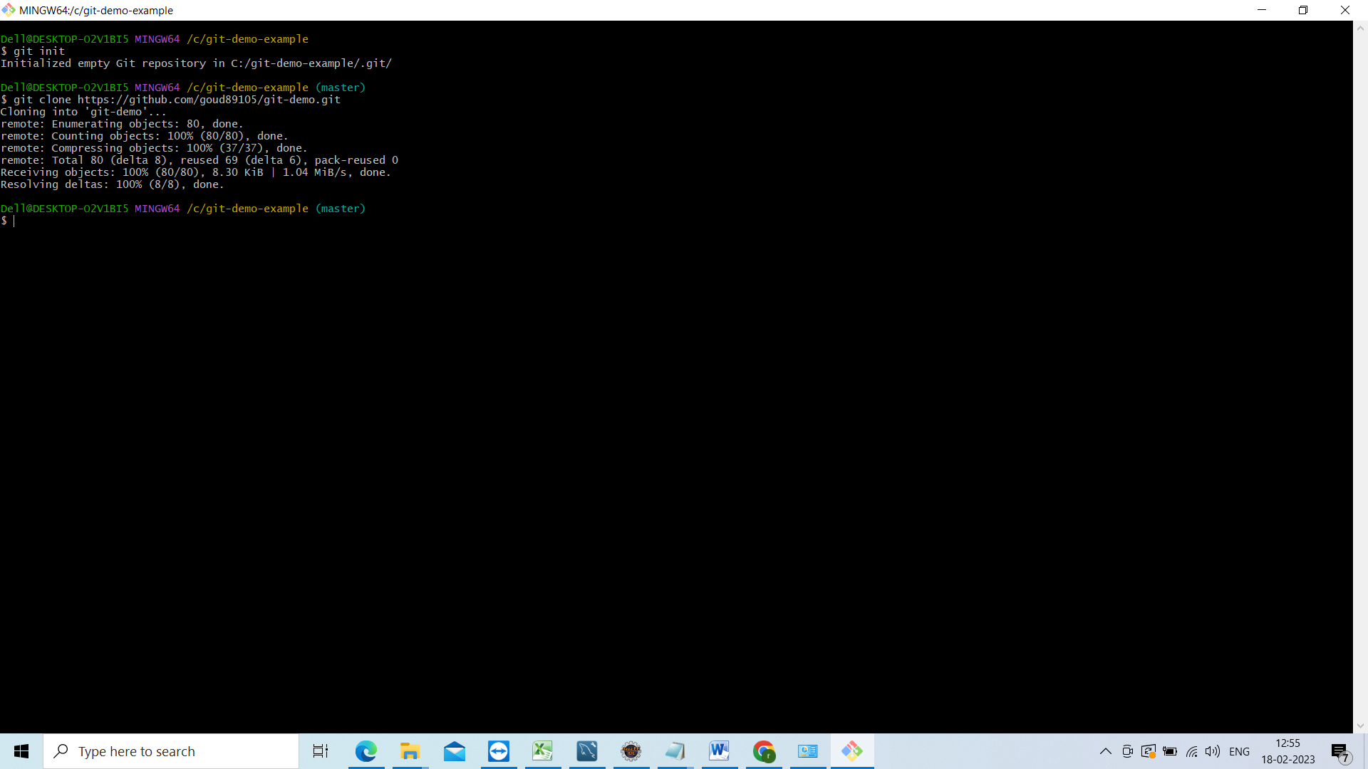

Assume developer 2 has made some changes in and he push the changes and will show how to take those changes to local repository

Am developer 2 doing changes go to git hub and click on edit this file

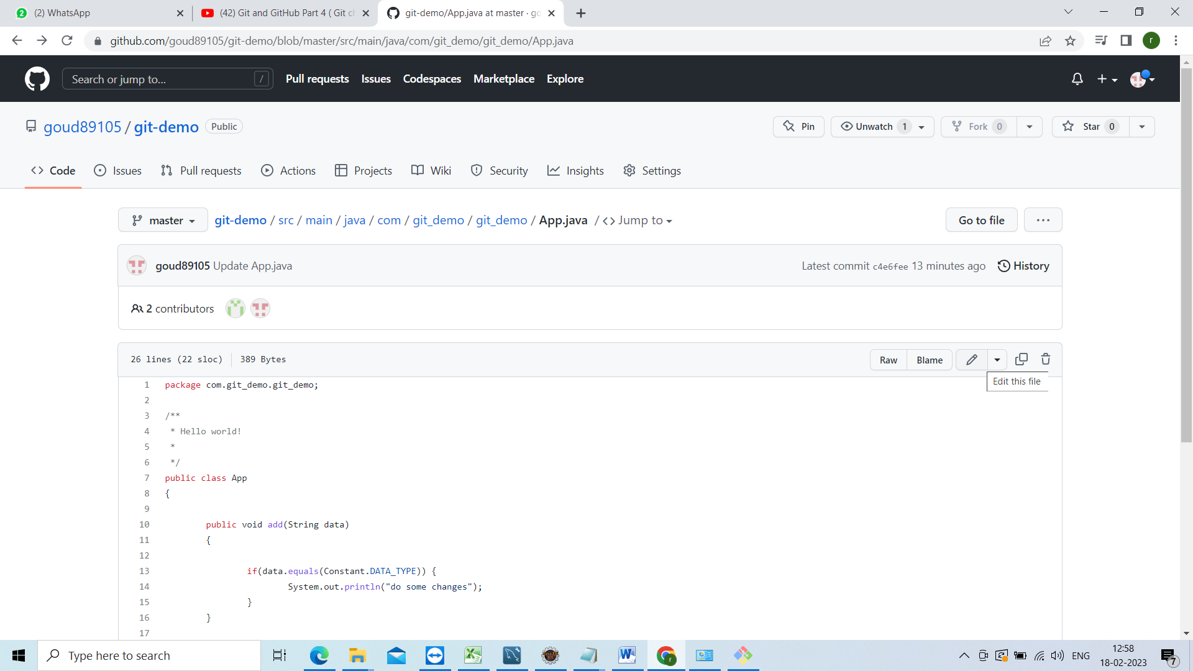

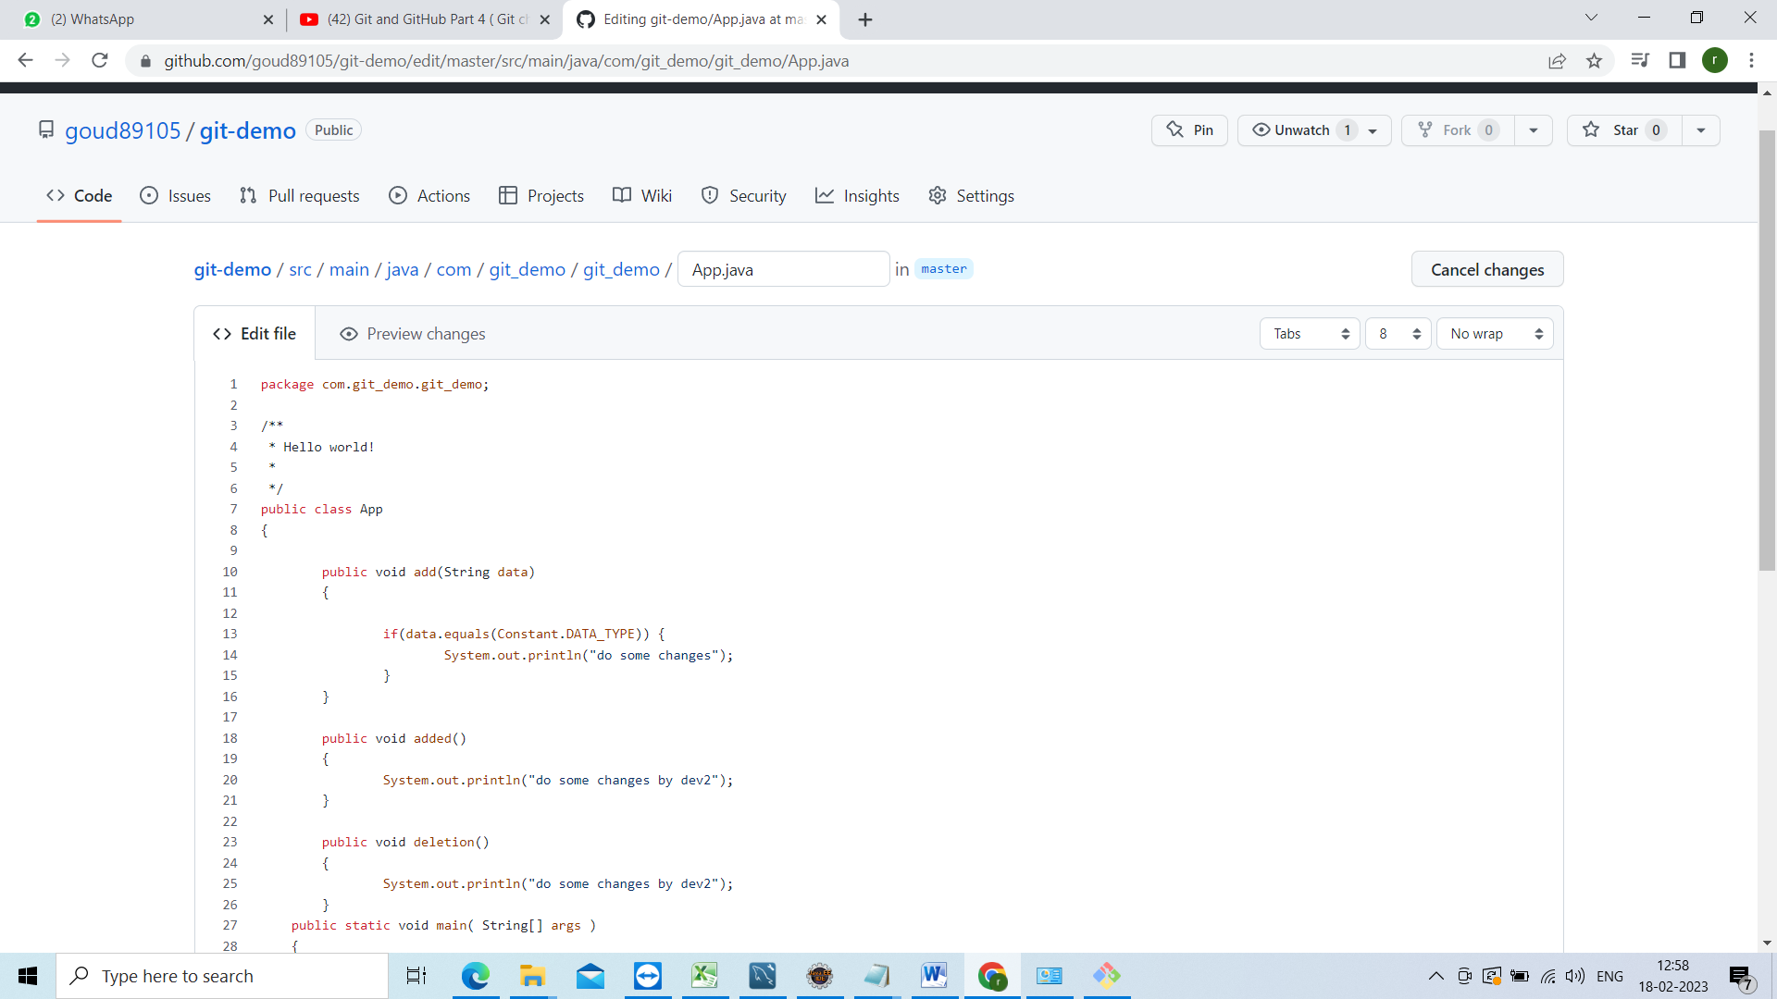

And commited the changes

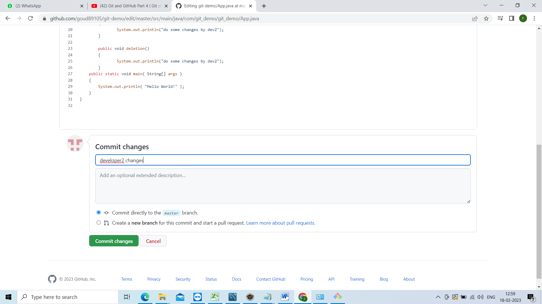

Now those changes wont be available in the local machine so how to pull those changes for that

Now go too ur local project directory open git bash and execute below command

Use git add origin master url of that github

And then

Git pull origin master

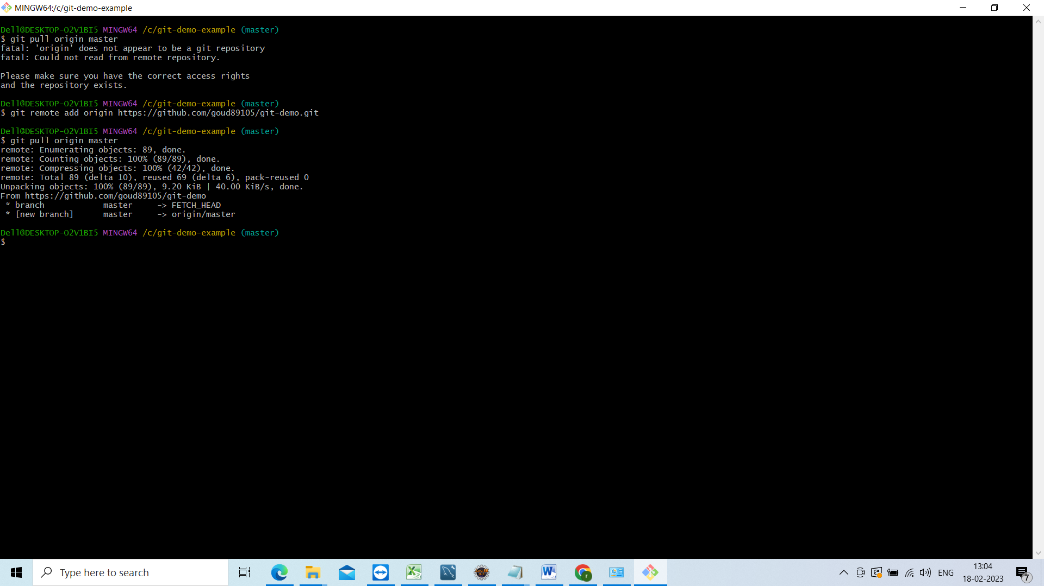

Now u go to ur project and check the changes

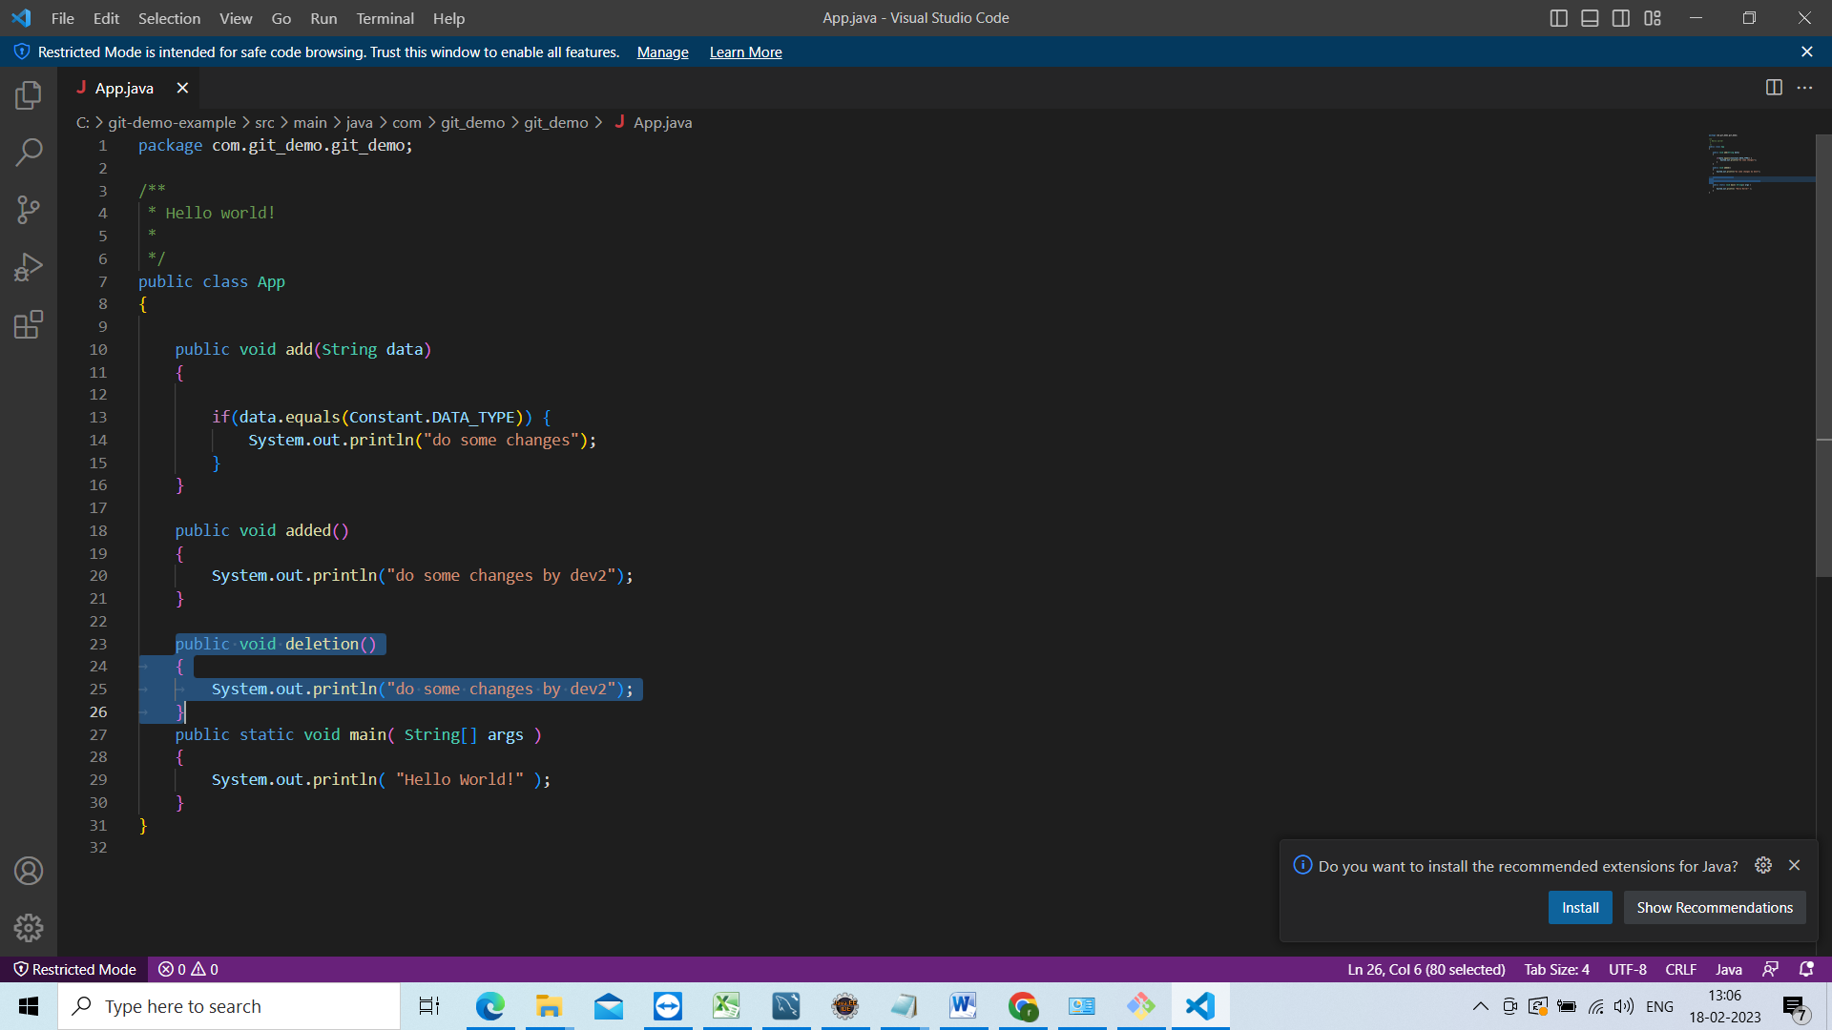

Import the project in to eclipse

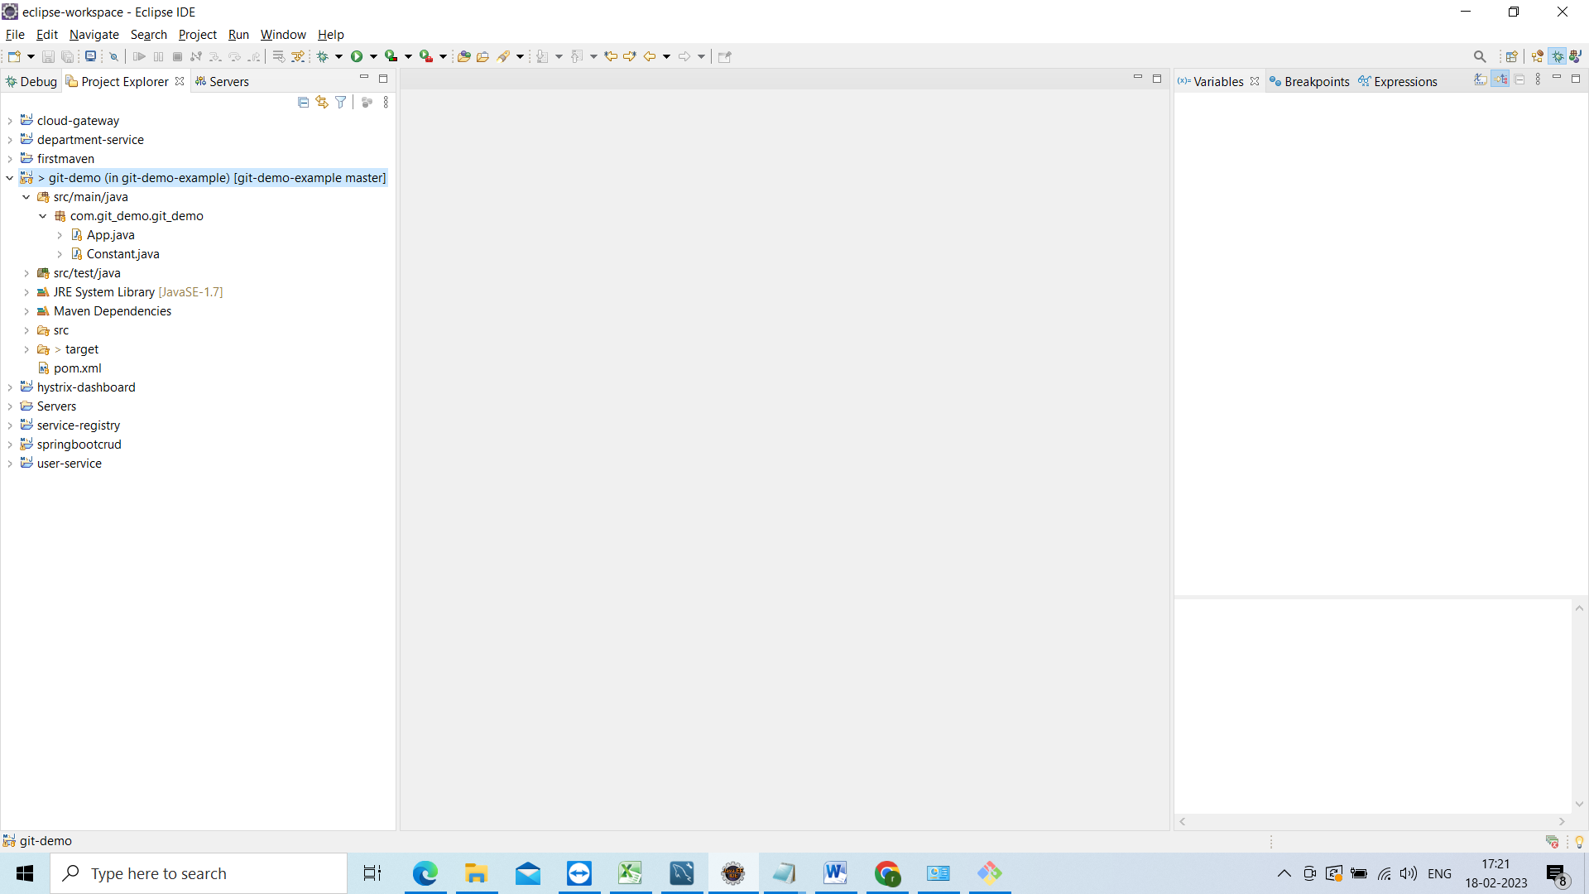

Now go to project folder do git bash and check the git branch

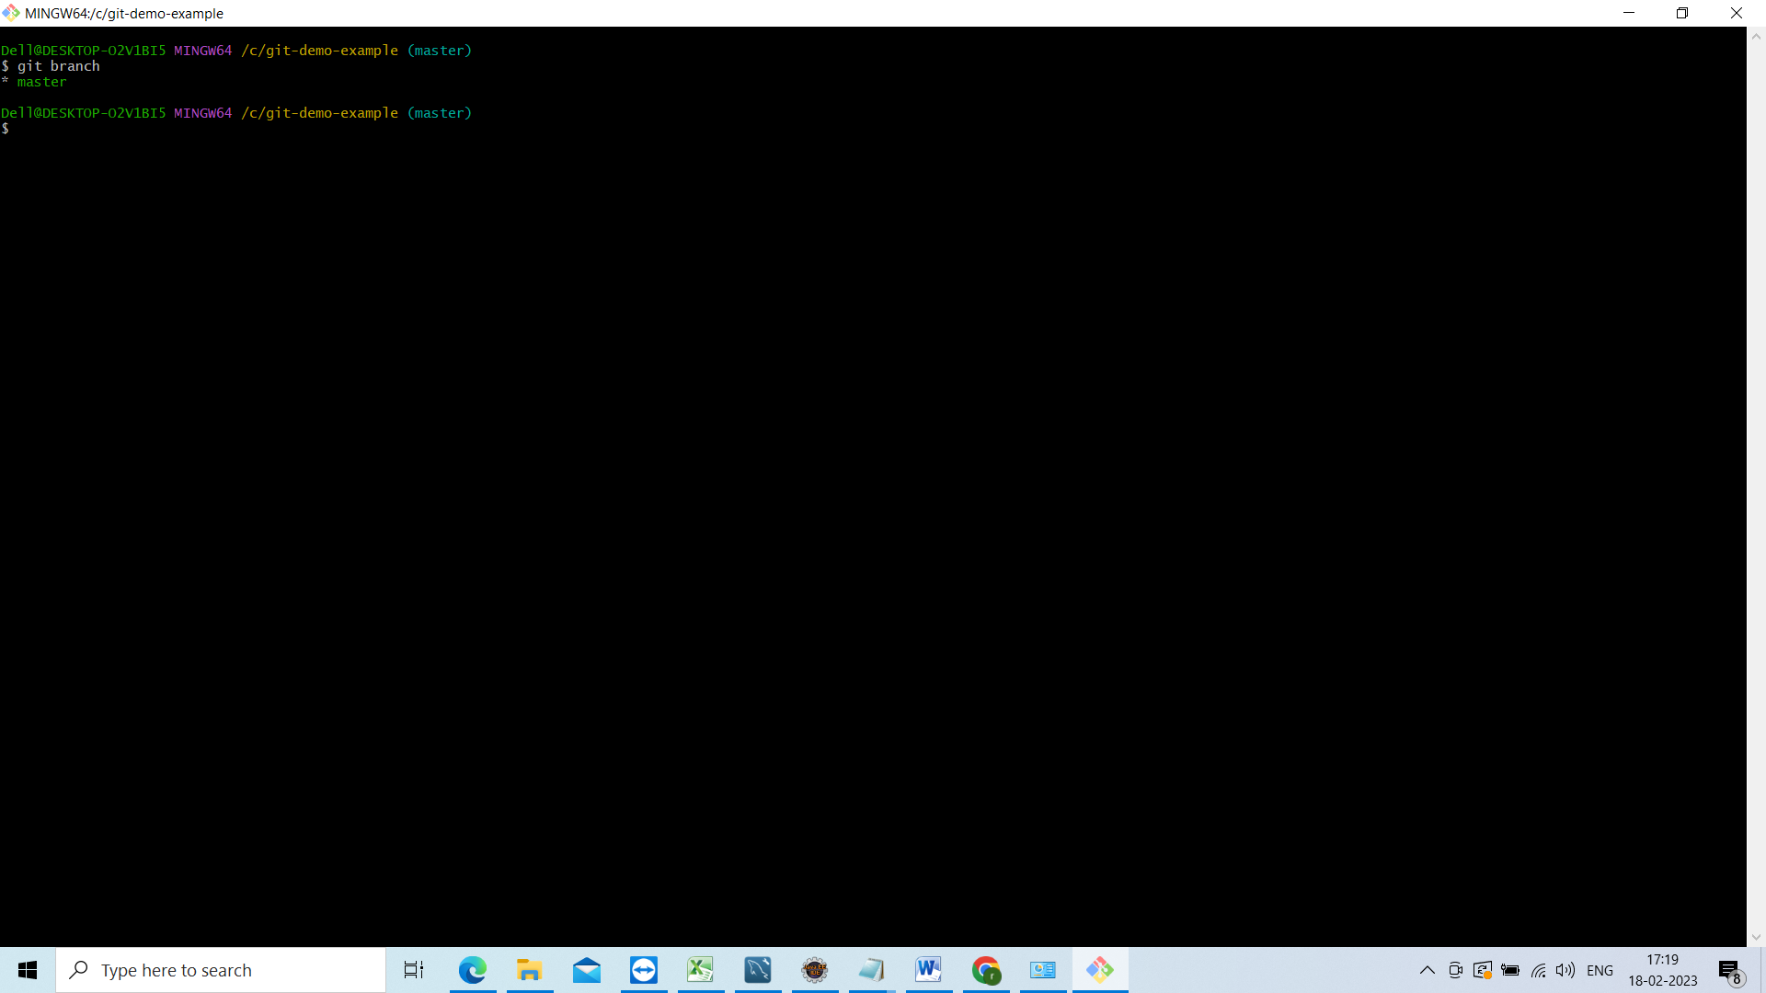

Create the new branch

Git branch name of the branch

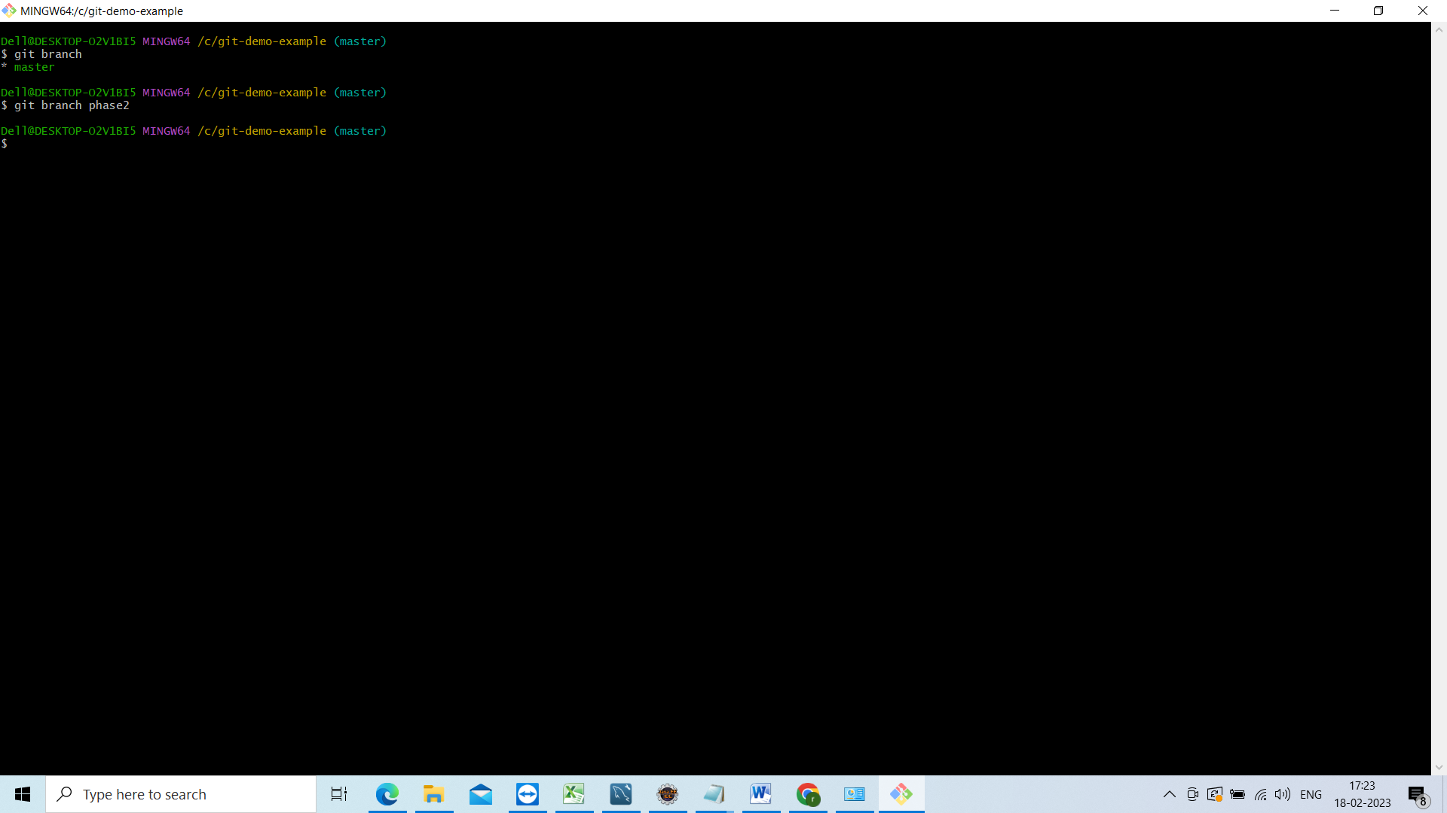

Now lets move to the

Git checkout phase2

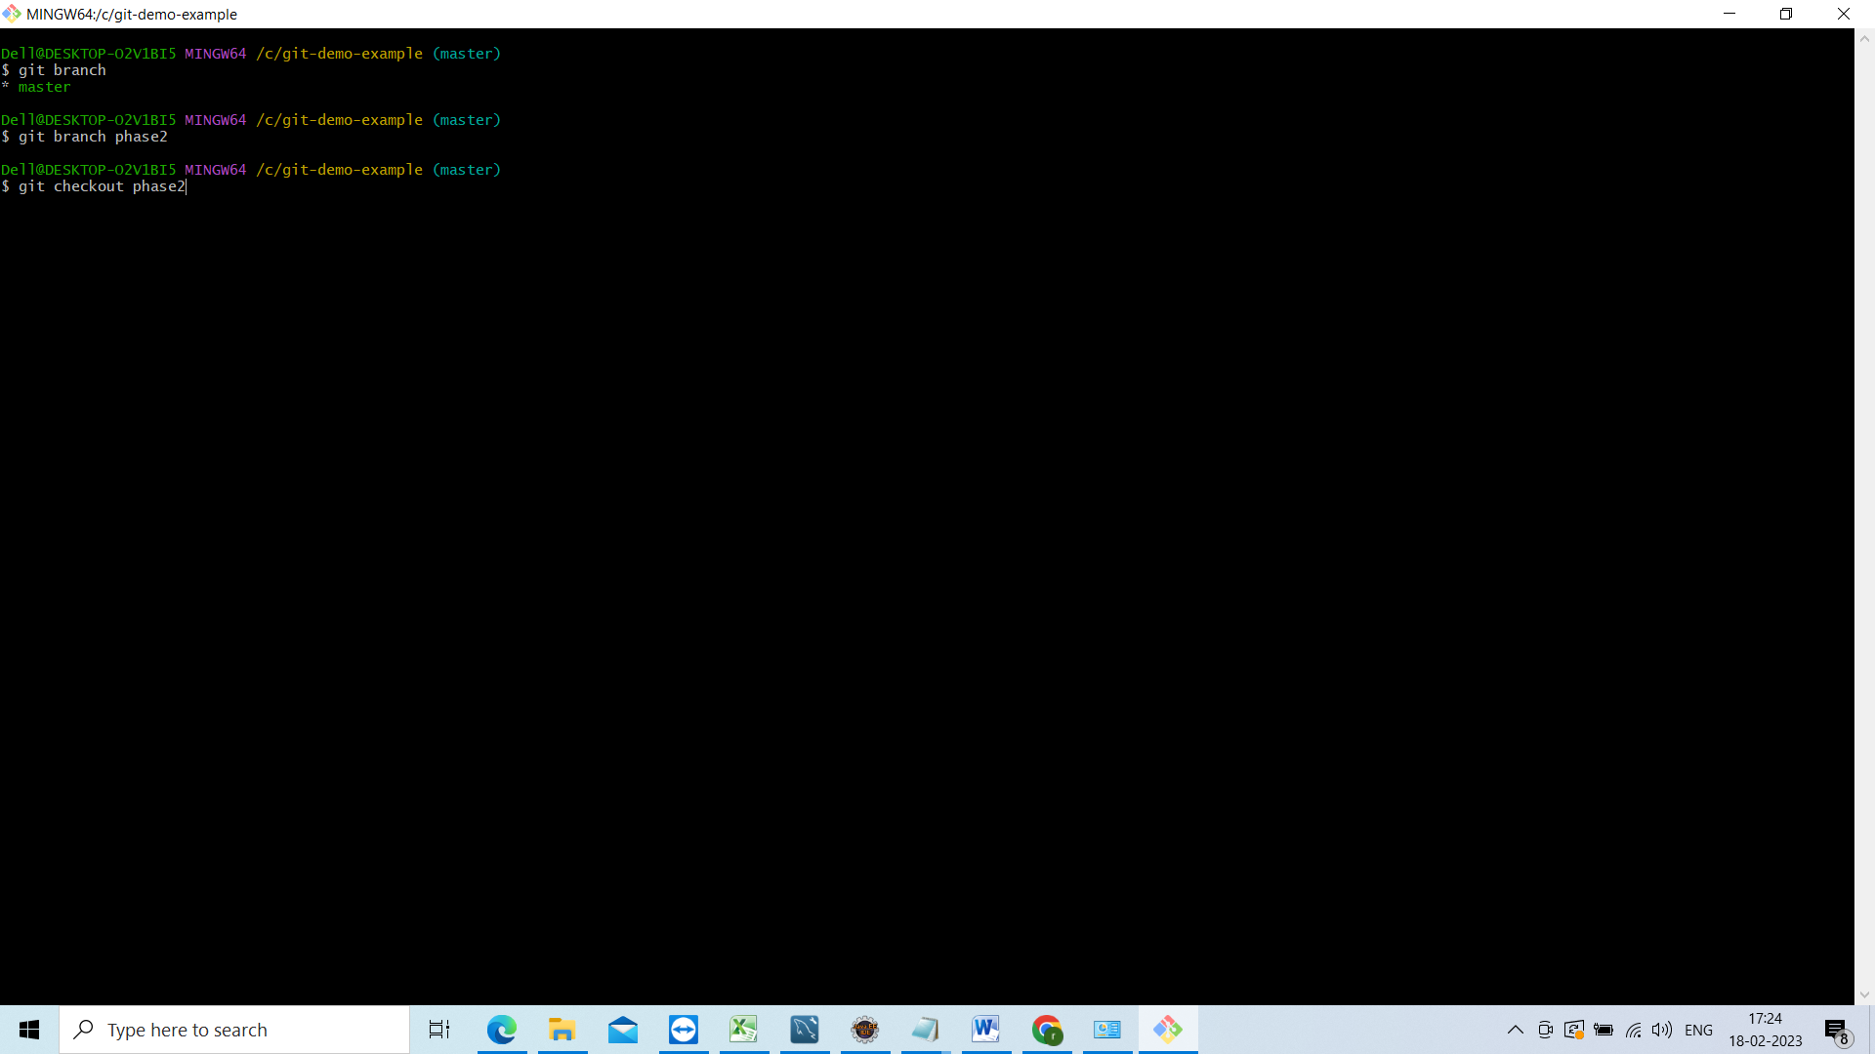

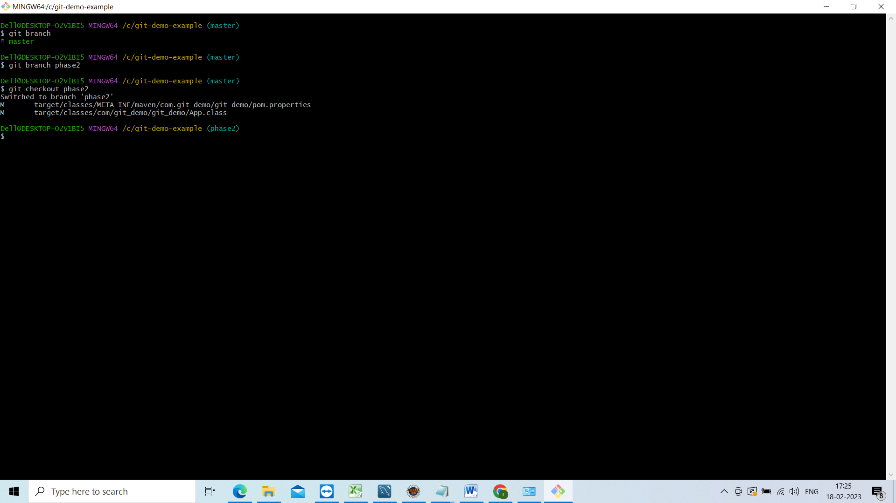

Now check the branch

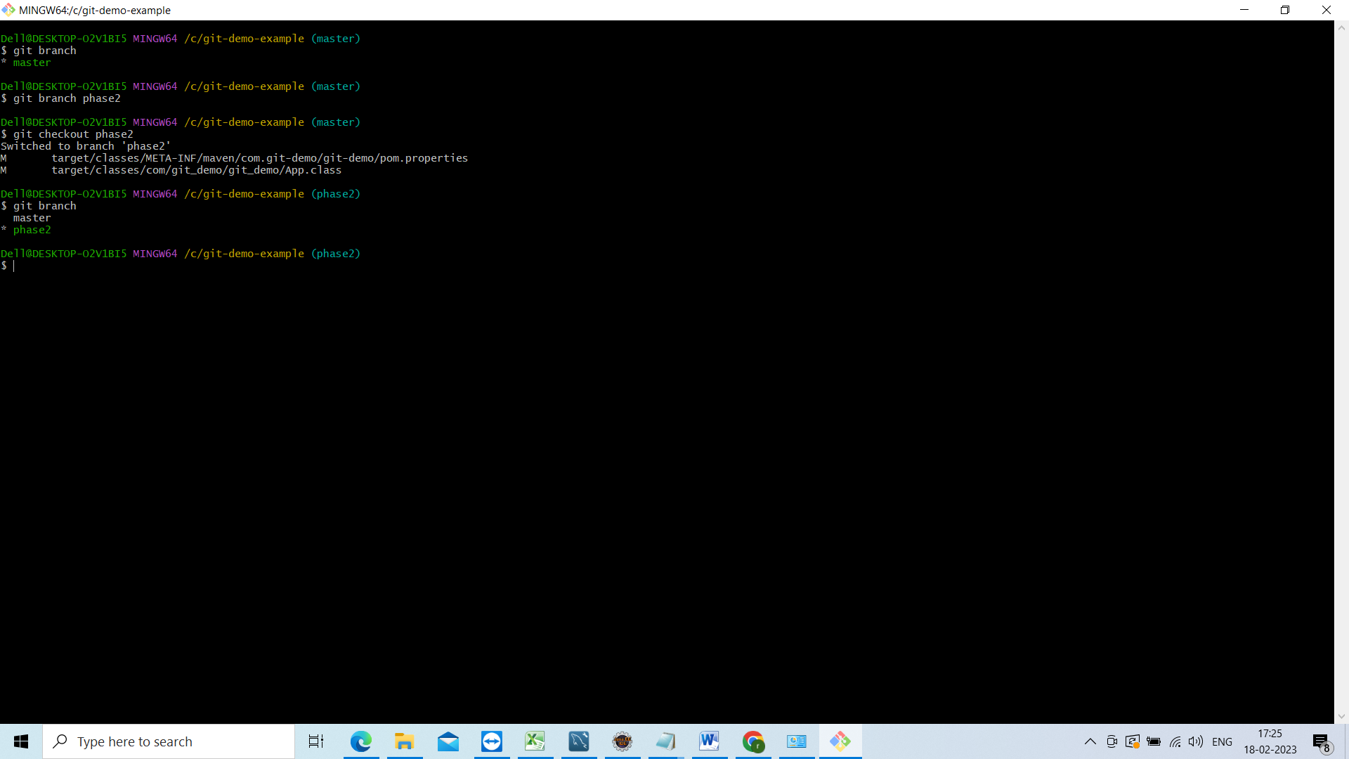

Now go to eclipse see now we are in phase2 branch

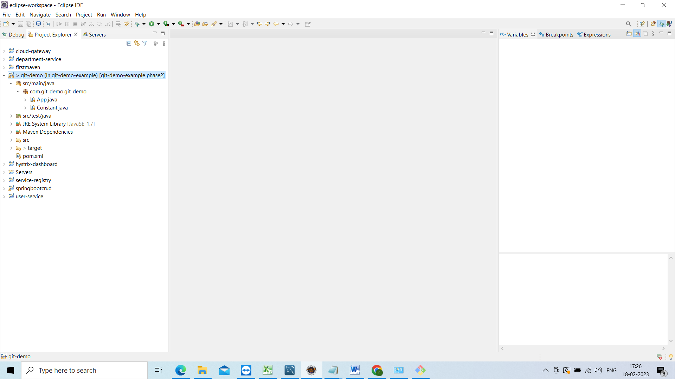

Now do some changes those changes will be in phase2 branch

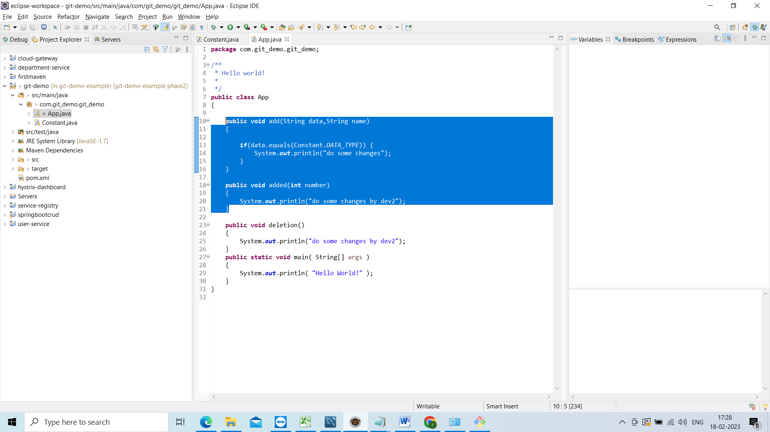

Now these changes not available in master branch

Go to git bash and see the changes in phase2

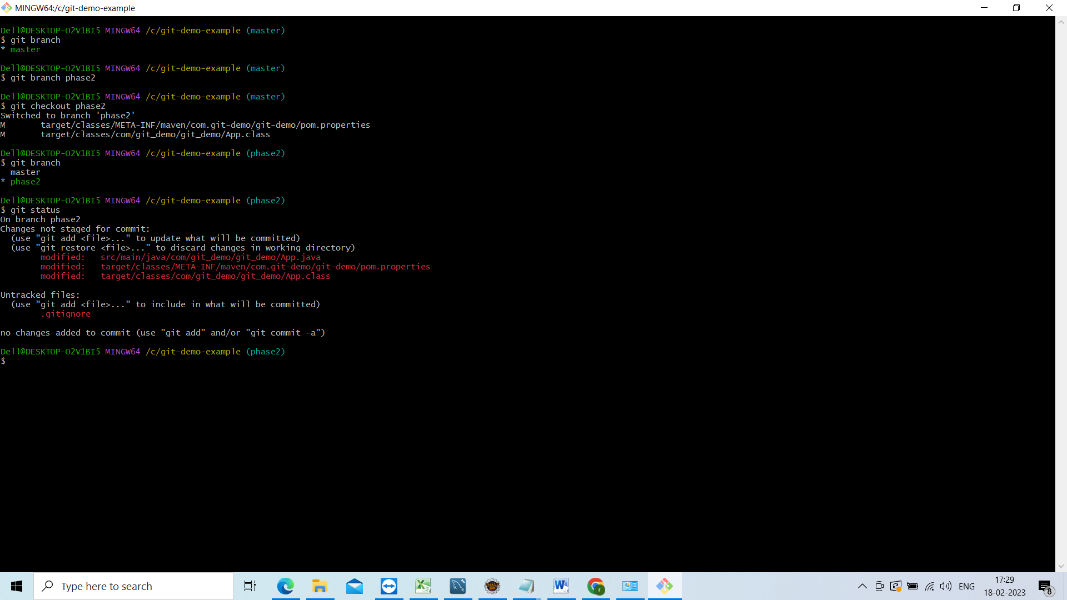

Now add it and commit

Git add .

Git commit –m “changes added”

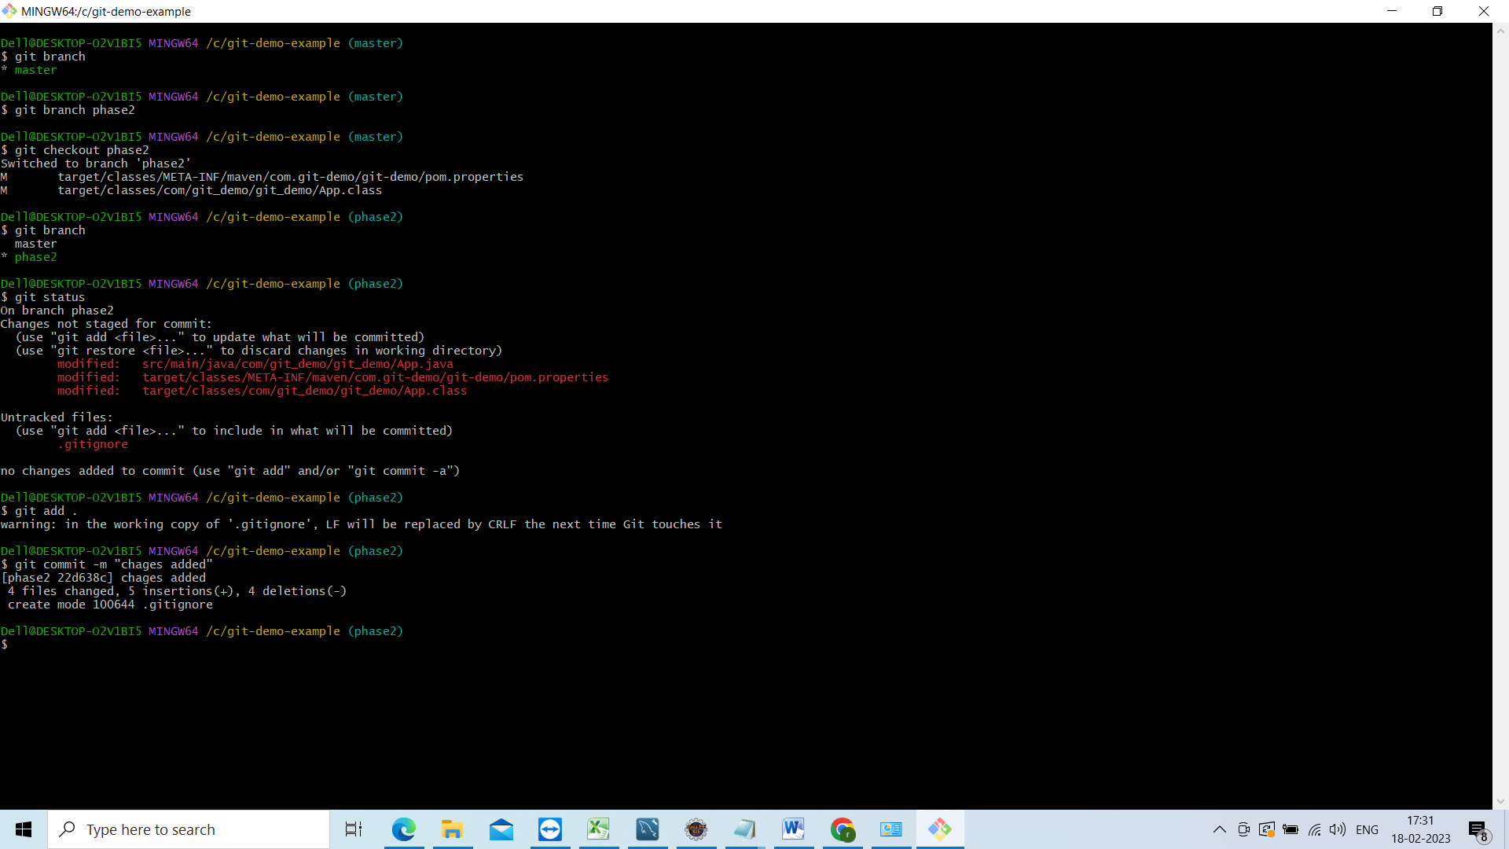

Now commited code in staging not in master and not in phase2

Now commit these changes to phase2

Git push origin phase2

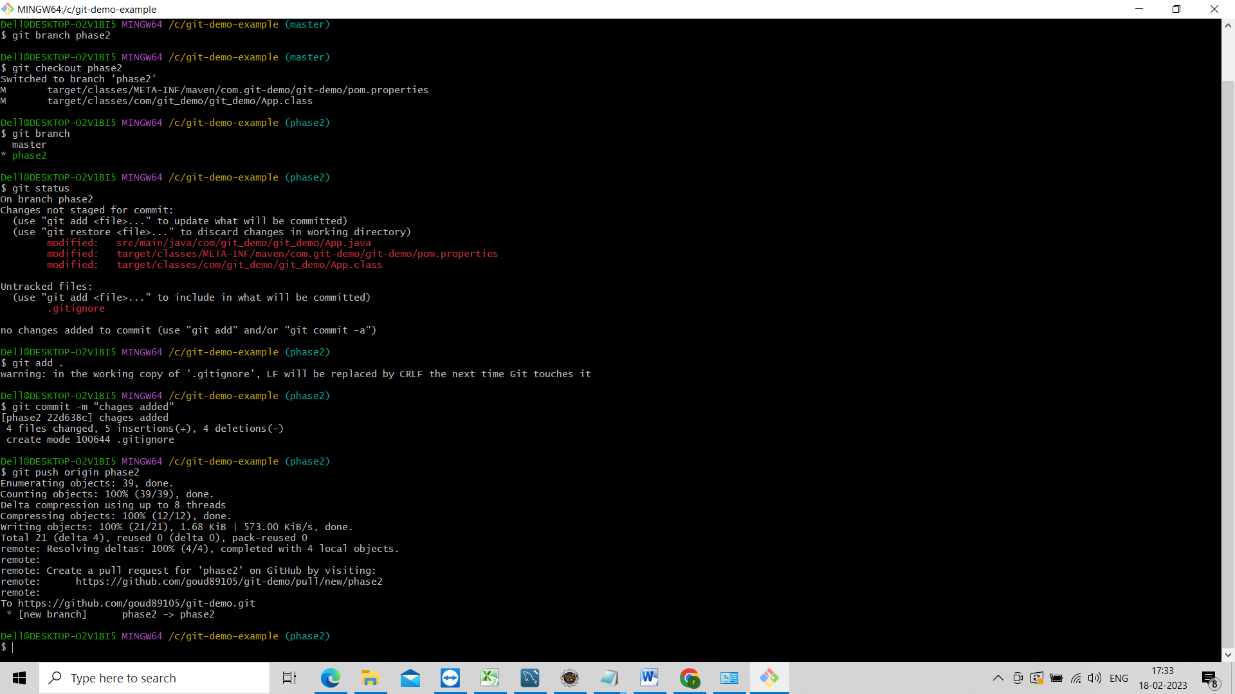

Now in git hub it will show the new branch phase2 go to git hub and see

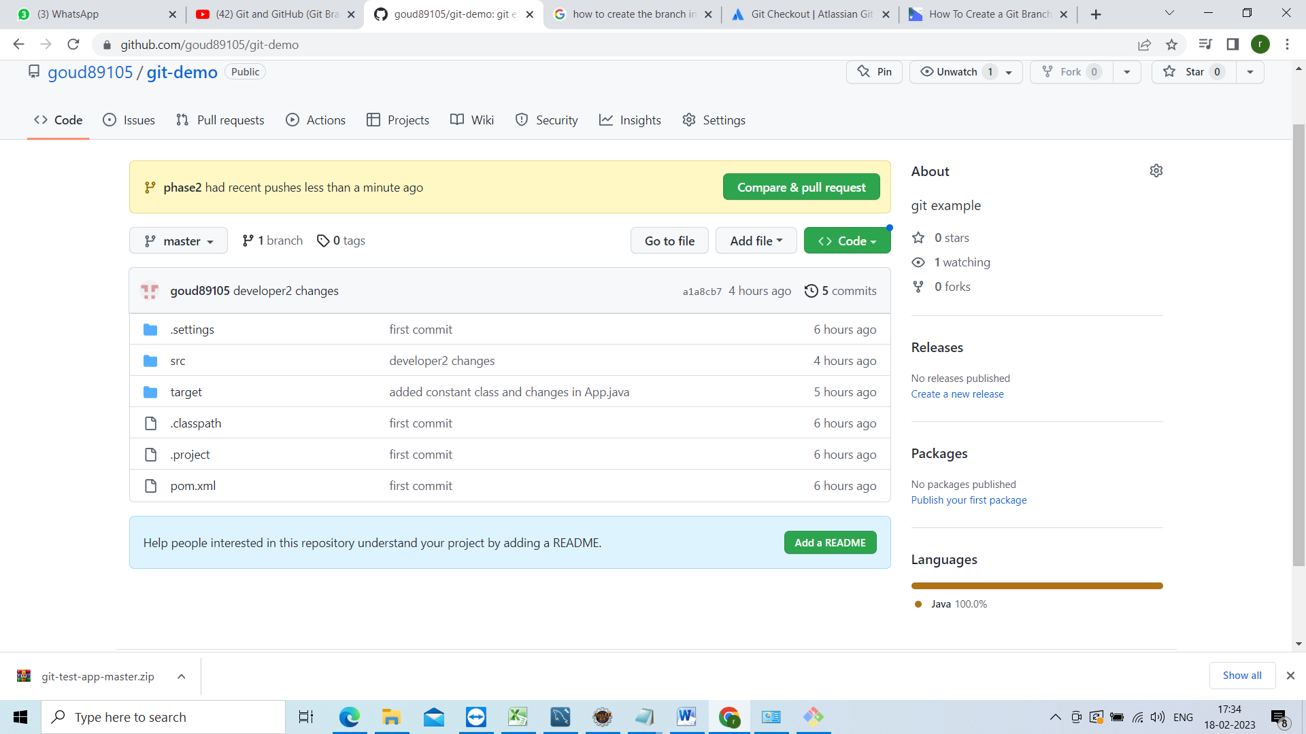

Now compare and create the pull request

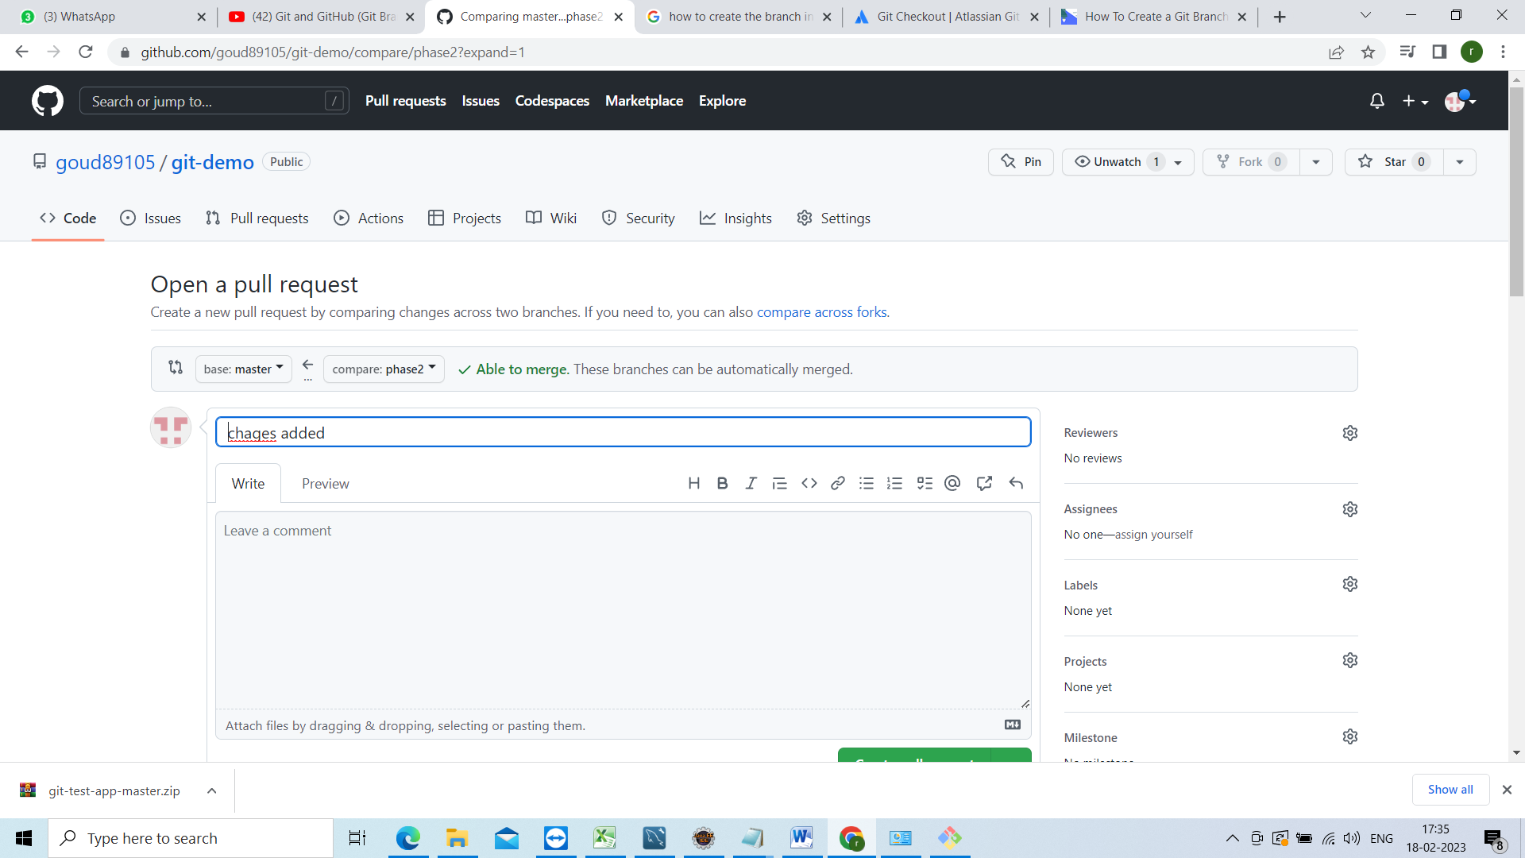

Now click on pull request

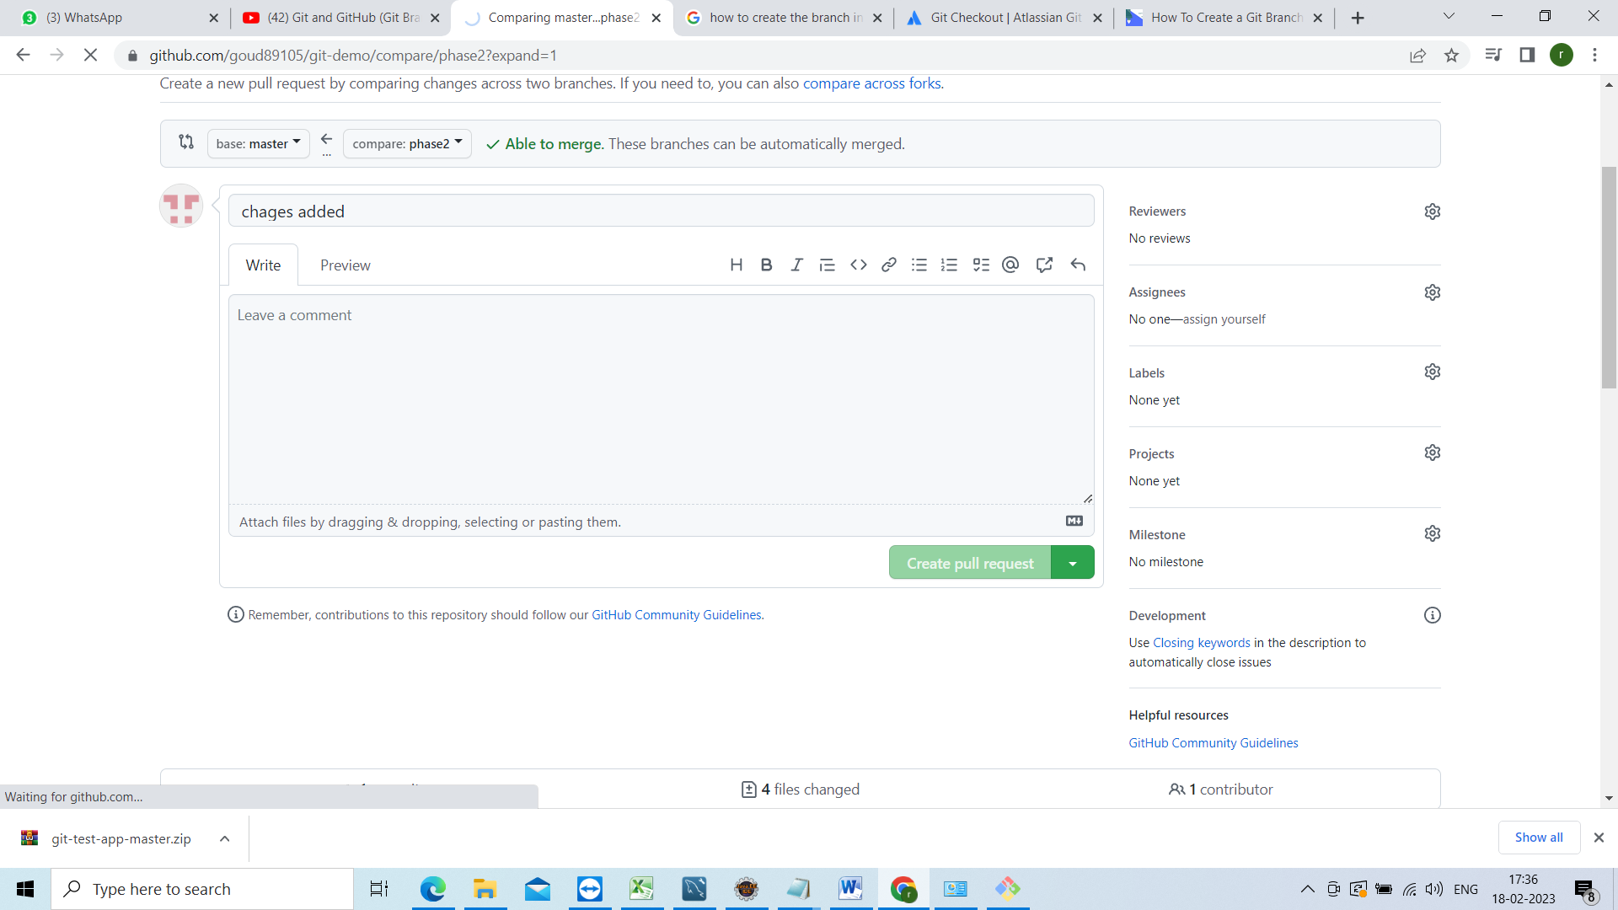

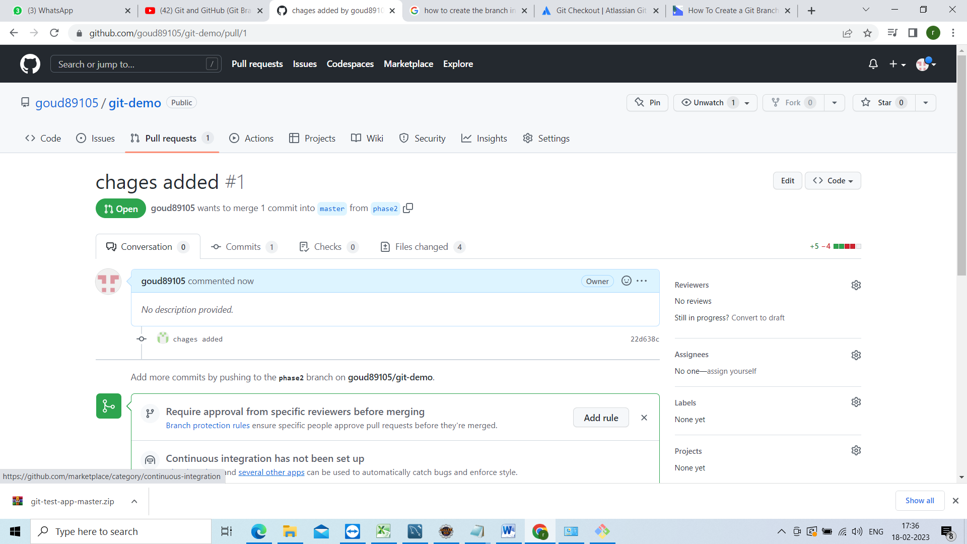

Now see this branch has no conflicts with the base branch

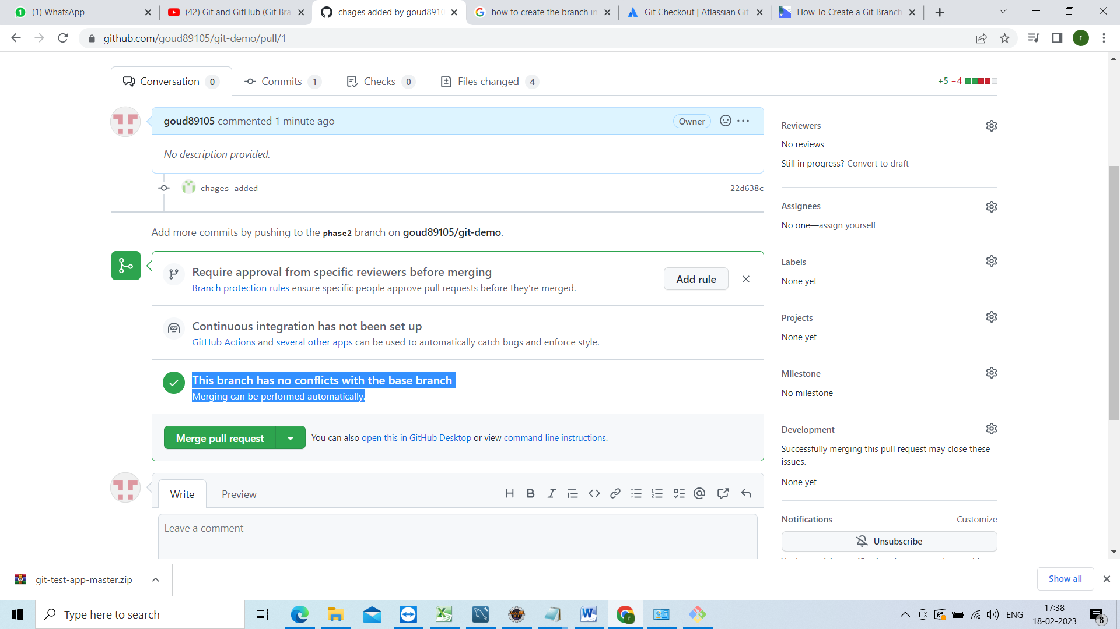

Before that lets check the changes click on files chaged

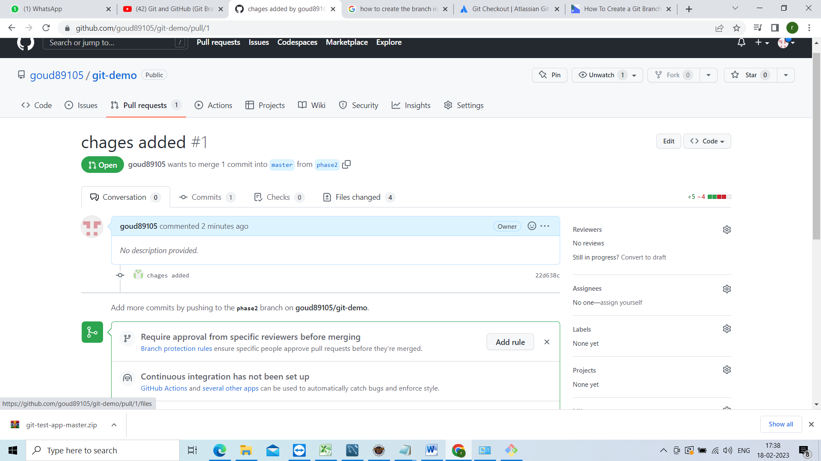

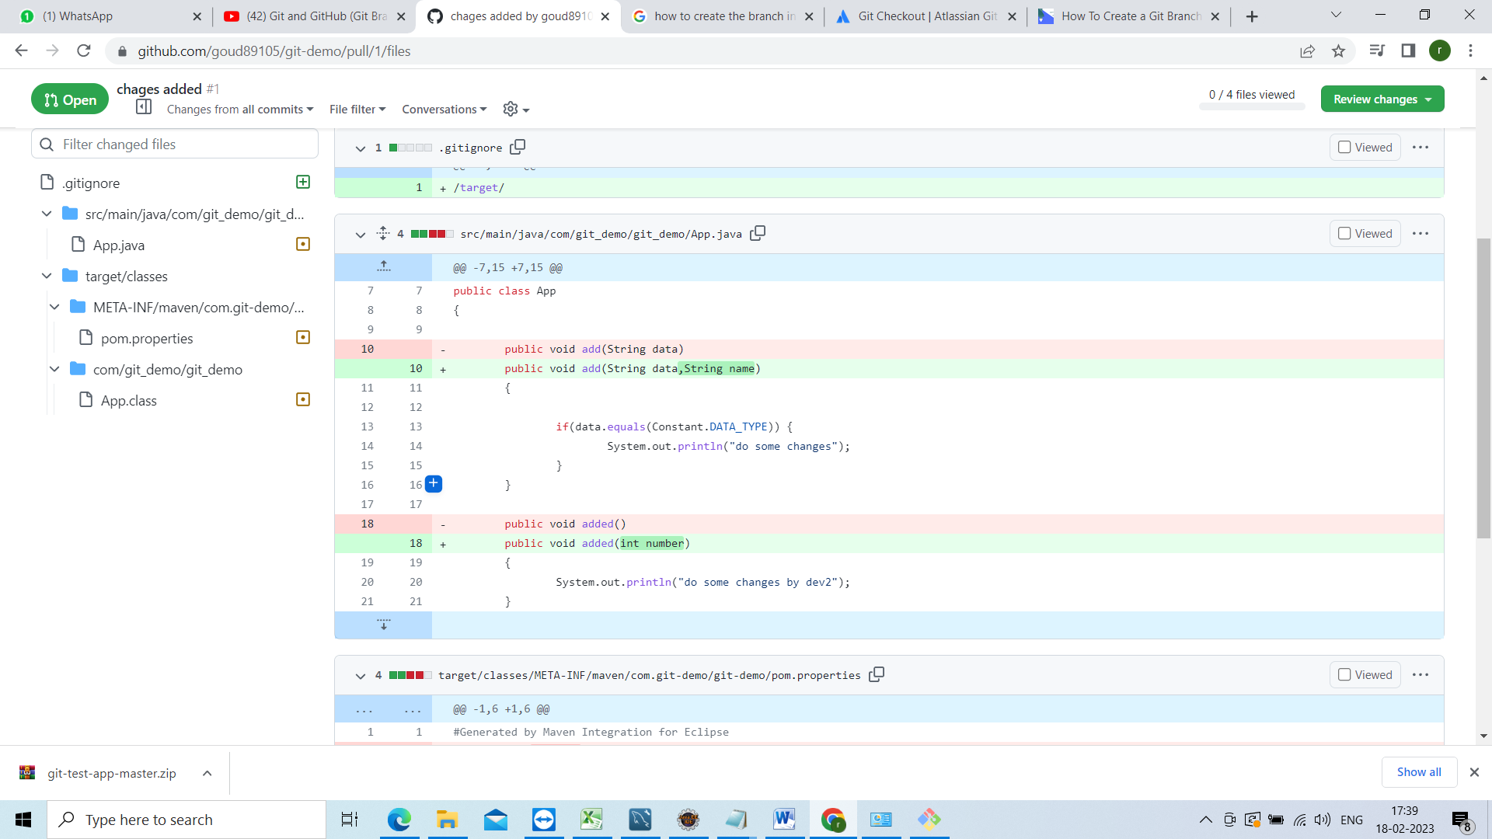

So that u can compare and can the review there

Now go back and click on merge pull request

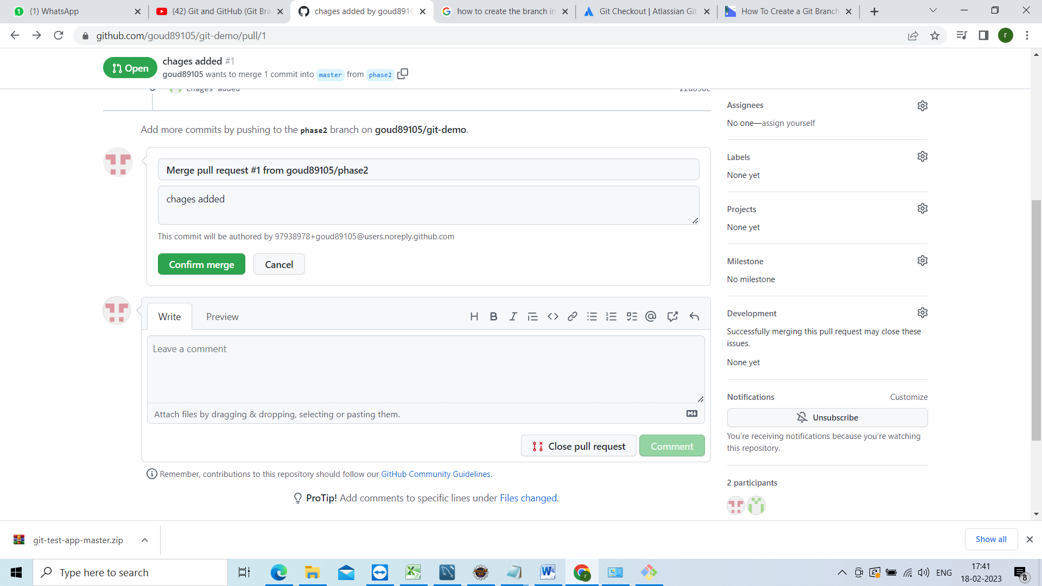

Click on confirm merge



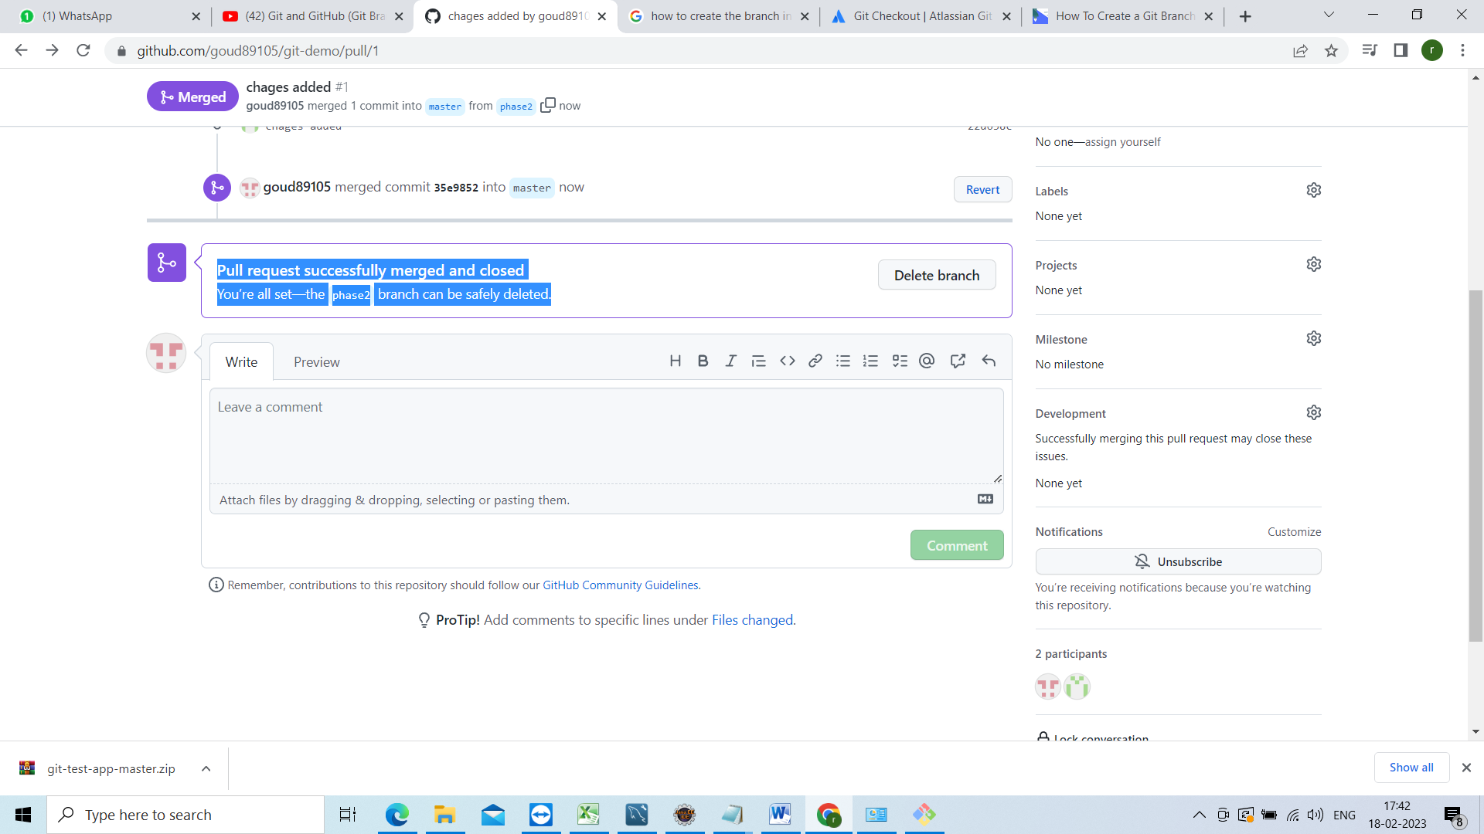

Now u have to give this pull request URL to ur team lead

<https://github.com/goud89105/git-demo/pull/1>

no go back and see this chages refleted or not

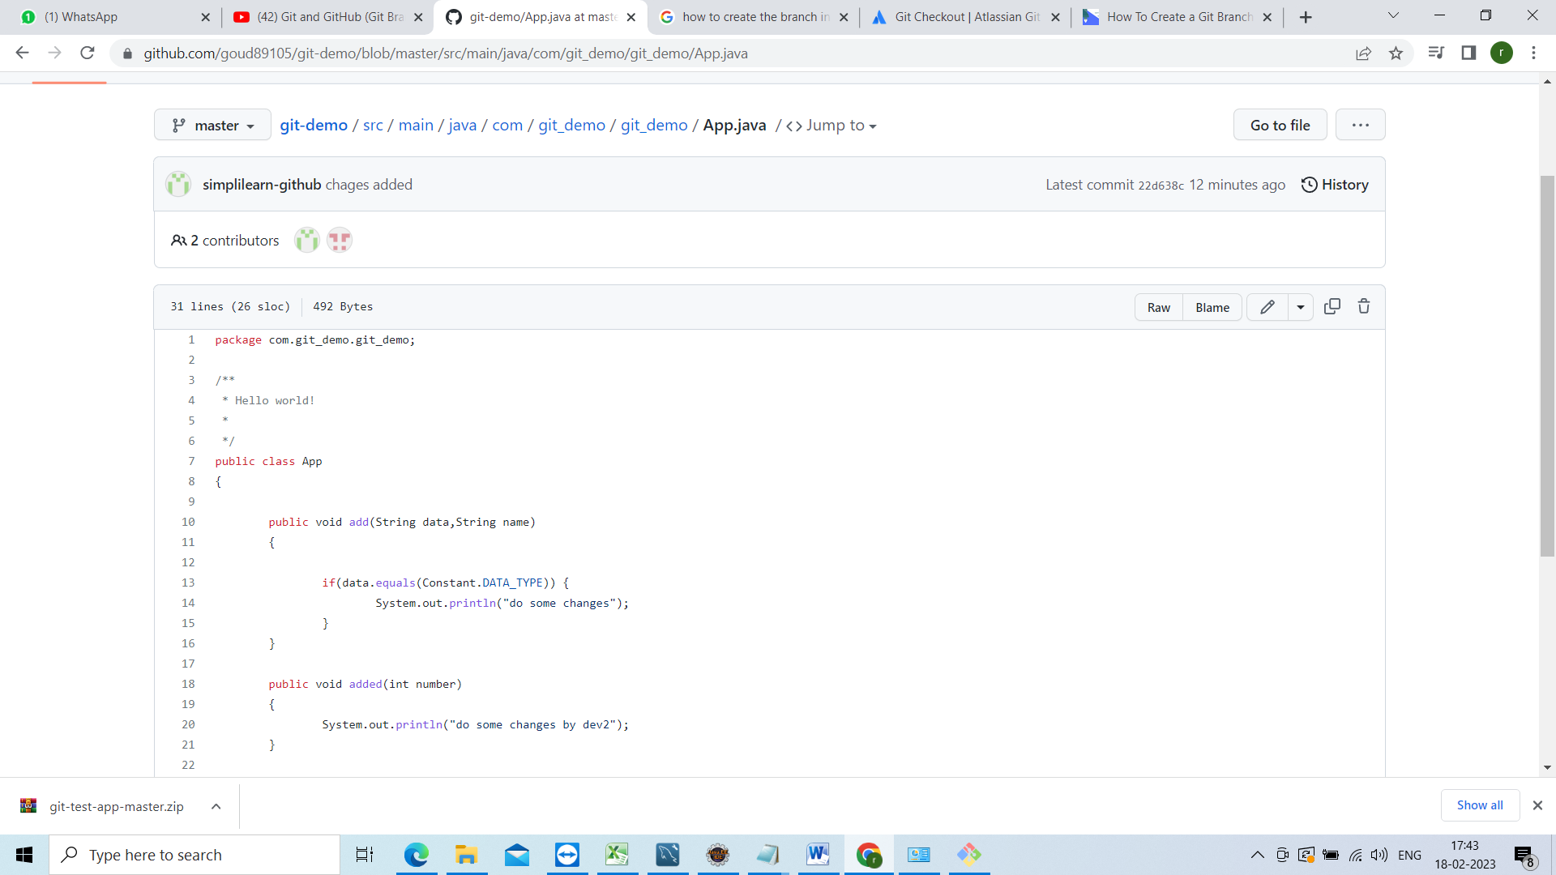

Now go to git bash changes are there in phase2 not in master changes wont come to master until u take pull

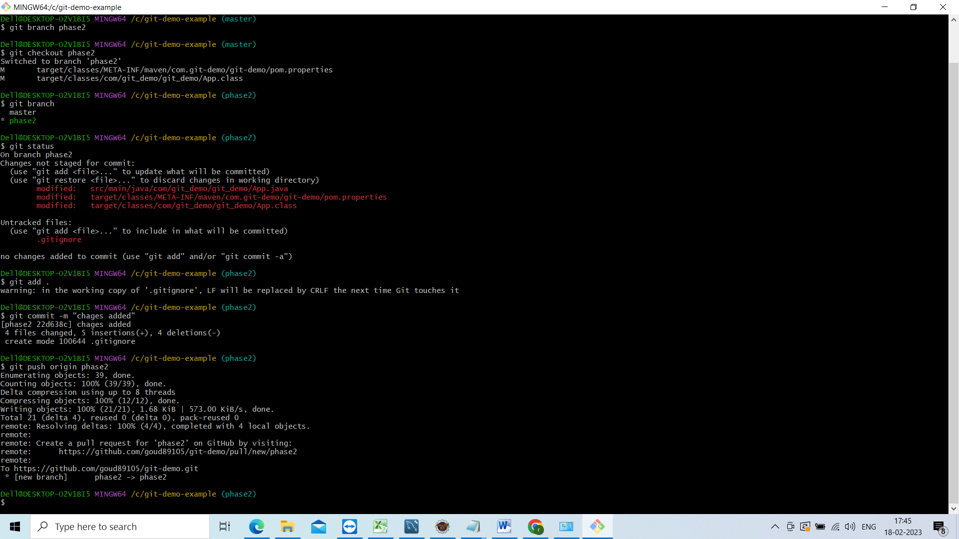

Switch to master branch

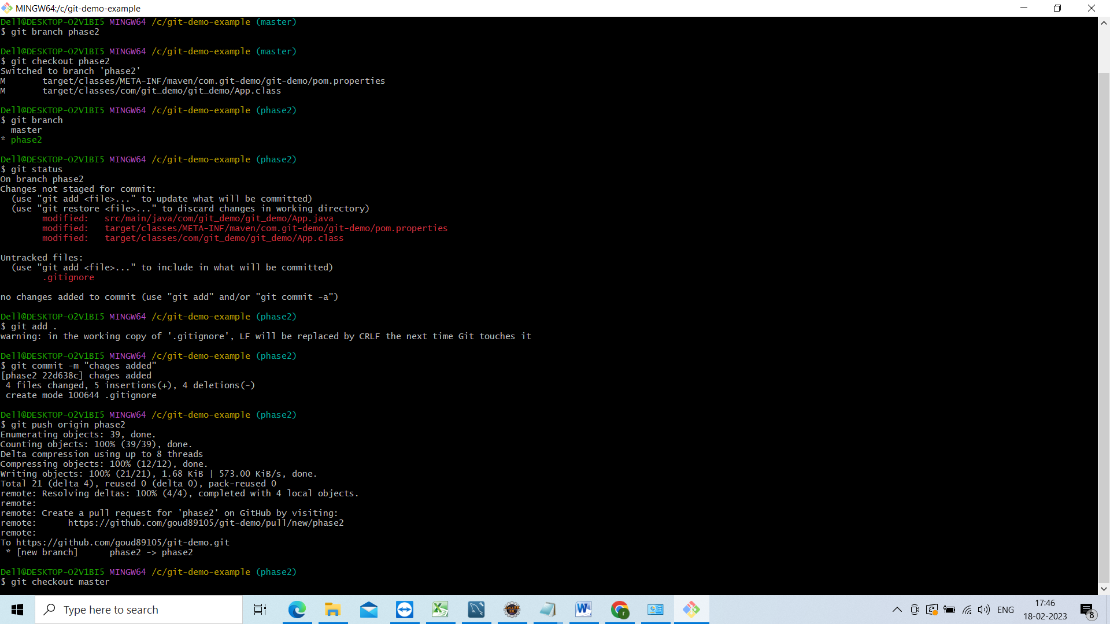

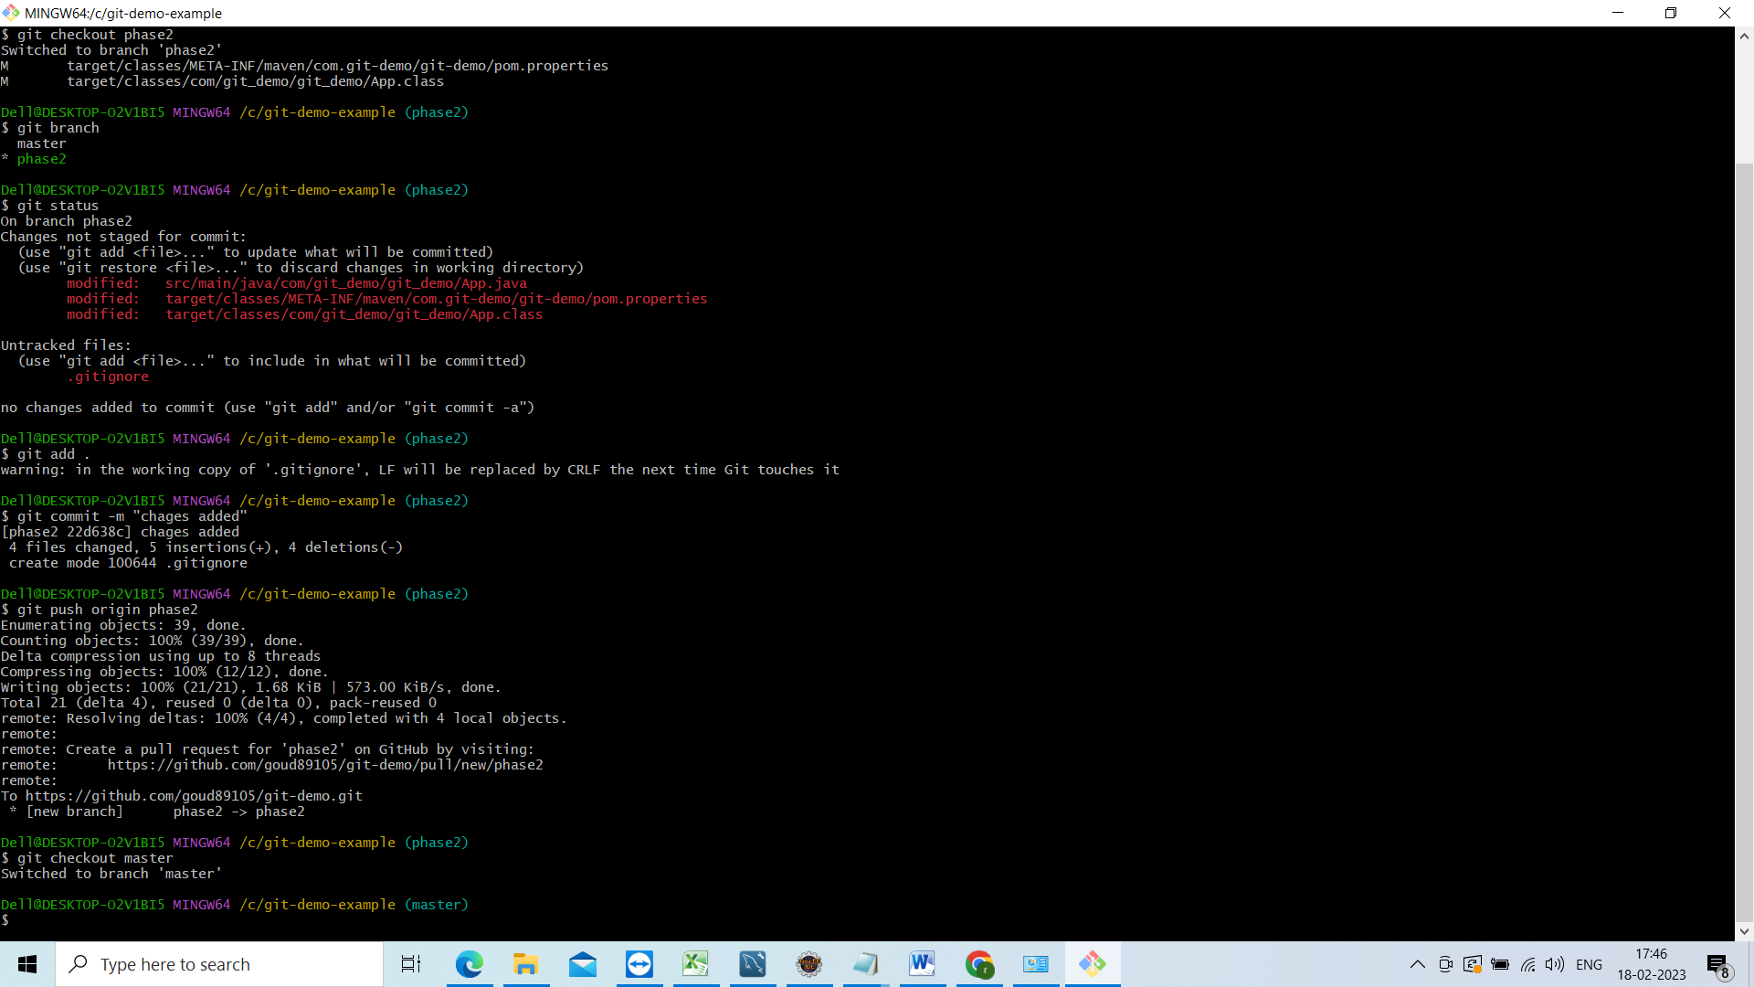

Now we are in master branch just clear the screen enter clear

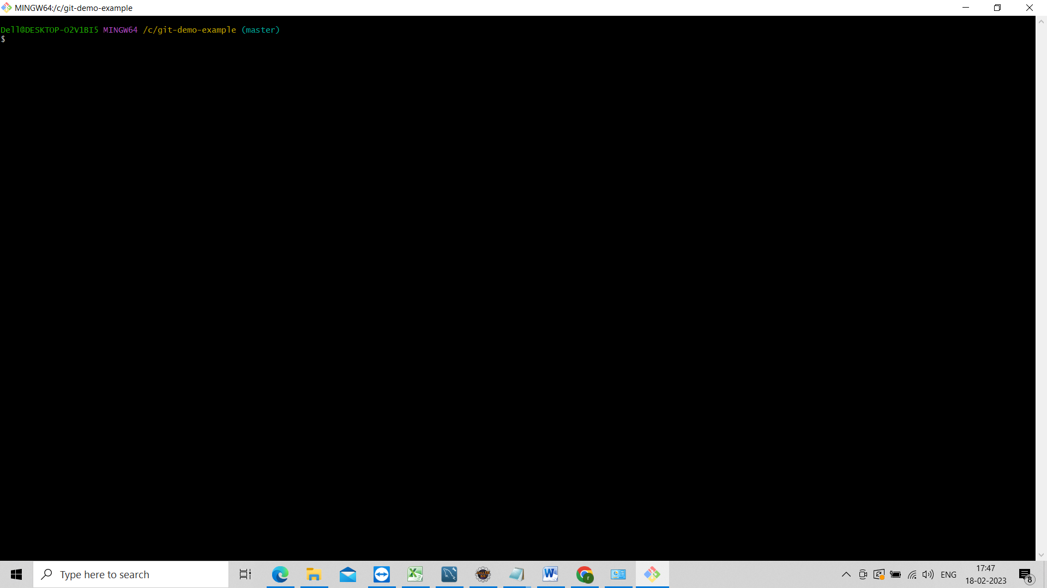

Now check git branch

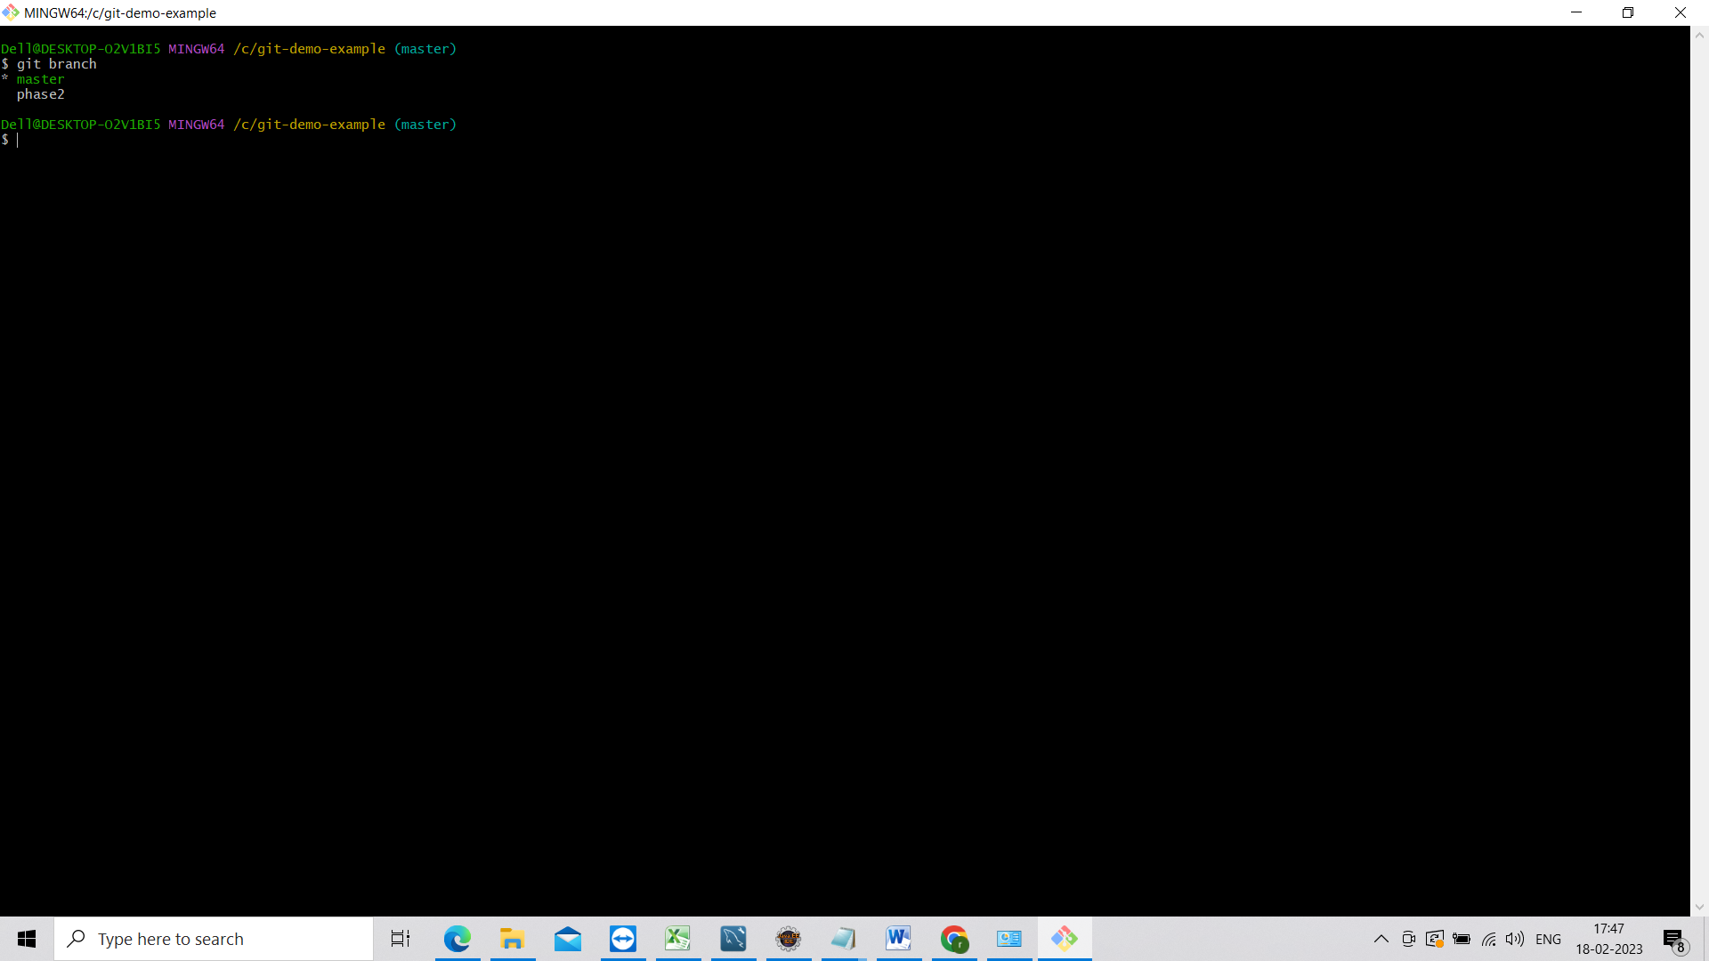

Now go to eclipse and see we are in master branch chages not refleted to the master branch

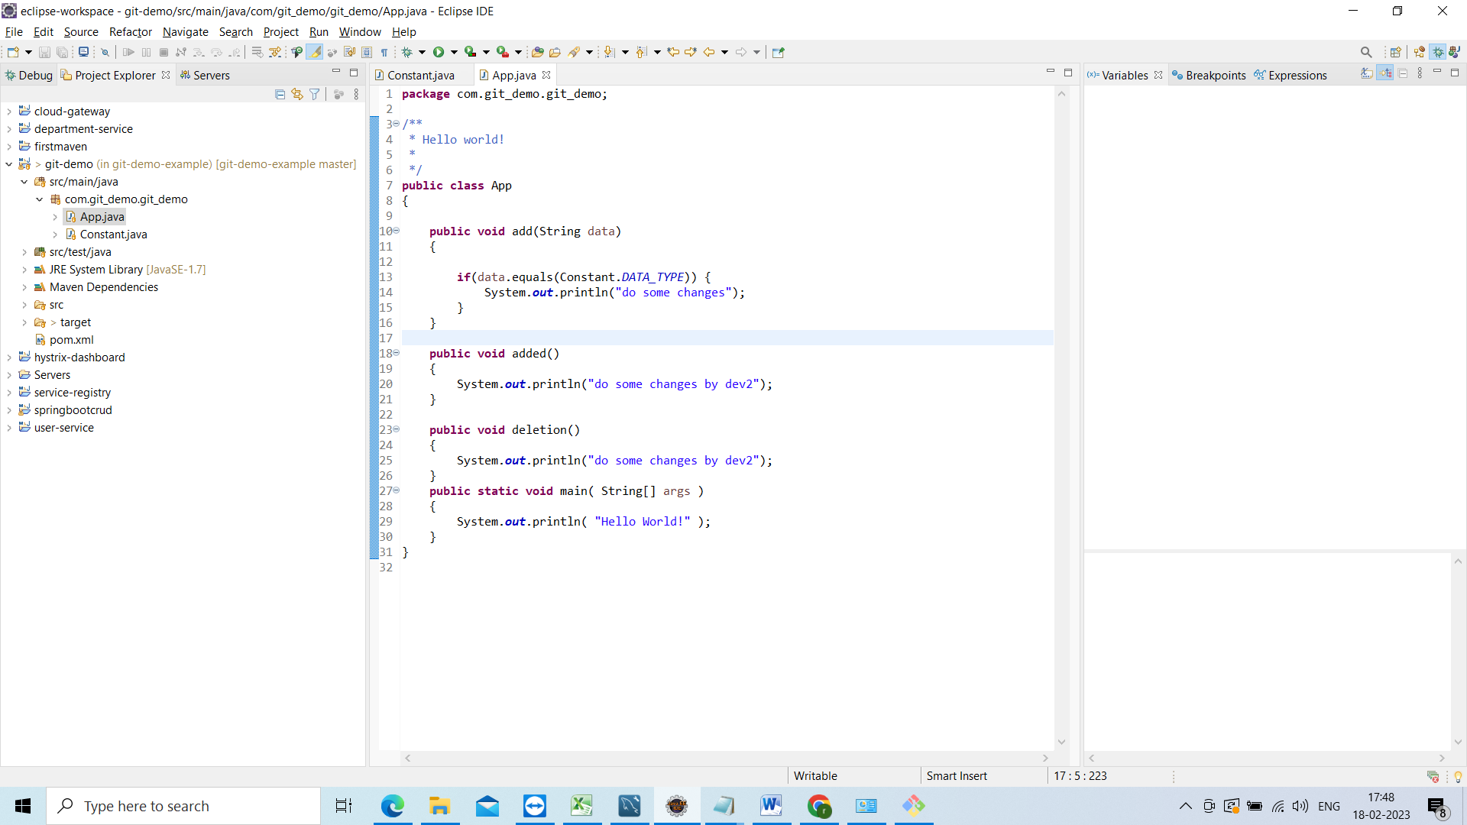

Now go to git bash and do pull

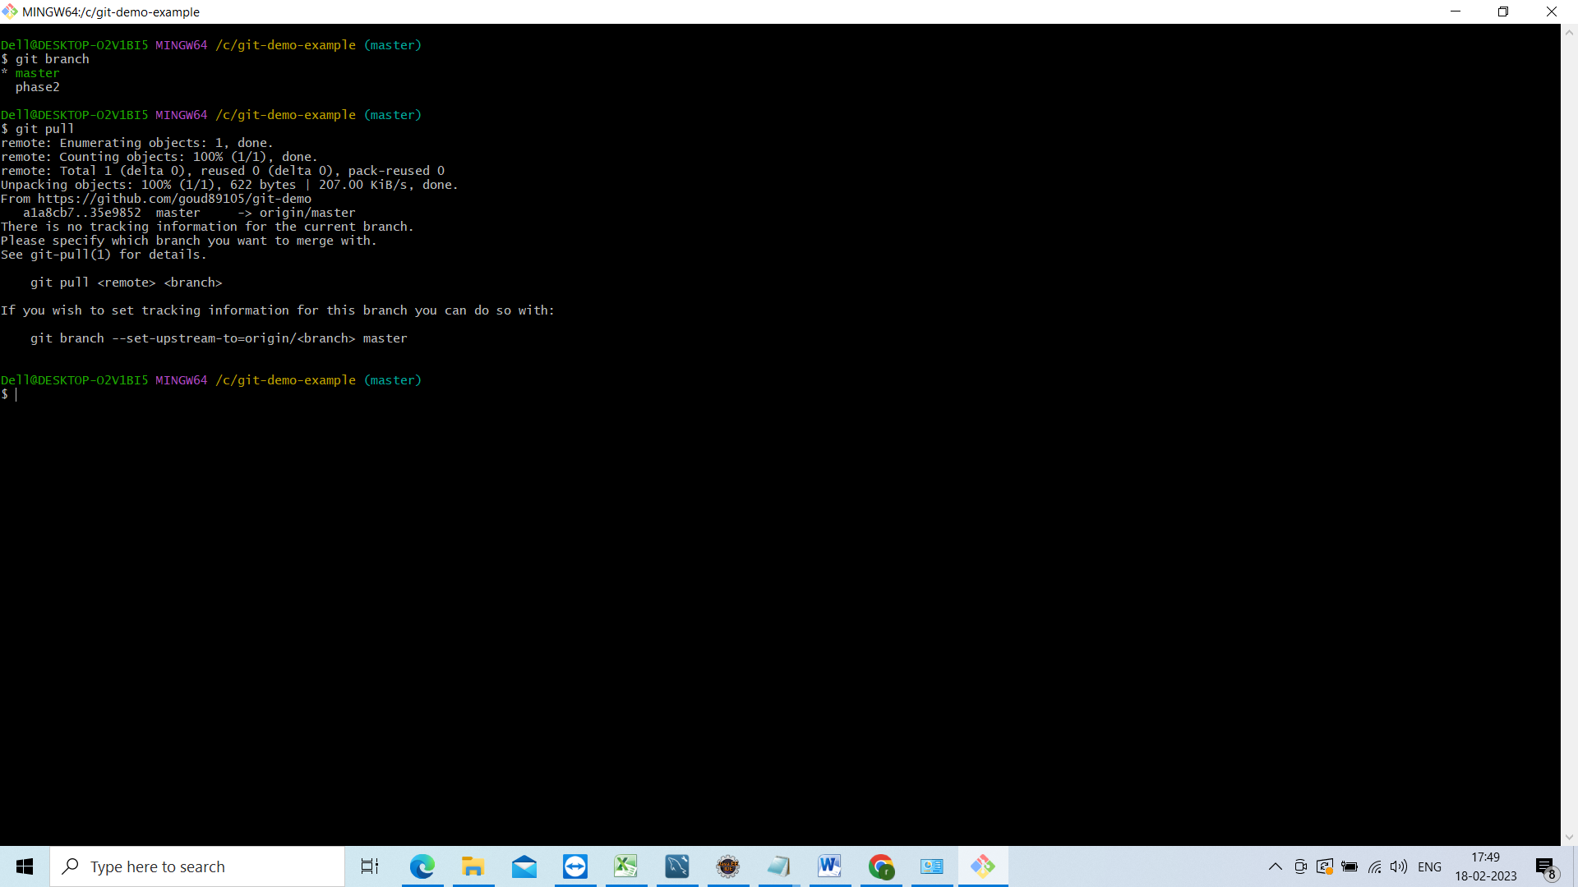

Now go to eclipse and see ur chages will be reflected in the master branch